**MINISTRY OF EDUCATION AND TRAINING**

**FPT UNIVERSITY**

Capstone Project Document

**Smart Wear on Your Route**

|  |  |
| --- | --- |
| **Group 2** | |
| **Group members** | Huỳnh Quang Thảo – SE60963  Trần Thanh Ngoan – SE61125  Nguyễn Trung Nam – SE61132  Ngô Tiến Đạt – SE60980 |
| **Supervisor** | Kiều Trọng Khánh |
| **Ext. Supervisor** | N/A |
| **Capstone Project Code** | SWR |

- Ho Chi Minh City, 09 September 2015 -

# Table of contents

Table of contents 2

List of Table 6

List of Figures 8

Definitions, Acronyms, and Abbreviations 10

A. Introduction 1

1. Project Information 1

2. Introduction 1

3. Current Situation 1

4. Problem Definition 2

5. Proposed Solution 2

5.1. Feature functions 2

5.2. Advantages and disadvantages 4

6. Functional Requirements 5

7. Role and Responsibility 5

B. Software Project Management Plan 6

1. Problem Definition 6

1.1. Name of this Capstone Project 6

1.2. Problem Abstract 6

1.3. Project Overview 6

2. Project organization 9

2.1. Software Process Model 9

2.2. Roles and responsibilities 10

2.3. Tools and Techniques 11

3. Project Management Plan 11

3.1. Software development life cycle 11

3.2. Phase Detail 14

3.3. Task sheet 15

3.4. All Meeting Minutes 15

4. Coding Convention 15

4.1. Java Coding Convention 15

4.2. Android Coding Convention 16

C. Software Requirement Specification 17

1. User Requirement Specification 17

1.1. Customer requirement 17

1.2. Staff requirement 17

2. System Requirement Specification 18

2.1. External Interface Requirement 18

2.2. System Overview Use Case 19

2.3. List of Use Case 24

3. Software System Attribute 71

3.1. Usability 71

3.2. Reliability 71

3.3. Availability 71

3.4. Security 71

3.5. Maintainability 71

3.6. Portability 71

3.7. Performance 71

4. Conceptual Diagram 72

D. Software Design Description 77

1. Design Overview 77

2. System Architecture Design 77

2.1. Web Application architecture description 77

2.2. Mobile Application Architecture Description 78

2.3. Android Wear Architecture Description 79

3. Component Diagram 79

4. Detailed Description Class Diagram 80

4.1. Web System class diagram 81

4.2. Web class diagram 84

4.3. Interactive Diagram 92

5. Interface 102

5.1. Component interface 102

5.2. Web application design 105

5.3. Mobile application design 107

5.4. Wear application design: 111

6. Database design 112

6.1. Main Entity Relationship diagram 113

6.2. Sub entity Relationship diagram 114

7. Algorithm 115

7.1. Raptor algorithm 115

7.2. Search bus two point: 119

7.3. Search bus more than two points 122

7.4. Search bus more than two points with optimize 124

7.5. Search motorbike more than two points 125

7.6. Search motorbike more than two points optimize 128

7.7. Distance from one point to segment algorithm 130

7.8. Notify algorithm when on right route. 131

7.9. Notify algorithm when on wrong route 133

7.10. Download audio file algorithm 136

E. System Implementation & Test 138

1. Introduction 138

1.1. Overview 138

1.2. Test Approach 138

2. Database Relationship Diagram 138

2.1. Physical Diagram 138

2.2. Data Dictionary 140

3. Performance Measures 143

3.1. Web application page load speed 143

3.2. Mobile application API load speed 144

4. Test Plan 146

4.1. Features to be tested 146

4.2. Features not to be tested 146

5. System Testing Test Case 146

5.1. Communication Diagrams 146

5.2. Test case 147

F. Software User’s Manual 173

1. Installation Guide 173

2. User Guide 173

2.1. Web Application 173

2.2. Mobile Application 177

2.3. Wear Application 183

G. Appendix 184

# List of Table

Table 1: Definitions, Acronyms, and Abbreviations 11

Table 2: Roles and Responsibilities 5

Table 3: Hardware requirement for continuous integrating server 8

Table 4: Hardware requirement for web development 8

Table 5: Hardware requirement for mobile development 9

Table 6: Hardware requirement for wear development 9

Table 7: Software requirement 9

Table 8: Roles and responsibilities 11

Table 9: Tools and Techniques 11

Table 10:Software development life cycle 13

Table 11: Requirements definition 14

Table 12: System and software design 14

Table 13: Implementation and unit test 14

Table 14: Integration and system testing 15

Table 15: Operation and maintenance 15

Table 16:Naming conventions for drawables 16

Table 17: Naming conventions for icons 16

Table 20: Use case WS02 - <Staff> Approve or reject all current system bus information change. 26

Table 21: Use case WS03 - <Staff> Approve or reject a detail bus information change. 28

Table 22: Use case WS04 - <Staff> Configure parsing source. 31

Table 23: Use case WS05 - <Staff> Configure parsing web. 32

Table 24: Use case WS06 - <Staff> Edit bus timetable route information. 34

Table 25: Use case WS07 - <Staff> Add bus timetable route information. 36

*Table 26: Use case WS08 - <Staff> Delete bus timetable information.* 38

Table 27: Use case WS09 - <Staff> Edit bus route information. 39

*Table 28: Use case WS10 - <Staff> Delete bus route information.* 41

*Table 29: Use case WS11 - <Staff> Add bus route information.* 45

Table 34: Use Case SC01 -<Scheduler> Parse bus route. 48

Table 35: Use case SC02 - <Scheduler> Parse bus timetable. 51

Table 37: Use case MB02 - <Guest> Search Bus Route 56

Table 39: Use case MB04 - <Guest> Search Motorbike Route 60

Table 41: Use case MB07 - <Guest> Input by voice search 61

Table 42: Use case MB08 - <Guest> Recommend place when user search 63

Table 43: Use case MB09 - <Guest> Help user go to next turn or station 64

Table 44: Use case MB10 - <Guest>Detect when guest goes to wrong route 65

Table 45: Use case WR01 - <Guest> Show information of a bus station on map 68

Table 46: Use case WR02 - <Guest> Notify when wear is received message from mobile 69

Table 47: Use case WR03 - <Guest> Navigate current place map 71

Table 48: Conceptual Diagram Data Dictionary 74

Table 49: Conceptual Diagram Data Dictionary 76

Table 50 Component Dictionary 80

Table 51: DispatcherServlet - Method 81

Table 52: ApplicationContext - Attribute 81

Table 53: ApplicationContext - Method 82

Table 54: IActionFactory - Method 82

Table 55: IAction - Method 82

Table 56 Class dictionary 84

Table 57: CityMap - Attribute 85

Table 58: CityMap - Method 85

Table 59: Route - Attribute 85

Table 60: Route - Method 86

Table 61: Station - Attribute 86

Table 62: Station - Method 86

Table 63: Trip - Attribute 87

Table 64: Trip - Method 87

Table 65: PathInfo - Attribute 87

Table 66: PathInfo - Method 87

Table 67: Connection - Attribute 88

Table 68: Connection - Method 88

Table 69: Path - Attribute 88

Table 70: Path - Method 88

Table 71: Segment - Attribute 89

Table 72: Segment - Method 89

Table 73: Result - Attribute 89

Table 74: Result - Method 89

Table 75: Journey - Attribute 89

Table 76: Journey - Method 90

Table 77: Account - Attribute 90

Table 78: Account - Method 90

Table 79: Role - Attribute 90

Table 80: Role - Method 90

Table 81: Notification - Attribute 90

Table 82: Notification - Method 90

Table 83: StationNotification - Attribute 91

Table 84: StationNotification - Method 91

Table 85: RouteNotification - Attribute 91

Table 86: RouteNotification - Method 91

Table 87: TripNotification - Attribute 92

Table 88: TripNotification - Method 92

Table 89: PathInfoNotification - Attribute 92

Table 90: PathInfoNotification - Method 92

Table 97: Configure Parse Source - fields 105

Table 98: Configure Parse Source - Buttons/Hyperlinks 105

Table 99: Manage Trip Information Change - fields. 106

Table 100: Manage Trip Information Change - Buttons/Hyperlinks 106

Table 110 Search Bus Three or Four Points – List View 107

Table 111 View Detail Result Bus Three or Four Points - Fields 108

Table 112 View Detail Result Bus Three or Four Points – Image Buttons 108

Table 113 View Detail Result Bus Three or Four Points – List View 108

Table 117 Search Motorbike - Fields 109

Table 118 Search Motorbike – List View 109

Table 127 Search with Voice – Image Buttons 109

Table 128 Search with Voice - Fields 110

Table 129 Search with Voice - Buttons 110

Table 135 Data table dictionary 139

Table 137 Web application page load speed test result 143

Table 138 Mobile app API load speed client specification 143

Table 139 Mobile app API load speed test cases 144

Table 140 Mobile application API load speed test result 144

Table 141: Guest – Search Bus Two Points 146

Table 142: Guest – Search Bus Three Points no Optimize 149

Table 143: Guest – Search Bus Three Points Optimize 153

Table 144: Guest – Search Bus Four Points no Optimize 158

Table 145: Guest – Search Bus Four Points Optimize 164

Table 149: Guest – Search Motorbike Three Points 165

Table 150: Guest – Search Motorbike Four Points 168

Table 151: Guest – Notify When on Right Route 169

Table 152: Guest – Notify When on Wrong Route 170

Table 155: Staff – Configure Parsing Source 170

Table 156: Staff – Configure Parsing from Web 171

# List of Figures

Figure 1: Waterfall model 10

Figure 2: System overview use case 20

Figure 3: Web application use case 21

Figure 4: Android mobile application use case 22

Figure 5: Android wear application use case 23

Figure 8 <Staff> Overview Use Case 24

Figure 10: <Staff> Approve or reject all current system bus information change. 25

Figure 11: <Staff> Approve or reject a detail bus information change. 27

Figure 12: <Staff> Configure parsing source. 29

Figure 13: <Staff> Configure parsing web 31

Figure 14: <Staff> Edit bus timetable information. 33

Figure 15: <Staff> Add bus timetable route information. 35

Figure 16: <Staff> Delete bus timetable information. 37

Figure 17: <Staff>Edit bus route information. 38

Figure 18: <Staff> Delete bus route information. 40

Figure 19: <Staff> Add bus route information. 41

Figure 25: <Scheduler> Overview Use Case 45

Figure 26: <Staff> Parse bus route 45

Figure 27: <Staff> Parse bus timetable 48

Figure 28: <Guest> Search Location 52

Figure 30: <Guest> Search Bus Route 52

Figure 32: <Guest> Search Motorbike Route 56

Figure 35: <Guest> Voice search input 60

Figure 36: <Guest> Recommend place when user search 62

Figure 37: <Guest> Help user go to next turn or station 63

Figure 38: <Guest> Detect when guest goes to wrong route 64

Figure 39: <Guest> Overview use case 66

Figure 40: <Guest> Show detail route on map. 66

Figure 41: <Guest> Notify when wear is received message from mobile. 68

Figure 42: <Guest> Navigate current place map 69

Figure 43: Conceptual Diagram 73

Figure 44: Mobile Conceptual diagram 75

Figure 45 System architecture design 77

Figure 46 Component Diagram 80

Figure 47: Web system class diagram 81

Figure 48: Sequence diagram - Parse source local action 93

Figure 49: Sequence diagram - Search two point bus route 94

Figure 50: Sequence diagram - Search multi point bus route 94

Figure 51: Activity Diagram - <Guest> Navigate current location on map 95

Figure 52: Activity Diagram - <Guest> Setting 96

Figure 53: Activity Diagram - <Guest> View detail 96

Figure 54 Activity Diagram - <Guest> Search bus route 97

Figure 55 Activity Diagram - <Guest> Search motorbike route 98

Figure 56: Activity Diagram - <Guest> Search arbitrary location on map 99

Figure 57: Activity Diagram - <Guest> Download audio file 99

Figure 59: Activity diagram - <Guest> Recommend place when user search 100

Figure 60: Activity diagram - <Guest> Route street 101

Figure 64 Interface - <Staff> Configure parse source 105

Figure 65 Interface - <Staff> Manage trip bus information change. 106

Figure 71: Interface - <Guest> Search Bus Three or Four Points 107

Figure 72: Interface - <Guest> View Detail Result Bus Three or Four Points 107

Figure 74: Interface - <Guest> Search Motorbike 108

Figure 78: Interface - <Guest> Search with Voice 109

Figure 81: Search bus two point algorithm – flowchart 120

Figure 82: Search bus more than two points algorithm – flowchart 122

Figure 83: Perpendicular example 129

Figure 84 Physical diagram 138

Figure 85 Web application page load speed test result 142

Figure 86 Mobile application API load speed test result 144

# Definitions, Acronyms, and Abbreviations

|  |  |
| --- | --- |
| Name | Definition |
| SWR | Smart Wear on your Route |
| API | Application Programming Interface |
| Wear device | Smart watch that uses Android Wear OS 4.4 or above |
| Staff | Administrator of website |
| BusMap | Official mobile application developed by Ho Chi Minh Ministry of Communications and Transport -http://www.buyttphcm.com.vn/Detail_News.aspx?sl=717 |
| RAPTOR | Round-based Public Transit Optimized Router |
| mcRAPTOR | More criteria RAPTOR |
| Station | Distinct location in the network where one can board or get off a vehicle (bus, train) |
| Round | Represents a sequence of stations a specific vehicle (train, bus, subway …) |
| Connection | A connection models a vehicle departing at one start station to end station of one trip without intermediate halt. |
| Trip | Trip is a round with time arrival information at each station. One trip often has many routes. |
| Footpath | Model walking connection between stations. |
| Pareto Set | A subset of the set of feasible points of solutions that contains all points that have at least one objective optimized while holding all other objectives constants. |

Table 1: Definitions, Acronyms, and Abbreviations

# 

# Introduction

## Project Information

Project name: Smart Wear on Your Route

Project Code: SWR

Product Type: Website, Android and Android Wear application

Start Date: September 7th, 2015

End Date: December 20th, 2015

## Introduction

Nowadays, within the strong development of presently economy, time is always one of the priorities in all areas. In particularly, when participating in traffic, how to know fastest route in the journey is the critical condition for user.

Presently, most of an application on market is not support searching through more than two points. For example, Google Map and BusMap just supports on searching through two points at most so that they cannot help user if user has more than one place to go. Moreover, no mobile application supports routing when participating traffic, for example notify message when customer near a station, or need to turn on specific street. Last but not least, no mobile application supports wear devices, so user must look up their mobile phone when participating in traffic and this behavior makes some inconveniences such as thief, accident …

Facing above problems, our team build the application named is “Smart Wear on Your Route”. In our application, we allow user find route through more than two points. We also support user choose their departure time so they can choose suitable route that they can come to place on time. We support user search by using voice command. We provide notify system function allowing customer know when participating traffic. We enhance this notify system by using sound notification when for user when participating traffic. We also provide wrong route detection system when user go to wrong route. We support map offline, so that customer doesn’t need network while participating traffic. Moreover, our application supports wear devices so user can look up on their wear device when they participating traffic avoiding some above problems. However, our system still works properly on mobile when wear has problems or doesn’t connected to mobile when participating traffic.

In additional, we also provide system software on website for staff to manage bus route, bus time information and approve the change from background handler.

## Current Situation

Nowadays, when participating in traffic, user often wants to find route through some locations. This situation becomes more important especially participating by bus or motorbike. Currently, mobile market has some applications that support routing such as Google map or BusMap.

Google Map and BusMap allow user enters starting location and ending location into their cell phones (with already networked). After that, Google Map and BusMap will suggest some optimal paths. Finally, user will choose the best route suitable for their need. When user finish selected their choice, mobile application will render route on mobile screen so user can follow the route.

With Google Map, user can optional enter arrival time and departure time. By this constraint, Google Map will find suitable routes that user can start and come to place on time.

## Problem Definition

Below are disadvantages of current situation:

* BusMap doesn't support motorbike route.
* BusMap doesn’t support time constraint (arrival time, departure time) when finding route.
* Google Map and BusMap don't support searching through more than two points.
* Google Map and BusMap don’t support routing when participating traffic.
* Google Map and BusMap don’t support sound routing when participating traffic.
* Google Map supports map offline with some limitations: Download area is limit with 50km x 50km and will be expired after 30 days. After 30 days, user must download that area again.
* Google Map voice search has some limitations such as just can only search one place.
* BusMap and Google Map don’t support using smart watch for routing when participating traffic, just for phone. There are some disadvantages of using only smartphone to find route such as theft, inconvenience, no safety in motorbike control as well as the bus.

## Proposed Solution

Our proposed solution is to build and mobile application and android wear application named “Smart Wear on Your Route” to resolve the current situations. We also design the system to be scalable so we can extend our system for more platforms (iOS, Windows Phone) in the future and can be used for more transit protocols (train, high-speed train)

SWR system includes a web application, background process, mobile application and wear application with following functions:

### Feature functions

Web application: design for staff. Those functions support staff manage route and bus timetable. So Staff can approve or reject data change before saving to database.

* Manage routing: staff edits information for bus route and bus timetable.
* Notify new update data from server to staff: if official website (http://www.buyttphcm.com.vn/) has new data, background process will notify to staff and staff will decide approve this update or not.

Background process: process for checking data for getting latest data and update to server.

* Check new data periodically: Background process will check new data at 0 AM each day. If background process detects that data has been changed, background process will write new data to temporary database and notify messages for staff.

Mobile application: developing functions on mobile supports user search bus route or motorbike route both using voice or typing. Mobile functions also support user route when participating traffic using voice or text. Also mobile functions will support user recommend right route when they are on wrong way.

* Searching bus route through from two points to four points: user inputs start point, two optional middle points and end point and optional departure time. Application will find the best bus route from start point through middle points to end point which optimize condition (shortest time, least number change route)
* Find bus route through from two points to four points with optimize: user inputs start point, two optional middle points and end point and optional departure time, then choose “optimize” option. Application will find the best bus route from start point through three points which optimize condition (shortest time, least number change route), no matter order last three points.
* Find motorcycle route through from two points to four points: user inputs start point, two optional middle points and end point and optional departure time. Application will find the best motorcycle route from start point through middle points to end point which optimize condition shortest time.
* Find motorcycle route through from two points to four points with optimize: user inputs start point, two optional middle points and end point and optional departure time, then choose “optimize” option. Application will find the best motorcycle route from start point through three points which optimize condition shortest time, no matter order last three points.
* Assist user searching using typing or voice command: User has two ways for input data: Using keyboard and typing text or using voice command.
* Routing bus route: when user chooses one bus route for participating traffic, application will start for tracking user’s location, and notify message (by vibrate, notification, sound) when user is near a bus station that need to get off station.
* Routing motorbike route: when user chooses one motorbike route for participating traffic, application will start for tracking user’s location, and notify message (by vibrate, notification, sound) when user is near a turn. Application also notify message when user goes to wrong route and recommmend suitable message when come to searched route again.
* Detect wrong motorbike route: When users go to wrong route, application will detect and notify message periodically for users know that they have gone wrong route.
* Recommend suitable motorbike direction for user when user is near searched route: when user is on wrong route and go near again searched route, application will recommend suitable direction for user.
* Map offline: By using map offline, user can use routing function without network connectivity.

Wear app: functions developing on wear supports user easily navigate searched route (i.e: when participating traffic, so user doesn’t need to open mobile).

* Bus: Application will notify for user when bus nears the station that user should to leave:  if bus in circular range of station of the route's plan, application will show the message name of the next station.
* Motorcycle:
* App will notify when user has to turn route: If user drives in circular range of next turn, application will automatically show message which should to do next and vibrate until user out of this range.
* App will notify when user goes to wrong route: If user goes to wrong route compare to original searched route, application will automatically show message that user has gone to wrong route.
* Map:
* Show your current location: show current user location on map with route user should to go (including bus or motorbike).

### Advantages and disadvantages

Advantages:

* Support optimization passes through multi points.
* Support bus route timetable so that user can easily find suitable round for their time.
* Support routing on street both on motorbike and bus.
* Support voice routing on street, both on motorbike and bus.
* Support two methods for searching place: using text typing or using voice.
* Support detect wrong route and notify to user when user uses motorbike.
* Support recommend new route when user is from wrong way and is near again searched route.
* Support map offline so user doesn’t need network connectivity when participating traffic.
* Support on smart wear. User can look up information easier than using mobile phone. Also using smart wear decreases ability for mobile phone to be stolen.

Disadvantages:

* + Smart wear has higher price than smart phone and these screen is slightly small and hard to use for newbie.
* Application must parse data from third website so server’s data cannot be updated intermediately.

## Functional Requirements

Web Component: (for staff only):

* Edit bus route and bus time information.
* Approve bus route and bus time change from background handler and write to official database.

Parser Component:

* Parse bus route information.
* Parse bus timetable information.
* Periodically, detect the change from official bus website in order to write to temporary database.

Mobile Component:

* Find the path’s optimization from two points to four points when using bus.
* Find the path’s optimization from two points to four points when using motorbike.
* Voice search for bus and motorbike.
* Routing when participating traffic both on bus and motorbike vehicle.
* Detecting wrong route and recommend again true direction.
* Sync data from mobile to wear.

Wear Component:

* Receive data from mobile.
* Notify message when user near the bus station that should to left.
* Notify next turns when user drive by motorbike.
* Auto scroll to current user’s location on map.

## Role and Responsibility

|  |  |  |  |  |
| --- | --- | --- | --- | --- |
| No | Full Name | Role | Position | Contact |
| 1 | Kiều Trọng Khánh | Project Manager | Supervisor | khanhkt@fpt.edu.vn |
| 2 | Huỳnh Quang Thảo | Developer | Leader | huynhquangthao@gmail.com |
| 3 | Trần Thanh Ngoan | Developer | Member | ngoanttse61125@fpt.edu.vn |
| 4 | Nguyễn Trung Nam | Developer | Member | namntse61132@fpt.edu.vn |
| 5 | Ngô Tiến Đạt | Developer | Member | datntse60980@fpt.edu.vn |

Table 2: Roles and Responsibilities

# Software Project Management Plan

## Problem Definition

### Name of this Capstone Project

Official name: Smart Wear on Your Route

Vietnamese name: Hỗ trợ đi đường với thiết bị đeo tay thông minh.

Abbreviation: SWR

### Problem Abstract

The transport system has a lot of roads and bus routes. Even local people hardly know well. With this system, users must spend a lot of time to know how to get from one location to others. With the worst case scenario, user can lose their phone or cause danger to themselves because look up mobile phone frequently when participating traffic.

We provide application, which helps users find bus routes or motorcycle routes from two points to four points with optimized conditions (shortest time, walking distance, number transfers and departure time). Application supports finding route on android phone and real-time navigation on mobile and smart wear. Application also supports detect and recommend suitable direction when user is on wrong way. Application supports map offline so user doesn’t need network connectivity when participating traffic. Application also supports voice speech command.

### Project Overview

#### Current Situation

Below are the problems encountered in this project:

* **Depend on other system**: all the crawl data is gotten from other system. So if data has been changed, our system will be out of update.
* **Network Connection:** mobile application must be connected to 3G for getting GPS and map information periodically. Moreover, wear device must be in range of Bluetooth because pairing with mobile device.
* **Testing:** hardly to test GPS function when switching between bus stations due to physical limitation.
* **Absent of team members:** team members get sick or unexpected problems. Working time and learning time are different among members.
* **Violence Google terms of Service:** Google API Terms of Service doesn’t allow real-time navigation or route guidance, including but not limited to turn-by-turn route guidance that is synchronized to the position of a user's sensor-enabled device.

#### The Proposed System

Based on current issues, combined with research results in HCM city traffic system, we propose a system allow user searches route on mobile phone and real-time navigation by using smart wear.

We also developed algorithm name RAPTOR algorithm[1] for finding shortest distance between two points on graph.

We also store a local database on mobile device to allow users search bus route information offline.

Moreover, we have built a background handler for checking third-party server periodically every 0AM to always get the latest data.

Our system includes three main subsystems: an online website for staffs, a mobile application as well as watch application for Participants traffic.

##### Website

Website provided following features:

* For staffs:
* Staff edits information for bus route and bus timetable.
* Notify new update data from server to staff.
* Beside above, website system also provides an API interface for mobile, wear applications to retrieve data.

##### Background Handler

Check new data periodically at 0 AM each day.

Parse data from website.

##### Bus Routing Mobile Application

This application is used by user and does followings:

* Find bus route from two points to four points.
* Find bus route from two points to four points with optimize.
* Find motorcycle route from two points to four points.
* Find motorcycle route from two points to four points with optimize.
* Routing for motorbike route.
* Routing for bus route.
* Detect wrong way and recommend true direction for user.
* Notification for user to know next bus route or motorbike turn.

##### Wear Application

Application for wear device must be paired with android phone and do following function:

* Bus: Application will notify for user when bus nears the station that user should to leave.
* Motorcycle: Application will notify when user has to turn route.
* Map: Show current user location on map with route user should to go (including bus or motorbike.

#### Boundaries of the System

Our system is working on Ho Chi Minh city transportation system.

The language for mobile application and wear application is Vietnamese. The language for staff management site is English.

Mobile devices run android 4.3 or above. Smart wears run android wear API 20 or above.

The complete product includes:

* Website application for staffs.
* Background handler.
* Mobile and wear application for users.

#### Future plans

Our current system only supports bus and motorbike route in Ho Chi Minh city. We also just optimize time travel, walking distance, number transfers and departure time. We design the system to make it easier for further development including:

* **Support more public transportation**: system will support more public transits such as train andhigh-speed train.
* **Support more conditions**: system will provide more options for user choice such as: minimum ticket price, ticket price (student, old people). Moreover, we will design system support user give both departure time and arrival time.
* **Support other cities in Viet Nam**: system will support user find routes in other big cities such as Ha Noi or Da Nang.

#### Development Environment

##### Hardware requirement

For continuous integrating server:

|  |  |  |
| --- | --- | --- |
| Hardware | Minimum Requirements | Recommended |
| Internet Connection | 512Kbps | 8 Mbps |
| Operating System | Ubuntu Server 12 LTS | Ubuntu Server 14.04.2 LTS |
| Computer Processor | Intel® Core 2 Duo | Intel® Core(TM) i5 CPU , M 460 @ 2.53GHz |
| Computer Memory | 1GB RAM | 3GB or more |

Table 3: Hardware requirement for continuous integrating server

For web development:

|  |  |  |
| --- | --- | --- |
| Hardware | Minimum Requirements | Recommended |
| Internet Connection | 512Kbps | 8 Mbps |
| Operating System | Window Vista, 7, 8 | Window 7, 8 |
| Computer Processor | Intel® Core 2 Duo | Intel® Core(TM) i5 CPU , M 460 @ 2.53GHz |
| Computer Memory | 4GB RAM | 6GB or more |

Table 4: Hardware requirement for web development

For mobile development:

|  |  |  |
| --- | --- | --- |
| Hardware | Minimum Requirements | Recommended |
| Internet Connection | Wi-Fi Connection 512Kbps  Bluetooth Connection 4.0 | Wi-Fi Connection 8Mbps  Bluetooth Connection 4.0 |
| Operating System | Android 4.3 | Android 5.0 |
| Hardware | GPS supported | GPS supported |
| Memory | 1 GB RAM | 2 GB or more |

Table 5: Hardware requirement for mobile development

For wear development:

|  |  |  |
| --- | --- | --- |
| Hardware | Minimum Requirements | Recommended |
| Internet Connection | Bluetooth Connection 4.0 | Bluetooth Connection 4.0 |
| Operating System | Android Wear API 20 | Android Wear API 22 |
| Hardware |  | GPS supported |
| Memory | 512MB RAM | 512 MB or more |

Table 6: Hardware requirement for wear development

##### Software requirement

|  |  |
| --- | --- |
| Software | Name / Version |
| Operating system | Windows 7 or above, MacOS 10.10 or above |
| Environment | JDK 1.6, Java EE 6, Android SDK minimum API 20 |
| Modeling tool | StartUML 5.0 |
| IDE | Intellij IDEA 14.1, Android Studio 1.3.1 |
| DBMS | MySQL 5.6 |
| Source control | Git 2.3.2, Source Tree 1.6.20.0 |
| Web browser | Chrome 42 or above |
| Team Collaboration | Slack 1.1.3 |
| Issues and Task Management | GitHub and ZenHub |
| Others | Microsoft Word, Microsoft Excel, Adobe Photoshop |

Table 7: Software requirement

## Project organization

### Software Process Model

This project is developed under waterfall model. We apply customized waterfall model to capable with current situation in our team. We choose this model because the following reasons:

* This project is 4 months long due to the FPT University Capstone Project timeline, which can be consider a short project.
* Based on discussing carefully before with our supervisor, the requirements of this project are stable, clear, fixed and well understood by all team members.
* This project use android and wear technology, which we have strong background knowledge and well practice skills. Moreover, google has enough tutorials, supporting for further research.



Figure 1: Waterfall model

Reference: Page 30, chapter 2, Software process model, SOFTWARE ENGINEERING 9th Edition, by Ian Sommerville.

We customize the waterfall model from the reference to make the process more capable with current situation of our team.

### Roles and responsibilities

|  |  |  |  |
| --- | --- | --- | --- |
| No | Full name | Role in Group | Responsibilities |
| 1 | Kiều Trọng Khánh | Supervisor / Project Manager | - Clarify user requirement.  - Technical support and business analysis.  - Tracking development process.  - Review document and product. |
| 2 | Huỳnh Quang Thảo | Team leader, BA, Developer, Tester | - Tracking process.  - Planning project, distribute tasks.  - Requirement analysis.  - Database design.  - Documentation.  - GUI Design.  - Coding.  - Testing.  - Deploy product. |
| 3 | Trần Thanh Ngoan | BA, Developer, Tester | - Requirement analysis.  - Database design.  - Documentation.  - GUI Design.  - Coding.  - Testing. |
| 4 | Nguyễn Trung Nam | BA, Developer, Tester | - Requirement analysis.  - Database design.  - Documentation.  - GUI Design.  - Coding.  - Testing. |
| 5 | Ngô Tiến Đạt | BA, Developer, Tester | - Requirement analysis.  - Database design.  - Documentation.  - GUI Design.  - Coding.  - Testing. |

Table 8: Roles and responsibilities

### Tools and Techniques

|  |  |
| --- | --- |
| Tool / Technique | Name / version |
| Frontend | HTML, CSS, JavaScript, jQuery, Bootstrap |
| Backend | JavaEE, Servlet, JSP, Hibernate |
| Web server | Apache Tomcat 7 |
| Mobile | Android Development. |
| Wear | Android Wear Development |
| Development tool | IntelliJ IDEA 14, Android Studio 1.3.1 |
| DBMS | MySQL 5.6 |
| Source control | Git 2.3.2, Source Tree 1.6.20.0 |
| Modeling tool | StarUML 5.0 |
| Document tool | Microsoft Word 2013, Microsoft Excel 2013 |

Table 9: Tools and Techniques

## Project Management Plan

### Software development life cycle

Below are all the major tasks that need to be performed sequentially during the development of the system.

|  |  |  |  |  |  |
| --- | --- | --- | --- | --- | --- |
| Phase | Description | Deliverables | Resource needed | Dependencies and Constrains | Risk |
| Requirements Definition | Identify and clarify system requirements. | Report No.1 Introduction. | 20 man-days | N/A | - Missing requirement.  - Project’s scope can be unclear.  - Lack of member share and understand. |
| System and Software Design | - Identify hardware and software requirements.  - Decide software architect and clarify software detail design.  - Design database. | Report No.2 Software Project Management Plan, Report No. 3 Software Requirement Specification and  Report No. 4 Software Design Description. | 50 man-days | Depend on Requirements Definition. | - Misunderstood or unclear system’s requirement.  - Lack of practical experience leading to unreasonable design. |
| Implementation and Unit Testing | - Implements all functions of system.  - Create test plan.  - Perform Unit testing. | Software package. | 120 man-days | - Base on Software Requirement Specification and Software Design Description.  - Coding try to follow coding convention. | - Member does not performs unit test.  - Lack of practical experience. |
| Integration and System Testing | - Perform integration test and system test. | Report No. 5 System Implementation & Test | 35 man-days | Implementation and Unit Testing are finished. | - Lack of testing experience leading to lack of test cases.  - Not enough time for performing test. |
| Operation and Maintenance | - Deploy the system  - Create the user’s manuals.  - Do routine maintenance activities. | Report No.6 Software User’s Manual | 15 man-days | Integration and System Testing are finished. | User’s manual may be difficult for user to understand and confuse. |

Table 10:Software development life cycle

### Phase Detail

#### Phase 1: Requirements Definition

|  |  |  |
| --- | --- | --- |
| Task | Description | Author |
| Identify and clarify system requirements. | Research current systems to collect requirements.  Define main and needed functions the system must include. | Huỳnh Quang Thảo  Trần Thanh Ngoan  Nguyễn Trung Nam  Ngô Tiến Đạt |

Table 11: Requirements definition

#### Phase 2: System and Software Design

|  |  |  |
| --- | --- | --- |
| Task | Description | Author |
| Identify hardware and software requirements. | Find out the suitable hardware and software for the system, as well as its minimum and recommended requirements. | Huỳnh Quang Thảo  Trần Thanh Ngoan  Nguyễn Trung Nam  Ngô Tiến Đạt |
| Decide software architect and clarify software detail design. | - Define the major software components and interfaces.  - Draw core flow diagram, use case diagram, prototype …  - Group meeting to review and modify. | Huỳnh Quang Thảo  Trần Thanh Ngoan  Nguyễn Trung Nam  Ngô Tiến Đạt |
| Design database. | - Design database for the system. | Huỳnh Quang Thảo  Trần Thanh Ngoan  Nguyễn Trung Nam  Ngô Tiến Đạt |

Table 12: System and software design

#### Phase 3: Implementation and Unit Testing

|  |  |  |
| --- | --- | --- |
| Task | Description | Author |
| Implements all functions of system. | Coding all the components. | Huỳnh Quang Thảo  Trần Thanh Ngoan  Nguyễn Trung Nam  Ngô Tiến Đạt |
| Create test plan. | Planning for testing. | Huỳnh Quang Thảo  Trần Thanh Ngoan  Nguyễn Trung Nam  Ngô Tiến Đạt |
| Perform Unit testing | - Write Unit test cases.  - Implement Unit tests. | Huỳnh Quang Thảo  Trần Thanh Ngoan  Nguyễn Trung Nam  Ngô Tiến Đạt |

Table 13: Implementation and unit test

#### Phase 4: Integration and System Testing

|  |  |  |
| --- | --- | --- |
| Task | Description | Author |
| Perform integration test and system test. | - Test groups of modules and test whole the system. | Huỳnh Quang Thảo  Trần Thanh Ngoan  Nguyễn Trung Nam  Ngô Tiến Đạt |

Table 14: Integration and system testing

#### Phase 5: Operation and Maintenance

|  |  |  |
| --- | --- | --- |
| Task | Description | Author |
| Deploy the system | Deploy the system in client environment. | Huỳnh Quang Thảo  Trần Thanh Ngoan  Nguyễn Trung Nam  Ngô Tiến Đạt |
| Create the user’s manuals. | Create a guideline to instruct users using system. | Huỳnh Quang Thảo  Trần Thanh Ngoan  Nguyễn Trung Nam  Ngô Tiến Đạt |
| Do routine maintenance activities. | Do routine maintenance activities for client system. | Huỳnh Quang Thảo  Trần Thanh Ngoan  Nguyễn Trung Nam  Ngô Tiến Đạt |

Table 15: Operation and maintenance

### Task sheet

Refer to “Task sheet” folder.

### All Meeting Minutes

Refer to “Meeting Minutes” folder.

## Coding Convention

### Java Coding Convention

This project follows “Code Conventions for the Java TM Programming Language, by Sun Microsystems, rev April 20, 1999”.

<http://www.oracle.com/technetwork/java/codeconventions-150003.pdf>

We use followings naming convention from the reference to capable with current situation in our team:

* Naming:
* Class names must be in Pascal case.
* Variable names must be in Camel case.
* Each Java class belongs to a single file.
* Intentions:
  + - * Use four spaces intentions.
      * Avoid lines with more than 80 characters
* Declaration:
  + - * One declaration per line is recommended since it encourages commenting.
      * In absolutely no case should variables and functions be declared on the same line.
* Do not put different types on the same line.

### Android Coding Convention

On Android Development and Wear Development, we follow guideline on:

<https://github.com/ribot/android-guidelines/blob/master/project_and_code_guidelines.md>

We use followings naming convention from the reference to capable with current situation in our team:

* Resources file names are written in lowercase_underscore.
* Naming conventions for drawables:

|  |  |  |
| --- | --- | --- |
| Asset Type | Prefix | Example |
| Action bar | ab_ | ab_stacked.9.png |
| Button | btn_ | btn_send_pressed.9.png |
| Dialog | dialog_ | dialog_top.9.png |
| Divider | divider_ | divider_horizontal.9.png |
| Icon | ic_ | ic_star.png |
| Menu | menu_ | menu_submenu_bg.9.png |
| Notification | notification_ | notification_bg.9.png |
| Tabs | tab_ | tab_pressed.9.png |

Table 16:Naming conventions for drawables

* Naming conventions for icons:

|  |  |  |
| --- | --- | --- |
| Asset Type | Prefix | Example |
|  |  |  |
|  |  |  |
| Icons | ic_ | ic_star.png |
| Launcher icons | ic_launcher | ic_launcher_calendar.png |
| Menu icons and Action Bar icons | ic_menu | ic_menu_archive.png |
| Status bar icons | ic_stat_notify | ic_stat_notify_msg.png |
| Tab icons | ic_tab | ic_tab_recent.png |
| Dialog icons | ic_dialog | ic_dialog_info.png |

Table 17: Naming conventions for icons

# **Software Requirement Specification**

## User Requirement Specification

### Customer requirement

Customer is user who uses mobile application and wear application and use web services for searching bus route or motorbike route. The customer can use some following functions:

* Mobile application includes:
* Search function includes:
  + - Search arbitrary location map.
    - Search bus route go through two points to four points.
    - Search bus route go through two points to four points with optimization.
    - Search motorbike route go through two points to four points.
    - Search motorbike route go through two points to four points with optimization.
  + View current location on map.
  + Routing function includes:
    - Routing for bus route.
    - Routing for motorbike route.
    - Detect wrong route and recommend true direction when participating traffic.
* Configuration
  + Download offline map.
  + Change notify distance for bus and motorbike.
  + Choose priority search option.
* Wear application includes:
* Map function includes:
  + View current location on map.
  + Navigate a bus station on map.
  + Navigate a motorbike route on map.
* Notification function includes:
  + Show notification when near the bus station user should to leave.
  + Show notification when come to other motorbike’s turn in motorbike route.
  + Show warning message when user goes to wrong route.
  + Show recommend message when user from wrong route near again original searched route.

### Staff requirement

Staff is people who works directly with system and can change information of bus route or bus timetable. Staff can use some following functions:

* Bus management function includes:
  + View bus route information.
  + View bus timetable information.
  + Edit bus route information.
  + Edit bus timetable information.
* A notification shows a new bus route or bus timetable information when data change. Notification management function includes:
  + View all system notifications.
  + View a detail notification.
  + Approve or reject all current system notifications. So all bus routes or bus timetable information will be updated or stay same respectively.
  + Approve or reject a detail notification. So that bus route or bus timetable information will be updated or stay same respectively.

## System Requirement Specification

### External Interface Requirement

#### User interface

* The user interface for mobile application and wear application uses Vietnamese language.
* The user interface for staff uses English language.
* Use consistent palette of colors between the text and the background.
* The user interface for web application displays best on 1024x768-screen size.
* The user interface for mobile application displays best on screen size larger than 4’’.
* The user interface for wear application displays best on screen size from 1.65’’.

#### Hardware Interface

* Smartphone with Wifi or 3G, GPS and Bluetooth.



* Wear has Bluetooth and optional 3G.



#### Software Interface

* Web application: work with Firefox (v30 or above), Chromes (v14 or above), Internet Explorer (v10 or above) browse.
* Mobile application: Android operating system (v 4.3 or above).
* Wear application: Android Wear operating system (API 20 or above)

#### Communication Protocol

* Use HTTP protocol 1.1 for communication between the web browser and the web server.
* Use HTTP protocol 1.1 for communication between the mobile application and the web service.

### System Overview Use Case

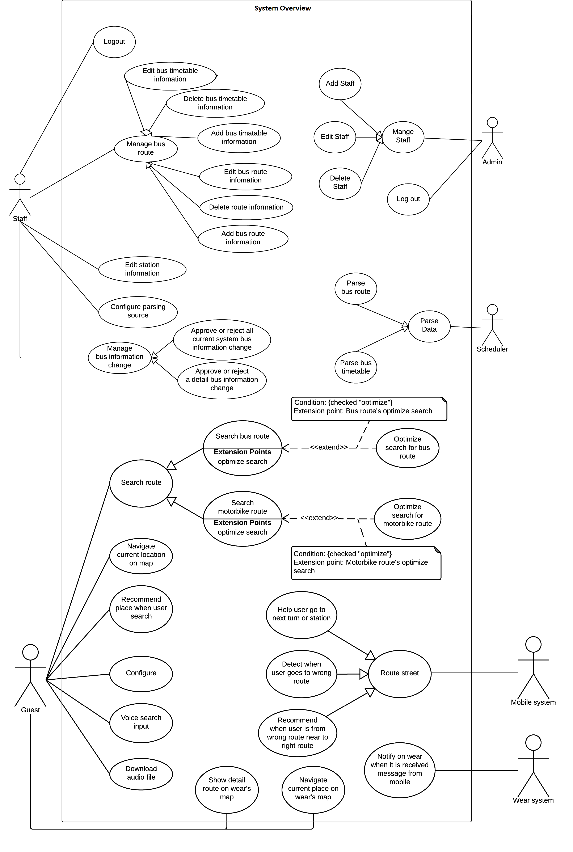

Figure 2: System overview use case

#### Web Application

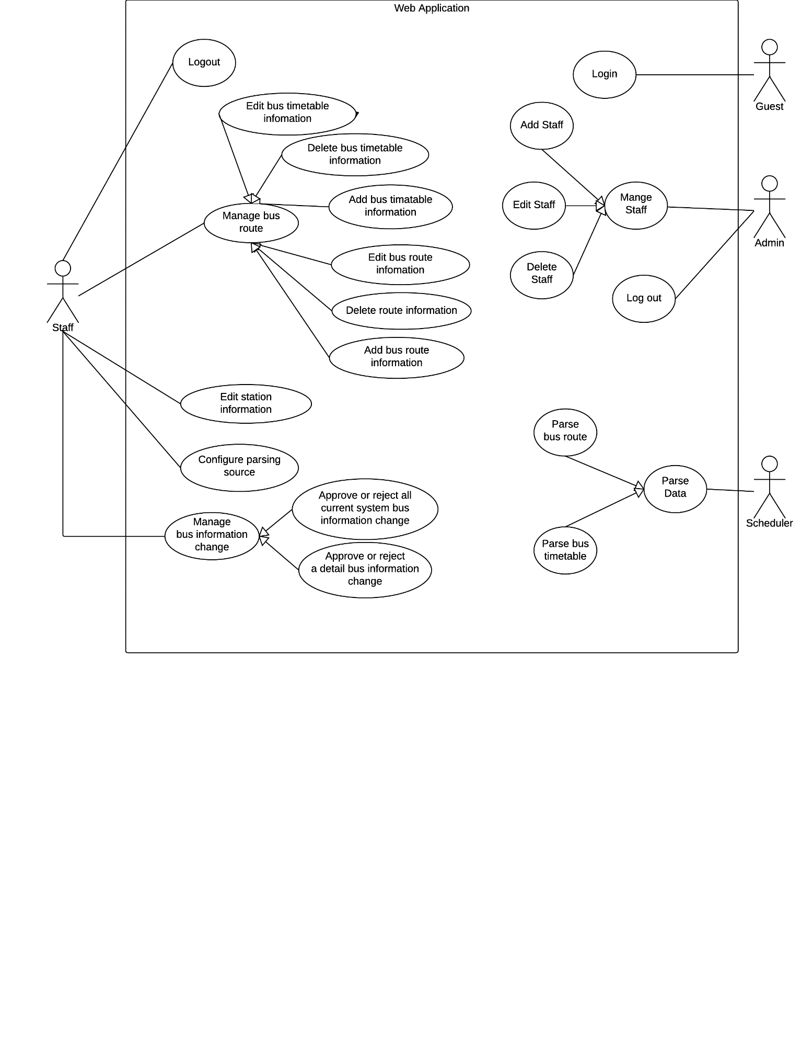

Figure 3: Web application use case

#### Android Mobile Application



Figure 4: Android mobile application use case

#### Android Wear Application



Figure 5: Android wear application use case

### List of Use Case

#### Web Application

##### <Staff> Overview Use Case



Figure 8 <Staff> Overview Use Case

###### <Staff> Approve or reject all current system bus information change.



Figure 10: <Staff> Approve or reject all current system bus information change.

|  |  |  |  |
| --- | --- | --- | --- |
| **USE CASE – WS02** | | | |
| **Use Case No.** | WS02 | **Use Case Version** | 2.0 |
| **Use Case Name** | Approve or reject all current system bus information change. | | |
| **Author** | DatNT | | |
| **Date** | 23/09/2015 | **Priority** | medium |
| Actor:   * Staff**.**   Summary:   * This use case allows staff to approve or reject all current system bus information change, and this function will implement on web application.   Goal:   * System provides approve or reject all current system bus information change for supporting staff manages system information change.   Triggers:   * Staff sends approve or reject all current system bus information change command.   Preconditions:   * Staff must login to the system with role Staff. * The bus information change must exist on system.   Post Conditions:   * Success**:** Data updated. Show successful message to staff. * Fail:Show error message.   Main Success Scenario:   |  |  |  | | --- | --- | --- | | **Step** | **Actor Action** | **System Response** | | **1** | Staff goes to all system bus information change view. | System will display all current system bus information change view following information:   * Table of bus change information will show following information:   + Route no: text.   + Route type: text.   + Content change: text.   + Action:     - Approve change: button.     - Reject change: button. * Approve all: button. * Reject all: button. | | **2** | Staff sends approve all command.  [Alternative 1]  [Exception 1] | System get all the bus information change.   * System updates new data to storage base on the bus information change. * System show successful message to staff. |   Alternative Scenario:   |  |  |  | | --- | --- | --- | | **Step** | **Actor Action** | **System Response** | | **1** | Staff sends reject all command.  [Exception 2] | * All bus information change will be removed. |   Exceptions:  **[Exception 1]**   |  |  |  | | --- | --- | --- | | **No.** | **Cause** | **System Response** | | **1** | Approve all is interrupted. | System show error message that approve all is interrupted. |   **[Exception 2]**   |  |  |  | | --- | --- | --- | | **No.** | **Cause** | **System Response** | | **1** | Reject all is interrupted. | System show error message that reject all is interrupted. |   Relationships: **N/A.**  Business Rules:   * When staff approves all system bus information change, system will update data from each bus information change:   + If bus information change is the change of timetable, system will update data of timetable.   + If bus information change is the change of bus route, system will update data of bus route. | | | |

Table 20: Use case WS02 - <Staff> Approve or reject all current system bus information change.

###### <Staff> Approve or reject a detail bus information change



Figure 11: <Staff> Approve or reject a detail bus information change.

|  |  |  |  |
| --- | --- | --- | --- |
| **USE CASE – WS03** | | | |
| **Use Case No.** | WS03 | **Use Case Version** | 2.0 |
| **Use Case Name** | Approve or reject a detail bus information change. | | |
| **Author** | DatNT | | |
| **Date** | 23/09/2015 | **Priority** | medium |
| Actor:   * Staff.   Summary:   * This use case allows staff to approve or reject a detail bus information change, and this function will implement on web application.   Goal:   * System provides approve or reject a detail bus information change for supporting staff manage bus information change and update the change data into storage.   Triggers:   * Staff sends approve or reject a detail bus information change command.   Preconditions:   * Staff must login into the system with role Staff.   Post Conditions:   * Success**:** Detail of bus information change will have approved or rejected. * Fail:Show error message.   Main Success Scenario:   |  |  |  | | --- | --- | --- | | **Step** | **Actor Action** | **System Response** | | **1** | Staff goes to detail bus information change view. | Display table of bus information change view with following information:   * Route no: text. * Route name: text. * Route type: Dropdown-list includes depart or return. * Content change: text. * Action:   + Approve change: button.   + Reject change: button. | | **2** | Staff sends approve command.  [Exception 1]  [Alternative 1] | * System get bus information change. * System updates new data to storage base one bus information change. * System shows successful message to staff. |   Alternative Scenario:  **[Alternative 1]**   |  |  |  | | --- | --- | --- | | **Step** | **Actor Action** | **System Response** | | **1** | Staff sends reject command.  [Exception 2] | This bus information change will be removed. |   Exceptions:  **[Exception 1]**   |  |  |  | | --- | --- | --- | | **No.** | **Cause** | **System Response** | | **1** | Approve is interrupted. | System show error message that approve is interrupted. |   **[Exception 2]**   |  |  |  | | --- | --- | --- | | **No.** | **Cause** | **System Response** | | **1** | Reject is interrupted. | System show error message that reject is interrupted. |   Relationships: **N/A.**  Business Rules:   * When staff approves detail bus information, system will update data:   + If bus information change is change of timetable, system will update data of timetable.   + If bus information change is change of bus route, system will update data of bus route. | | | |

Table 21: Use case WS03 - <Staff> Approve or reject a detail bus information change.

###### <Staff> Configure parsing source



Figure 12: <Staff> Configure parsing source.

|  |  |  |  |
| --- | --- | --- | --- |
| USE CASE – WS04 | | | |
| Use Case No. | WS04 | **Use Case Version** | 2.0 |
| Use Case Name | Configure parsing source. | | |
| Author | DatNT | | |
| Date | 23/09/2015 | **Priority** | medium |
| Actor:   * Staff.   Summary:   * This use case allows staff to choose parsing source and this function will implement on web application.   Goal:   * The system provides configure parsing source for parser knows which source to parse.   Triggers:   * Staff sends configure parsing source command.   Preconditions:   * Staff must login into the system with role Staff. * Staff must specific source for parsing.   Post Conditions:   * Success: System call scheduler for parsing data. * Fail: Show error message.   Main Success Scenario:   |  |  |  | | --- | --- | --- | | Step | Actor Action | System Response | | 1 | Staff sends configure parsing source command. | System have two option for parsing:   * If staff chooses parsing from file:   + Staff selects file from local computer.   + If selected files for parsing bus route: reference use case: <Scheduler> Parse bus route   + If selected files for parsing bus timetable: reference use case: <Scheduler> Parse bus timetable.   [Exception 1,2]   * If staff chooses parsing from web:   + System request parsed link: <http://www.buyttphcm.com.vn/TTLT.aspx> (link 1) and   <http://mapbus.ebms.vn/> (link 2).   * + Within parsed link, system fetches data by using parser.   + System call scheduler:     - Within link 1, system call parse bus timetable (reference use case <Scheduler> Parse bus timetable)     - With link 2, system call parse bus route (reference use case <Scheduler> Parse bus route) |   Alternative Scenario: N/A.  Exceptions:  [Exception 1]   |  |  |  | | --- | --- | --- | | No. | Cause | System Response | | 1 | No file for parsing. | Show message to notify staff must select file before configure parsing source. |   [Exception 2]   |  |  |  | | --- | --- | --- | | No. | Cause | System Response | | 1 | File is inappropriate with required file from system. | Show message to notify staff select incorrect file for parsing. |   Relationships: N/A.  Business Rules:   * In presently, system just supports for map of Ho Chi Minh bus. * Local file for parsing must correct following template file:   C:\Users\datnt\Desktop\excelTemplate.JPG   * + System currently just support Excel 97-2003 (*.xls).   + File name must follow format: C:\Users\datnt\Desktop\fileName.JPG (9: route no, depart: route type).   + Successful message Content: “Parse bus timetable successful”. * Error message: Content: “Parse bus timetable failed. Please make sure excel file is correct with (above template)”. | | | |

Table 22: Use case WS04 - <Staff> Configure parsing source.

###### 2.4.1.2.5 <Staff> Configure parsing web



Figure 13: <Staff> Configure parsing web

|  |  |  |  |
| --- | --- | --- | --- |
| **USE CASE – WS05** | | | |
| **Use Case No.** | WS05 | **Use Case Version** | 2.0 |
| **Use Case Name** | Configure parsing web | | |
| **Author** | DatNT | | |
| **Date** | 25/11/2015 | **Priority** | medium |
| Actor:   * Staff.   Summary:   * This use case allows staff to configure parsing web and this function will implement on web application.   Goal:   * The system provides configure parsing web for updating data in storage from server.   Triggers:   * Staff sends configure parsing web command.   Preconditions:   * Staff must login into the system with role Staff.   Post Conditions:   * **Success:** System call scheduler for parsing data. * **Fail**:Show error message.   Main Success Scenario:   |  |  |  | | --- | --- | --- | | **Step** | **Actor Action** | **System Response** | | **1** | Staff sends configure parsing web command. | * System get specified web for parsing. * System fetch data from web. [Exception 1] * Within fetched data, system call schedule follow step:  1. Parse bus route: reference use case - <Scheduler> Parse bus route. 2. Parse bus timetable: reference use case - <Scheduler> Parse bus timetable. |   Alternative Scenario: **N/A.**  Exceptions:  **[Exception 1]**   |  |  |  | | --- | --- | --- | | No. | Cause | System Response | | 1 | Fetching data is interrupted. | System show message to notify staff that fetching data is interrupted. |   Relationships: **N/A.**  Business Rules:   * In presently, system just supports for map of Ho Chi Minh bus. * Specified web for parsing: <http://buyttphcm.com.vn/>. | | | |

Table 23: Use case WS05 - <Staff> Configure parsing web.

###### 2.4.1.2.6 <Staff> Edit bus timetable route information



Figure 14: <Staff> Edit bus timetable information.

|  |  |  |  |
| --- | --- | --- | --- |
| **USE CASE – WS06** | | | |
| **Use Case No.** | WS06 | **Use Case Version** | 2.0 |
| **Use Case Name** | Edit bus timetable information. | | |
| **Author** | DatNT | | |
| **Date** | 22/11/2015 | **Priority** | medium |
| Actor:   * Staff.   Summary:   * This use case allows staff to edit bus timetable information and this function will implement on web application.   Goal:   * System provides edit bus timetable information for supporting staff can edit bus timetable.   Triggers:   * Staff sends edit bus timetable information command.   Preconditions:   * Staff must login into the system with role Staff.   Post Conditions:   * **Success:** Bus timetable information will be updated. * **Fail**:Show error message.   Main Success Scenario:   |  |  |  | | --- | --- | --- | | **Step** | **Actor Action** | **System Response** | | **1** | Staff goes to bus timetable edit view. | System displays view with following information:   * Route no: text. * Route name: text. * Route type: text. * Table with following information:   + Start time: time picker.   + End time: time picker.   + Edit bus timetable: link. | | **2** | Staff input start time.  [Exception 1] | Input field shows time picker that staff pick start time. | | **3** | Staff input end time.  [Exception 2] | Input field shows time picker that staff pick end time. | | **3** | Staff sends edit bus timetable command. | Validate start time and end time.  Update bus timetable’s new time to system. [Exception 3]  Reload table bus timetable information. |   Alternative Scenario: **N/A.**  Exceptions:  **[Exception 1]**   |  |  |  | | --- | --- | --- | | No. | Cause | System Response | | 1 | Missing of start time. | Show message to notify staff choose start time. |   **[Exception 2]**   |  |  |  | | --- | --- | --- | | No. | Cause | System Response | | 2 | Missing of end time. | Show message to notify staff choose end time. |   **[Exception 3]**   |  |  |  | | --- | --- | --- | | No. | Cause | System Response | | 1 | Edit bus timetable route information is interrupted. | Show error message that edit bus timetable is interrupted. |   Relationships: **N/A.**  Business Rules:   * Start time and end time must follow format “hh:mm”, example: 16:00. | | | |

Table 24: Use case WS06 - <Staff> Edit bus timetable route information.

###### 2.4.1.2.7 <Staff> Add bus timetable route information



Figure 15: <Staff> Add bus timetable route information.

|  |  |  |  |
| --- | --- | --- | --- |
| **USE CASE – WS07** | | | |
| **Use Case No.** | WS07 | **Use Case Version** | 2.0 |
| **Use Case Name** | Add bus timetable route information. | | |
| **Author** | DatNT | | |
| **Date** | 22/11/2015 | **Priority** | medium |
| Actor:   * Staff.   Summary:   * This use case allows staff to add bus timetable route information and this function will implement on web application.   Goal:   * System provides add bus timetable route information for supporting staff can add bus timetable.   Triggers:   * Staff sends add bus timetable information command.   Preconditions:   * Staff must login into the system with role Staff.   Post Conditions:   * **Success**: New bus timetable is added into storage. * **Fail**: Show error message.   Main Success Scenario:   |  |  |  | | --- | --- | --- | | **Step** | **Actor Action** | **System Response** | | **1** | Staff goes to bus timetable add view. | System display view with following information:   * Route no: text. * Route name: text. * Route type: text. * Table of bus timetable information with following information:   + Start time: time picker.   + End time: time picker.   + Add bus timetable: button.   + Edit bus timetable: button. | | **2** | Staff input start time.  [Exception 1] | Input field shows time picker that staff pick start time. | | **4** | Staff input end.  [Exception 2] | Input field shows time picker that staff pick end time. | | **3** | Staff sends add bus timetable command. | Validate start time and end time.  Add bus timetable’s new time to storage.  [Exception 3]  Show successful message. |   Alternative Scenario: **N/A.**  Exceptions:  **[Exception 1]**   |  |  |  | | --- | --- | --- | | No. | Cause | System Response | | 1 | Missing of start time. | Show message to notify staff choose start time. |   **[Exception 2]**   |  |  |  | | --- | --- | --- | | No. | Cause | System Response | | 1 | Missing of start time. | Show message to notify staff choose start time. |   **[Exception 3]**   |  |  |  | | --- | --- | --- | | No. | Cause | System Response | | 1 | Add bus timetable route information is interrupted. | Show error message that add bus timetable is interrupted. |   Relationships: **N/A.**  Business Rules:   * Start time and end time must follow format “hh:mm” with hh is hour in range 0 – 23, mm is minute in range 0 – 59 such as: 16:00. | | | |

Table 25: Use case WS07 - <Staff> Add bus timetable route information.

###### 2.4.1.2.8 <Staff> Delete bus timetable information



Figure 16: <Staff> Delete bus timetable information.

|  |  |  |  |
| --- | --- | --- | --- |
| **USE CASE – WS08** | | | |
| **Use Case No.** | WS08 | **Use Case Version** | 2.0 |
| **Use Case Name** | Delete bus timetable information. | | |
| **Author** | DatNT | | |
| **Date** | 22/11/2015 | **Priority** | medium |
| Actor:   * Staff.   Summary:   * This use case allows staff to delete bus timetable information and this function will implement on web application.   Goal:   * System provides delete bus timetable information for support staff can delete bus timetable information.   Triggers:   * Staff send delete bus timetable information command.   Preconditions:   * Staff must login into the system with role Staff.   Post Conditions:   * Success: Delete selected bus timetable information. * Fail: Show error message.   Main Success Scenario:   |  |  |  | | --- | --- | --- | | **Step** | **Actor Action** | **System Response** | | **1** | Staff goes to bus timetable delete view. | System display view with following information:   * Route no: text. * Route name: text. * Route type: text. * Table with following information:   + Start time: text.   + End time: text.   + Edit bus timetable: button.   + Delete bus timetable: button. | | **2** | Staff sends delete bus timetable command. | System delete selected bus timetable information.  [Exception 1]  Show success message. |   Alternative Scenario: **N/A.**  Exceptions:  **[Exception 1]**   |  |  |  | | --- | --- | --- | | No. | Cause. | System Response | | 1 | Delete bus timetable route information is interrupted. | Show error message that delete bus timetable is interrupted. |   Relationships: **N/A.**  Business Rules: | | | |

*Table 26: Use case WS08 - <Staff> Delete bus timetable information.*

###### 2.4.1.2.9 <Staff> Edit bus route information



Figure 17: <Staff>Edit bus route information.

|  |  |  |  |
| --- | --- | --- | --- |
| **USE CASE – WS09** | | | |
| **Use Case No.** | WS09 | **Use Case Version** | 2.0 |
| **Use Case Name** | Edit bus route information | | |
| **Author** | DatNT | | |
| **Date** | 22/11/2015 | **Priority** | medium |
| Actor:   * Staff.   Summary:   * This use case allows staff to edit bus route information and this function will implement on web application.   Goal:   * System support edit bus route information for support staff can edit route information.   Triggers:   * Staff send edit bus route information command.   Preconditions:   * Staff must login with role staff.   Post Conditions:   * **Success**: Edited bus route information will be updated into storage. * **Fail**: Show error message.   Main Success Scenario:   |  |  |  | | --- | --- | --- | | **Step** | **Actor Action** | **System Response** | | **1** | Staff goes to route management view. | System display table view with following information:   * Index: text. * Route no: text. * Route name: text. * Edit route: link * Delete route: link. | | **2** | Staff inputs route name. | Input field show route name that staff inputs route name. | | **3** | Staff sends edit bus route information command. | System update edited bus route information into storage.  [Exception 2]  Show successful message. |   Alternative Scenario: **N/A.**  Exceptions:  **[Exception 1]**   |  |  |  | | --- | --- | --- | | No | Cause | System Response | | 1 | Edit but route information is interrupted. | Show error message that edit bus route is interrupted. |   Relationships: **N/A.**  Business Rules: | | | |

Table 27: Use case WS09 - <Staff> Edit bus route information.

###### 2.4.1.2.10 <Staff> Delete bus route information



Figure 18: <Staff> Delete bus route information.

|  |  |  |  |
| --- | --- | --- | --- |
| **USE CASE – WS10** | | | |
| **Use Case No.** | WS10 | **Use Case Version** | 2.0 |
| **Use Case Name** | Delete bus route information | | |
| **Author** | DatNT | | |
| **Date** | 22/11/2015 | **Priority** | medium |
| Actor:   * Staff.   Summary:   * This use case allows staff to delete bus route information and this function will implement on web application.   Goal:   * System provides delete bus route information for support staff delete can delete bus route information.   Triggers:   * Staff sends delete bus route information command.   Preconditions:   * Staff must login with role staff. * Bus route for deleting must exist in system   Post Conditions:   * Success: Selected route will be removed in storage. * Fail: Show error message.   Main Success Scenario:   |  |  |  | | --- | --- | --- | | **Step** | **Actor Action** | **System Response** | | **1** | Staff goes to route management view. | System display table view with following information:   * Route no: text. * Route name: text. * Edit route: link. * Delete route: link. | | **2** | Staff sends delete bus route information. | System will delete selected route in storage.  [Exception 1]  Show successful message. |   Alternative Scenario: **N/A.**  Exceptions:  **[Exception 1]**   |  |  |  | | --- | --- | --- | | No. | Cause | System Response | | 1 | Delete but route information is interrupted. | Show error message that delete bus route is interrupted. |   Relationships: **N/A.**  Business Rules: | | | |

*Table 28: Use case WS10 - <Staff> Delete bus route information.*

###### <Staff> Add bus route information



Figure 19: <Staff> Add bus route information.

|  |  |  |  |
| --- | --- | --- | --- |
| **USE CASE – WS10** | | | |
| **Use Case No**. | WS11 | **Use Case Version** | 2.0 |
| **Use Case Name** | Add bus route information. | | |
| **Author** | DatNT | | |
| **Date** | 22/11/2015 | **Priority** | medium |
| Actor:   * Staff.   Summary:   * This use case will allow staff add bus route information and this function will implement on web application.   Goal:   * System provides add bus route information for support staff can add route information.   Triggers:   * Staff sends add route information command.   Preconditions:   * Staff must login with role staff.   Post Conditions:   * Success: Selected route will be removed in storage. * Fail: **N/A.**   Main Success Scenario:   |  |  |  | | --- | --- | --- | | **Step** | **Actor Action** | **System Response** | | **1** | Staff goes to add bus route information view. | System display view following information:   * Route no: input text, length 1 - 5. * Route name: input text, length 3 - 250. * Route type: drop-down list, includes DEPART or RETURN. * Source json file: input file. * Source excel file: input file. * Add route: button. | | **2** | Staff inputs route no.  [Exception 1] | Input field show route no that staff inputs route no. | | **3** | Staff inputs route name.  [Exception 2] | Input field show route name that staff inputs route name. | | **4** | Staff choose route type.  [Exception 3] | Drop-down list show route type that staff choose route type. | | **5** | Staff sends add bus route information command. | Validate data.  With selected json file, system calls scheduler for parse json file (reference use case: <Scheduler> Parse bus route).  With selected excel file, system call scheduler for parse excel file (reference use case: <Scheduler> Parse bus timetable>) [Exception 4, 5] |   Alternative Scenario: **N/A.**  Exceptions:  **[Exception 1]**   |  |  |  | | --- | --- | --- | | **No.** | **Cause** | **System Response** | | **1** | Staff missing input route name. | * System show message to notify staff that route name is missing. |   **[Exception 2]**   |  |  |  | | --- | --- | --- | | **No.** | **Cause** | **System Response** | | **1** | Staff missing input route no. | * System show message to notify staff that route no is missing. |   **[Exception 3]**   |  |  |  | | --- | --- | --- | | **No.** | **Cause** | **System Response** | | **1** | Staff missing input route type. | * System show message to notify staff that route type is missing. |   **[Exception 4]**   |  |  |  | | --- | --- | --- | | **No.** | **Cause** | **System** **Response** | | **1** | No file for parsing. | Show message to notify staff must select file before configure parsing source. |   **[Exception 5]**   |  |  |  | | --- | --- | --- | | **No.** | **Cause** | **System** **Response** | | **2** | File is inappropriate with required file from system. | Show message to notify staff select incorrect file for parsing. |   Relationships: **N/A.**  Business Rules:   * System just support json file for parsing route information and must follow template json:      * Field 1 is route no. * Field 2 currently is not use. * Field 3 currently is not use. * Field 4 is middle point in path. * If field 5 is false, “return route”. If field 5 is true, “depart route”. * Field 7 is order in path. * Field 8 is not use. * Field 9 is name of station. * Field 10 is a latitude. * Field 11 is a longitude. * Field 12 is not use. * Field 13 is name of route. * Field 14 is id of station. * System just support excel file for parsing bus time table and must correct following template file:   C:\Users\datnt\Desktop\excelTemplate.JPG   * + System currently just support Excel 97-2003 (*.xls).   + File name must follow format: C:\Users\datnt\Desktop\fileName.JPG (9: route no, depart: route type).   + Successful message Content: “Parse bus timetable successful”. * Error message: Content: “Parse bus timetable failed. Please make sure excel file is correct with above template”. | | | |

*Table 29: Use case WS11 - <Staff> Add bus route information.*

#### Scheduler

##### <Scheduler> Overview Use Case



Figure 25: <Scheduler> Overview Use Case

###### <Scheduler> Parse bus route



Figure 26: <Staff> Parse bus route

|  |  |  |  |
| --- | --- | --- | --- |
| **USE CASE – SC01** | | | |
| **Use Case No.** | SC01 | **Use Case Version** | 2.0 |
| **Use Case Name** | Parse bus route. | | |
| **Author** | DatNT | | |
| **Date** | 23/09/2015 | **Priority** | medium |
| Actor:   * Scheduler.   Summary:   * This use case allows scheduler to parse bus route.   Goal:   * The system provides parses bus route for parse data from web source or local source in order to update data in storage.   Triggers:   * Scheduler sends parsing source command.   Preconditions:   * Staff must configure parsing source command.   Post Conditions:   * Success: New data inserted to storage. * Fail: Nothing changed in storage and show error message.   Main Success Scenario:   |  |  |  | | --- | --- | --- | | **Step** | **Actor Action** | **System Response** | | **1** | Scheduler sends parse bus route from local source command.  [Alternative 1] | * System read json files from local source. * Validate each file [Exception 1] * If file is valid, system read file and insert data into storage. [Exception 2] * Show successful message to staff. |   Alternative Scenario:  **[Alternative 1]**   |  |  |  | | --- | --- | --- | | **Step** | **Actor action** | **System Response** | | **1** | Scheduler sends parse bus route from web source commands. | * System crawl data from json file on web. * Within crawled data, system validate data [Exception 3]. * If data is validate, system insert data into storage [Exception 4] * Show successful message to staff. |   Exceptions:  **[Exception 1]**   |  |  |  | | --- | --- | --- | | **No.** | **Cause** | **System Response** | | **1** | File is incorrect format with current system file template support. | * System terminates process parsing. * System sends fail message to staff and notify which file is incorrect format. |   **[Exception 2]**   |  |  |  | | --- | --- | --- | | **No.** | **Cause** | **System Response** | | **1** | Insert data from local source into storage is interrupted. | * System show error message to staff that process insert data is interrupted. |   **[Exception 3]**   |  |  |  | | --- | --- | --- | | **No.** | **Cause** | **System Response** | | **1** | Crawled data is incorrect. | * System terminates process parsing. * System sends fail message to staff. |   **[Exception 4]**   |  |  |  | | --- | --- | --- | | **No.** | **Cause** | **System Response** | | **1** | Insert data from web source into storage. | * System show error message to notify staff that insert data from web source is interrupted. |   Relationships: **N/A.**  Business Rules:   * The format file template file for suggestion can download from URL:   [http://mapbus.ebms.vn/ajax.aspx?action=listRouteStations&id={busId}&isgo={true|false}](http://mapbus.ebms.vn/ajax.aspx?action=listRouteStations&id=%7bbusId%7d&isgo=%7btrue|false%7d)   * busId parameter: route no. Can get from link <http://map.ebms.vn/> * isGo parameter: decide to get depart or return of one bus route. If isGo is true, server will return “depart route”. Otherwise, serve will return “return route”. * Currently system supports JSON format for template file. * Local file for parsing must correct following template file:      * Field 1 is route no. * Field 2 currently is not use. * Field 3 currently is not use. * Field 4 is middle point in path. * If field 5 is false, “return route”. If field 5 is true, “depart route”. * Field 7 is order in path. * Field 8 is not use. * Field 9 is name of station. * Field 10 is a latitude. * Field 11 is a longitude. * Field 12 is not use. * Field 13 is name of route. * Field 14 is id of station. | | | |

Table 34: Use Case SC01 -<Scheduler> Parse bus route.

###### <Scheduler> Parse bus timetable.



Figure 27: <Staff> Parse bus timetable

|  |  |  |  |
| --- | --- | --- | --- |
| **USE CASE – SC02** | | | |
| **Use Case No.** | SC02 | **Use Case Version** | 2.0 |
| **Use Case Name** | Parse bus timetable. | | |
| **Author** | DatNT | | |
| **Date** | 23/09/2015 | **Priority** | medium |
| Actor:   * Staff**.**   Summary:   * This use case allows scheduler to parse bus timetable.   Goal:   * The system provides parse bus timetable for getting all bus timetable of each route from web source or local source in order update data in storage.   Triggers:   * Scheduler sends parsing source command.   Preconditions:   * Source has configured.   Post Conditions:   * Success**:** New data inserted to storage. * Fail: Nothing changed in storage.   Main Success Scenario:   |  |  |  | | --- | --- | --- | | **Step** | **Actor Action** | **System Response** | | **1** | Scheduler sends parse bus time from local source command.  [Alternative] | * System read excel files from local source. * Validate each file [Exception 1] * If excel file is valid, system read file and insert data into storage. [Exception 2] * Show successful message to staff. |   Alternatives Scenario:  **[Alternative 1]**   |  |  |  | | --- | --- | --- | | **Step** | **Actor action** | **System Response** | | **1** | Scheduler sends parse bus timetable from web source commands. | * System crawl data from excel file on web. * Within crawled data, system validate data [Exception 3]. * If data is validate, system insert data into storage [Exception 4] * Show successful message to staff. |   Exceptions:  **[Exception 1]**   |  |  |  | | --- | --- | --- | | **Step** | **Cause** | **System Response** | | **1** | File is incorrect format with current system file template support. | * System terminates process parsing. * System sends fail message to staff and notify which file is incorrect format. |   **[Exception 2]**   |  |  |  | | --- | --- | --- | | **Step** | **Cause** | **System Response** | | **1** | Insert data from local source into storage is interrupted. | * System show error message to staff that process insert data is interrupted. |   **[Exception 3]**   |  |  |  | | --- | --- | --- | | **Step** | **Cause** | **System Response** | | **1** | Crawled data is incorrect. | * System terminates process parsing. * System sends fail message to staff. |   **[Exception 4]**   |  |  |  | | --- | --- | --- | | **Step** | **Cause** | **System Response** | | **1** | Insert data from web source into storage. | * System show error message to notify staff that insert data from web source is interrupted. |   Relationships: **N/A.**  Business Rules:   * Excel file from local for parsing must correct following template file:   C:\Users\datnt\Desktop\excelTemplate.JPG   * + Currently, system just support Excel 2003-2007 (*.xls).   + File name must follow format: C:\Users\datnt\Desktop\fileName.JPG (9: route no, depart: route type) | | | |

Table 35: Use case SC02 - <Scheduler> Parse bus timetable.

#### Android Mobile Application

##### <Guest> Overview Use Case



Figure 28: <Guest> Search Location

###### <Guest> Search Bus Route



Figure 30: <Guest> Search Bus Route

|  |  |  |  |
| --- | --- | --- | --- |
| USE CASE – MB02 | | | |
| Use Case No. | MB02 | Use Case Version | 2.0 |
| Use Case Name | Search Bus Route | | |
| Author | NgoanTT | | |
| Date | 23/09/2015 | Priority | Normal |
| Actor:   * Guest   Summary:   * This use case allows Guest search bus route through some locations (from two to four points) on the mobile application.   Goal:   * The system suggests some bus optimal paths to the Guest. Guest can use this result to navigate a route when participating traffic.   Triggers:   * Guest sends a search bus route command.   Preconditions:   * Mobile must be connected to the internet.   Post Conditions:   * Success: The system draws route from the start location to the end location and show on the map. * Fail: Show an error message.   Main Success Scenario:   |  |  |  | | --- | --- | --- | | Step | Actor Action | System Response | | 1 | The Guest goes to search route view. | Display search route view including:   * Start location: free input text. * End location: free input text. * Send a search command: button. * Send a set time command: button. * Send an optional command: button. * Send a voice command: button. | | 2 | When Guest selects start location input text or end location input text. | Display new view for selecting place with following information:   * Location: free text input. * Location lists from history. * Send a voice command: button. | | 3 | If Guest inputs start or end location.  [Alternative 1] | Input field shows location that Guest has selected. | | 4 | The Guest goes to choose the departure time view.  [Alternative 2] | System shows date time picker for customer selecting time. | | 5 | The Guest can optionally choose departure time. | System update date on date time picker. | | 6 | The Guest goes to choose the middle locations view. | Display new view with following information:   * First middle location: free input text. * Second middle location: free input text. * Optimal: checkbox * Optimal route: can be optional selected from these values: * “Đi bộ tối đa giữa hai trạm (mét)”. * “Số lần chuyển tuyến tối đa” | | 7 | The Guest can input two middle locations.  [Alternative 1] | Input field shows location that Guest has selected. | | 8 | Guest can choose the optimal path through multi point’s option. | Optimal path option dialog will show checked symbol. | | 9 | Guest can choose those option:   * “Đi bộ tối đa giữa hai trạm (mét)” * “Số lần chuyển tuyến tối đa” | System will show checkbox and free text field for the option user has selected. | | 10 | Guest can go to search location with voice view. | Display new view with following information:   * Search voice command: button. | | 11 | When Guest talk location in order to search. | Input field shows location that Guest has talk. | | 12 | Guest sends search bus route command. | System shows a list with some optimal paths.  [Exception 1,2,3] | | 13 | Guest chooses one optimal path. | System draws the path on map and shows the detailed path. |   Alternative Scenario:  [Alternative 1]   |  |  |  | | --- | --- | --- | | Step | Actor Action | System Response | | 1 | If Guest sends a location from history. | System will show the location that Guest has selected on free input text. |   [Alternative 2]   |  |  |  | | --- | --- | --- | | Step | Actor Action | System Response | | 1 | Guest can choose current system time. | System will update current system time on date picker. |   Exceptions:  [Exception 1]   |  |  |  | | --- | --- | --- | | No. | Cause | System Response | | 1 | Mobile doesn’t connect the internet. | Show an error message that this device hasn’t connected to the internet yet. |   [Exception 2]   |  |  |  | | --- | --- | --- | | Step | Cause | System Response | | 1 | If the start location or the end location text field is empty. | System shows missing a field message to the customer. |   [Exception 3]   |  |  |  | | --- | --- | --- | | Step | Cause | System Response | | 1 | Guest chooses optimal path between multi points option but only two locations has inputted. | System shows message that must has at least three locations for using this function. |   [Exception 4]   |  |  |  | | --- | --- | --- | | Step | Cause | System Response | | 1 | System not found nearby station bus. | System shows message that “Không có trạm xe bus nào gần vị trí bạn tìm kiếm”. |   Relationships: Has an extension optimize search for bus route.  Business Rules:   * System uses Nutiteq map to display the map. * Location must be in HCM city. * The algorithm for finding bus route is called from SWR web service. * The optimal path for multi points option: Normally, first inputted point and last inputted point will be kept and system just rearrange all middle points for finding optimal path. By choosing this option, first inputted point will be start location, and all rest points will be rearranging for finding optimal path. So in this case, last inputted point doesn’t necessary a last location user will visited. * The system gives some options for finding optimal path: * Số lần chuyển tuyến tối đa: system will find fasted path that number of transfer doesn’t exceed certain number (input by user). System set default 2 transfers. * Khoảng cách đi bộ tối đa giữa hai trạm: Default is 300 m. So every walking between two stations or from first location to first station doesn’t exceed this number. If “Khoảng cách đi bộ tối đa giữa hai trạm” of Guest input not found route path but distance less than 1000 m found route, system will notify message ask Guest want choose walking 1000m. If Guest accept, system show route path else system show message “Không tìm thấy trạm nào gần”. | | | |

Table 37: Use case MB02 - <Guest> Search Bus Route

###### <Guest> Search Motorbike Route



Figure 32: <Guest> Search Motorbike Route

|  |  |  |  |
| --- | --- | --- | --- |
| USE CASE – MB04 | | | |
| Use Case No. | MB04 | Use Case Version | 2.0 |
| Use Case Name | Search Motorbike Route | | |
| Author | NgoanTT | | |
| Date | 23/09/2015 | Priority | Normal |
| Actor:   * Guest   Summary:   * This use case allows Guest search motorbike route thought some locations (from two to four) on the mobile application.   Goal:   * The system suggests some motorbike optimal paths to the Guest. Guest can use this result to navigate a route when participating traffic.   Triggers:   * Guest sends search motorbike route command.   Preconditions:   * Mobile must be connected to the internet.   Post Conditions:   * Success: System draws route from the start location to the end location and shows on the map. * Fail: Show an error message.   Main Success Scenario:   |  |  |  | | --- | --- | --- | | Step | Actor Action | System Response | | 1 | The Guest goes to search route view. | Display search route view including:   * Start location: free input text. * End location: free input text. * Send a search command: button * Send a set time command: button. * Send an optional command: button. * Send a voice command: button. | | 2 | When Guest select start location input text or end location input text. | Display new view with following information:   * Location: free text input. * Location from history. | | 3 | If Guest inputs start and end location.  [Alternative 1] | Input field shows location that Guest has selected. | | 4 | The Guest goes to choose the departure time view. | System shows date time picker for Guest selecting time. | | 5 | The Guest can optionally choose departure time.  [Alternative 3] | System update date on date time picker. | | 6 | The Guest goes to choose the middle locations view. | Display new view with following information:   * First middle location: free input text. * Second middle location: free input text. * Optimal: checkbox * Optimal route: can be optional selected from these values: * “Đi bộ tối đa giữa hai trạm (mét)” (disable). * “Số lần chuyển tuyến tối đa” (disable). | | 7 | The Guest can input two middle locations.  [Alternative 1] | Input field shows location that Guest has selected. | | 8 | Guest can choose the optimal path through multi point’s option. | Optimal path option dialog will show checked symbol. | | 9 | Guest can go to search location with voice view. | Display new view with following information:  Search voice command: button. | | 10 | When Guest talk location in order to search. | Input field shows location that Guest has talk. | | 11 | Guest sends a command search. | System shows a list with some optimal paths.  [Exception 1, 2, 3] | | 12 | Guest chooses one path command. | System draws the path on map and shows the detailed path. |   Alternative Scenario:  [Alternative 1]   |  |  |  | | --- | --- | --- | | No. | Actor Action | System Response | | 1 | If Guest sends the location from history. | System processes and input field shows the location that Guest has selected. |   [Alternative 2]   |  |  |  | | --- | --- | --- | | No. | Actor Action | System Response | | 1 | Guest can choose current system time. | System will update current system time on date picker. |   Exceptions:  [Exception 1]   |  |  |  | | --- | --- | --- | | No. | Cause | System Response | | 1 | Mobile doesn’t connect the internet. | Show an error message that this device hasn’t connected to the internet yet. |   [Exception 2]   |  |  |  | | --- | --- | --- | | No. | Cause | System Response | | 2 | If the start location or the end location text field not input. | System shows missing field message to customer. |   [Exception 3]   |  |  |  | | --- | --- | --- | | No. | Cause | System Response | | 1 | Guest chooses optimal path between multi points option but only two locations has inputted. | System shows message that must has at least three locations for using this function. |   Relationships: Has an extension optimize search for motorbike route.  Business Rules:   * System uses Nutiteq map to display the map. * Using Google map API for searching route. * Location must be in HCM city. * The optimal path for multi point’s option: Normally, first inputted point and last inputted point will be kept and system just rearrange between points for finding optimal path. By choosing this option, first inputted point will be start location, and all rest points will be rearranging for finding optimal path. So in this case, last inputted point doesn’t necessary a last location user will visited. | | | |

Table 39: Use case MB04 - <Guest> Search Motorbike Route

###### <Guest> Input by voice search



Figure 35: <Guest> Voice search input

|  |  |  |  |
| --- | --- | --- | --- |
| USE CASE – MB07 | | | |
| Use Case No. | MB07 | Use Case Version | 2.0 |
| Use Case Name | Input by voice search | | |
| Author | NamNT | | |
| Date | 23/09/2015 | Priority | Normal |
| Actor:   * Guest   Summary:   * This use case allows guests to search location with their voice.   Goal:   * The application displays a list of locations base on guest’s speech.   Triggers:   * Guest searches by voice.   Preconditions:   * Mobile must be connected to internet.   Post Conditions:   * Success: Application displays locations that guest has said. * Fail: Show error message.   Main Success Scenario:   |  |  |  | | --- | --- | --- | | Step | Actor Action | Application Response | | 1 | Guest goes to voice search view. | Application show voice button. | | 2 | Guest selects voice button and says follow syntax. | System will use Google Speech To Text API for speech recognition.  After recognize, system will analysis text base on grammar to get location text.  [Alternative 1]  System will send this location string to Google API for getting detail location (including latitude and longitude).  [Exception 1]  System displays that location for user to know.  Based on syntax, application detects his/her voice to keyword.  With that keyword, application will search location and save it, which closer with keyword.  [Exception 2] |   Alternative Scenario:  [Alternative 1]   |  |  |  | | --- | --- | --- | | No. | Cause | System Response | | 1 | If sentence doesn’t follow predefined grammar. | System shows message: “Khổng thể nhận dạng cấu trúc câu.” |   Exceptions:  [Exception 1]   |  |  |  | | --- | --- | --- | | No. | Cause | System Response | | 1 | If mobile is not connected to network. | System shows message to notify that mobile must be connect to network. |   [Exception 2]   |  |  |  | | --- | --- | --- | | No. | Cause | System Response | | 2 | If Google API return no result | Result text field shows empty string. |   Relationships: N/A  Business Rules:   * The grammar is: * Departure location must be said: “Tôi muốn đi từ” or “Từ ...” * First middle location must be said: “Điểm trung gian thứ nhất là ...” * Second middle location must be said: “Điểm trung gian thứ hai là ...” * Arrival location must be said: “Tôi muốn đi đến …” or “Đến …” * When guest inputs new location of same field, old location will be overwriting. | | | |

Table 41: Use case MB07 - <Guest> Input by voice search

###### <Guest> Recommend place when user search



Figure 36: <Guest> Recommend place when user search

|  |  |  |  |
| --- | --- | --- | --- |
| USE CASE – MB08 | | | |
| Use Case No. | MB08 | Use Case Version | 2.0 |
| Use Case Name | Recommend place when user search | | |
| Author | NamNT | | |
| Date | 23/09/2015 | Priority | Normal |
| Actor:   * Guest   Summary:   * This use case allows guest to search location with key word.   Goal:   * The application displays a list of locations have name closer with keyword.   Triggers:   * Guest input key word into textbox.   Preconditions:   * Mobile must be connected to internet.   Post Conditions:   * Success: Application displays a list of locations. * Fail: Show an error message.   Main Success Scenario:   |  |  |  | | --- | --- | --- | | Step | Actor Action | Application Response | | 1 | Guest goes to autocomplete view. | Application show autocomplete textbox and locations’ history, which customer has searched. | | 2 | Guest input keyword | Application show list of locations, which have name closer with keyword.  [Exception 1]  [Alternative 1] | | 3 | Guest choose location on list. And click back button. | Application will save that location to prepare for search route. |   Alternative Scenario:   |  |  |  | | --- | --- | --- | | No. | Cause | Application Response | | 1 | If no location was founded. | Application returns empty list. |   Exceptions:   |  |  |  | | --- | --- | --- | | No. | Cause | Application Response | | 1 | If mobile is not connected to internet. | Application will show message that mobile must be connect to internet. |   Relationships:  Business Rules:   * Location are loaded using Google AutoComplete API. * When system sends text to Google service for getting location, application will stop getting data from user input for saving queries. After getting data, system will again new user input to server. | | | |

Table 42: Use case MB08 - <Guest> Recommend place when user search

###### <Guest> Help user go to next turn or station



Figure 37: <Guest> Help user go to next turn or station

|  |  |  |  |
| --- | --- | --- | --- |
| USE CASE – MB09 | | | |
| Use Case No. | MB09 | Use Case Version | 2.0 |
| Use Case Name | Help user go to next turn or station | | |
| Author | NamNT | | |
| Date | 23/09/2015 | Priority | Normal |
| Actor:   * Guest   Summary:   * This use case allows application notifies to guest when he/she move on right turn or station.   Goal:   * The application show notification to guest. And he/she will know what should do next.   Triggers:   * When gps changed, notify system detects that guest moves on right route.   Preconditions:   * Notify system detects that guest moves on right route, which they have chosen and meet events on that route. * When GPS location is changed. * Mobile’s GPS is enabled. * Tracking is enable.   Post Conditions:   * Success: Application notifies on mobile and wear. * Fail: Show error message.   Main Success Scenario:   |  |  |  | | --- | --- | --- | | Step | Actor Action | Application Response | | 1 | Notify system detects that guest moves on right route and meet events on it | Application will send notification about how guest should to do next.  Mobile will send message to wear, and it will show notification. |   Alternative Scenario: N/A  Exceptions:  [Exception 1]   |  |  |  | | --- | --- | --- | | No. | Cause | System Response | | 1 | If mobile’s GPS does not enable. | System shows message to notify that mobile’s GPS is not enabled. |   Relationships: N/A  Business Rules:   * Guest will be notified by message on mobile, by sound and by message on wear. * Message will depend on what event they meet. These events include: * Guest is near a bus station that should to leave * Guest is near a motorbike turn that should to turn. * Guest is near the place (in both bus and motorbike) that they want to come. | | | |

Table 43: Use case MB09 - <Guest> Help user go to next turn or station

###### <Guest> Detect when guest goes to wrong route



Figure 38: <Guest> Detect when guest goes to wrong route

|  |  |  |  |
| --- | --- | --- | --- |
| USE CASE – MB10 | | | |
| Use Case No. | MB10 | Use Case Version | 2.0 |
| Use Case Name | Detect when guest goes to wrong route | | |
| Author | NamNT | | |
| Date | 23/09/2015 | Priority | Normal |
| Actor:   * Guest   Summary:   * This use case allows application notifies to guest when he/she moves on wrong route when using motorbike.   Goal:   * The application shows notification to guest when they go to wrong way so he/she know can view again route before continue to participating traffic.   Triggers:   * Notify system detect that guest moved on wrong route.   Preconditions:   * Notify system detects that guest doesn’t move on right route, which they have chosen. * When GPS location is changed. * Mobile’s GPS is enabled. * Tracking is enable.   Post Conditions:   * Success: Application notifies on mobile and wear. * Fail: Show error message.   Main Success Scenario:   |  |  |  | | --- | --- | --- | | Step | Actor Action | Application Response | | 1 | Notify system detects that guest doesn’t move on right route. | Application will send notification that guest is going to wrong way.  Mobile will send message to wear, and it will show notification. |   Alternative Scenario: N/A  Exceptions:  [Exception 1]   |  |  |  | | --- | --- | --- | | No. | Cause | System Response | | 1 | If mobile’s GPS does not enable. | System shows message to notify that mobile’s GPS is not enabled. |   Relationships: N/A  Business Rules:   * Notify system will be notified by message on mobile, by sound and by message on wear. | | | |

Table 44: Use case MB10 - <Guest>Detect when guest goes to wrong route

#### Android Wear Application

##### <Guest> Overview Use Case



Figure 39: <Guest> Overview use case

###### <Guest> Show detail route on map



Figure 40: <Guest> Show detail route on map.

|  |  |  |  |
| --- | --- | --- | --- |
| USE CASE – WR01 | | | |
| Use Case No. | WR01 | Use Case Version | 1.0 |
| Use Case Name | Show detail route on map. | | |
| Author | NamNT | | |
| Date | 27/11/2015 | Priority | Medium |
| Actor:   * Guest.   Summary:   * This use case allows customer see motor route or bus route on map, which guest has chosen.   Goal:   * Show detail of route on map which guest has chosen. Using this function, customer can locate which turn on map for easier navigate where they are on street.   Triggers:   * Guest sends show detail route command.   Preconditions:   * Wear is paired with mobile. * Mobile has sent data to wear. * Android and wear are in connecting range. * If wear device doesn’t have internet, mobile must be connected to internet.   Post Conditions:   * Success: Map moves to new place and shows information of route. * Fail: Show error message.   Main Success Scenario:   |  |  |  | | --- | --- | --- | | Step | Actor Action | Application Response | | 1 | Choose route on mobile | Wear turn on map, navigate to location of route and show detail of it.  [Exception 1, 2, 3, 4] |   Alternative Scenario: N/A  Exceptions:  [Exception 1]   |  |  |  | | --- | --- | --- | | No. | Cause | System Response | | 1 | Wear is not paired | System shows message to notify that wear is not paired. |   [Exception 2]   |  |  |  | | --- | --- | --- | | No. | Cause | System Response | | 2 | Mobile hasn’t sent data to wear. | System shows message to notify that wear hasn’t received data yet. |   [Exception 3]   |  |  |  | | --- | --- | --- | | No. | Cause | System Response | | 3 | If wear doesn’t have GPS and mobile’s GPS does not enable. | System shows message to notify that mobile’s GPS is not enabled. |   [Exception 4]   |  |  |  | | --- | --- | --- | | No. | Cause | System Response | | 4 | If wear doesn’t have internet and mobile is not connected to internet | Show message to notify that mobile is not connected to internet. |   Relationships: N/A  Business Rules:   * Application uses Google Map for rendering route. * If android wear has own GPS, application will use android wear’s GPS. Otherwise, android wear application will use GPS from mobile device * Detail information includes: * Bus route or motorbike route. * Important location including: * Departure place and arrival place. * Middle bus stations that user should to leave. * Motorbike turn on searched route. | | | |

Table 45: Use case WR01 - <Guest> Show information of a bus station on map

###### <Guest> Notify when wear is received message from mobile



Figure 41: <Guest> Notify when wear is received message from mobile.

|  |  |  |  |
| --- | --- | --- | --- |
| USE CASE – WR05 | | | |
| Use Case No. | WR02 | Use Case Version | 1.0 |
| Use Case Name | Notify when wear is received message from mobile | | |
| Author | NamNT | | |
| Date | 27/05/2015 | Priority | Medium |
| Actor:   * Guest.   Summary:   * This use case allows wear notifies to guest when has message from mobile.   Goal:   * Wear will show notification of mobile so guest can see easily on wear.   Triggers:   * Mobile send message to wear.   Preconditions:   * Wear is paired with mobile. * Android and wear are in connecting range.   Post Conditions:   * Success: Wear shows notification to customer. * Fail: Show error message.   Main Success Scenario:   |  |  |  | | --- | --- | --- | | Step | Actor Action | Application Response | | 1 | Mobile send data to wear. | Wear will receive notification and display notification to guest.  [Exception 1, 2, 3, 4] |   Alternative Scenario: N/A  Exceptions:  [Exception 1]   |  |  |  | | --- | --- | --- | | No. | Cause | System Response | | 1 | Wear is not paired | System shows message to notify that wear is not paired. |   [Exception 2]   |  |  |  | | --- | --- | --- | | No. | Cause | System Response | | 2 | Mobile hasn’t sent data to wear. | System shows message to notify that wear hasn’t received data yet. |   [Exception 3]   |  |  |  | | --- | --- | --- | | No. | Cause | System Response | | 3 | If wear doesn’t have GPS and mobile’s GPS does not enable. | System shows message to notify that mobile’s GPS is not enabled. |   [Exception 4]   |  |  |  | | --- | --- | --- | | No. | Cause | System Response | | 4 | If wear doesn’t have internet and mobile is not connected to internet | Show message to notify that mobile is not connected to internet. |   Relationships: N/A  Business Rules:   * Mobile sends data to wear when: * Guest is near a bus station that should to leave * Guest is near a motorbike turn that should to turn. * Guest goes to wrong route and need to notify * Guest comes again to true route and system will display a notify for Guest knows which should to do next. * A notification on wear often has two screen: * First screen: summarize information such as image of direction, short description of which action should to do next * Second screen: more detail information about next place. | | | |

Table 46: Use case WR02 - <Guest> Notify when wear is received message from mobile

###### <Guest> Navigate current place on map



Figure 42: <Guest> Navigate current place map

|  |  |  |  |
| --- | --- | --- | --- |
| USE CASE – WR03 | | | |
| Use Case No. | WR03 | Use Case Version | 1.0 |
| Use Case Name | Navigate current place on map | | |
| Author | NamNT | | |
| Date | 27/05/2015 | Priority | Medium |
| Actor:   * Guest.   Summary:   * This use case allows guest turn back to current place and implement on wear device.   Goal:   * Map moves to a current place to guest knows his/her location.   Triggers:   * Guest sends current place command.   Preconditions:   * Wear is paired with mobile. * Android and wear are in connecting range. * Mobile has sent data to wear. * If wear device doesn’t have GPS function, mobile must be enabled GPS. * If wear device doesn’t have internet, mobile must be connected to internet.   Post Conditions:   * Success: Map focuses to current user’s location. * Fail: Show error message.   Main Success Scenario:   |  |  |  | | --- | --- | --- | | Step | Actor Action | System Response | | 1 | Guest goes to map view. | System will show map view.  [Exception 1, 2, 3, 4] | | 2 | Guest sends current place command. | Map focuses to current user’s location.  [Exception 1, 2, 3, 4] |   Alternative Scenario: N/A  Exceptions:  [Exception 1]   |  |  |  | | --- | --- | --- | | No. | Cause | System Response | | 1 | Wear is not paired | System shows message to notify that wear is not paired. |   [Exception 2]   |  |  |  | | --- | --- | --- | | No. | Cause | System Response | | 2 | Mobile hasn’t sent data to wear. | System shows message to notify that wear hasn’t received data yet. |   [Exception 3]   |  |  |  | | --- | --- | --- | | No. | Cause | System Response | | 3 | If wear doesn’t have GPS and mobile’s GPS does not enable. | System shows message to notify that mobile’s GPS is not enabled. |   [Exception 4]   |  |  |  | | --- | --- | --- | | No. | Cause | System Response | | 4 | If wear doesn’t have internet and mobile is not connected to internet | Show message to notify that mobile is not connected to internet. |     Relationships: N/A  Business Rules:   * Map will be zoomed and current place will be showed on center of map. * System uses Google Map for rendering bus station. * If android wear has own GPS, application will use android wear’s GPS. Otherwise, android wear application will use GPS from mobile device. | | | |

Table 47: Use case WR03 - <Guest> Navigate current place map

## Software System Attribute

### Usability

#### Graphic User Interface

For mobile application and wear application, all the texts, labels and alerts will be written in Vietnamese.

For web application, all the texts, labels and alerts will be written in English.

#### Usability

* The system usability is easy to use that will need less than 3 days of training for company staffs to use the system management.
* Customers can use all mobile application’s functions by reading help manual inside mobile application.

#### Installation

* User can follow installation and manual guide for installation. If there are any problems, user cans contacts developer for help.

### Reliability

* Scheduler task runs at OAM everyday with 100% execution rate.

### Availability

* N/A

### Security

* All data are validated before saving to database.
* Staff password must be encrypted in database.
* All privacy information such as search history is only stored at local database.

### Maintainability

* The system is separated into modules.

### Portability

* Staff can use application on every OS supported web browser.
* Customer can use mobile application on every Android smartphone that have version greater than 4.3 and wear that have version from API 20.

### Performance

* Requests from mobile application to server for finding bus route are responded in less than 15 seconds at network connection 8 Mbps.
* Algorithm for finding bus route must run less than 10 seconds for Ho Chi Minh bus system.
* Mobile application synchronizes data with server in less than 1 minute at network connection 8 Mbps.

## Conceptual Diagram

Web conceptual diagram:

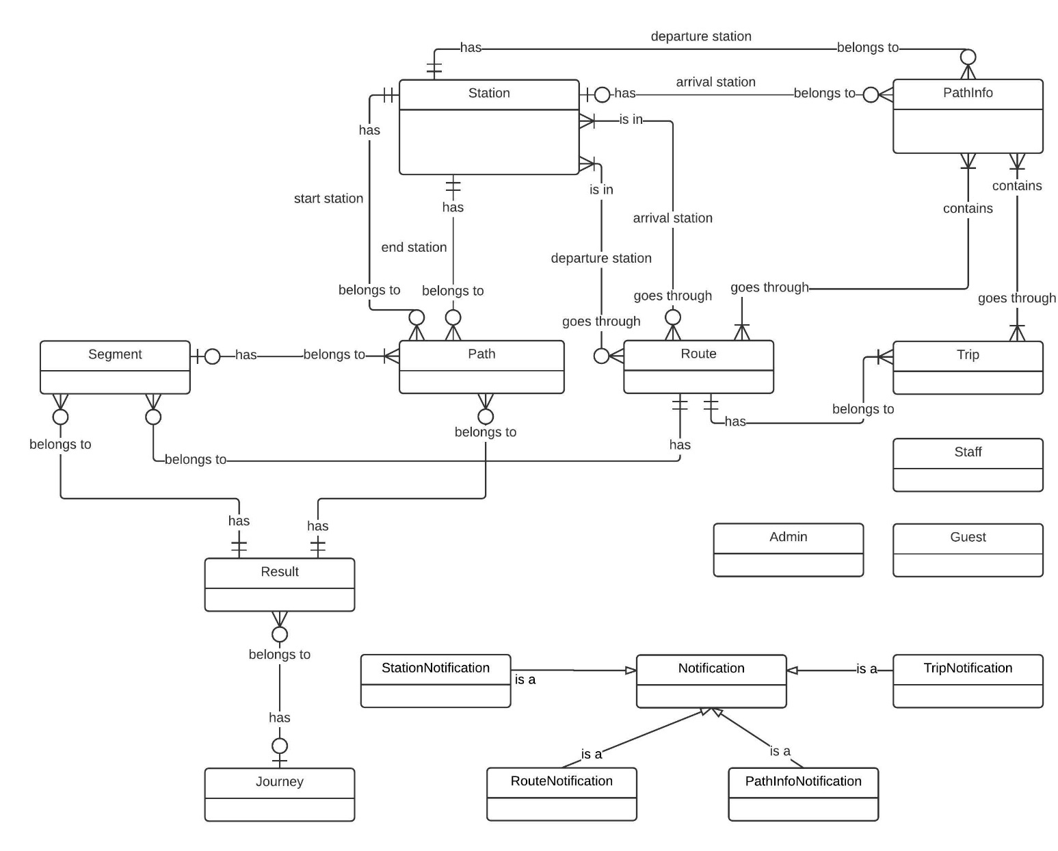

Figure 43: Conceptual Diagram

Data Dictionary

|  |  |
| --- | --- |
| Entity Data dictionary: describe all content of all entities | |
| Entity Name | Description |
| Admin | Abstract entity describes an admin in system. |
| Staff | Abstract entity describes a staff in system. |
| Guess | Abstract entity describes a guess in system. |
| Notification | Abstract entity describes a notification in system. |
| StationNotification | Notification for bus route. |
| TripNotification | Notification for bus time. |
| PathInfoNotification | Notification for PathInfo. |
| RouteNotification | Notification for route. |
| Station | Abstract entity represents distinct location in the network where one can board or get off a vehicle (bus, train) |
| Trip | Abstract entity represents a journey of one route with start time from first station and end time of last station. |
| Route | Abstract entity represents a sequence of stations a specific vehicle (train, bus, subway …) |
| PathInfo | Abstract entity represents one bus route’s segment including start station and end station. |
| Result | Abstract entity describes a bus result of two points. |
| Journey | Abstract entity describes a bus result of three or four points. |
| INode | Abstract entity describes common interface for segment and Path. |
| Segment | Abstract entity describes a bus route’s information in one result. |
| Path | Abstract entity describes a detail information between two bus station in one result. |

Table 48: Conceptual Diagram Data Dictionary

4.2. Mobile conceptual diagram:

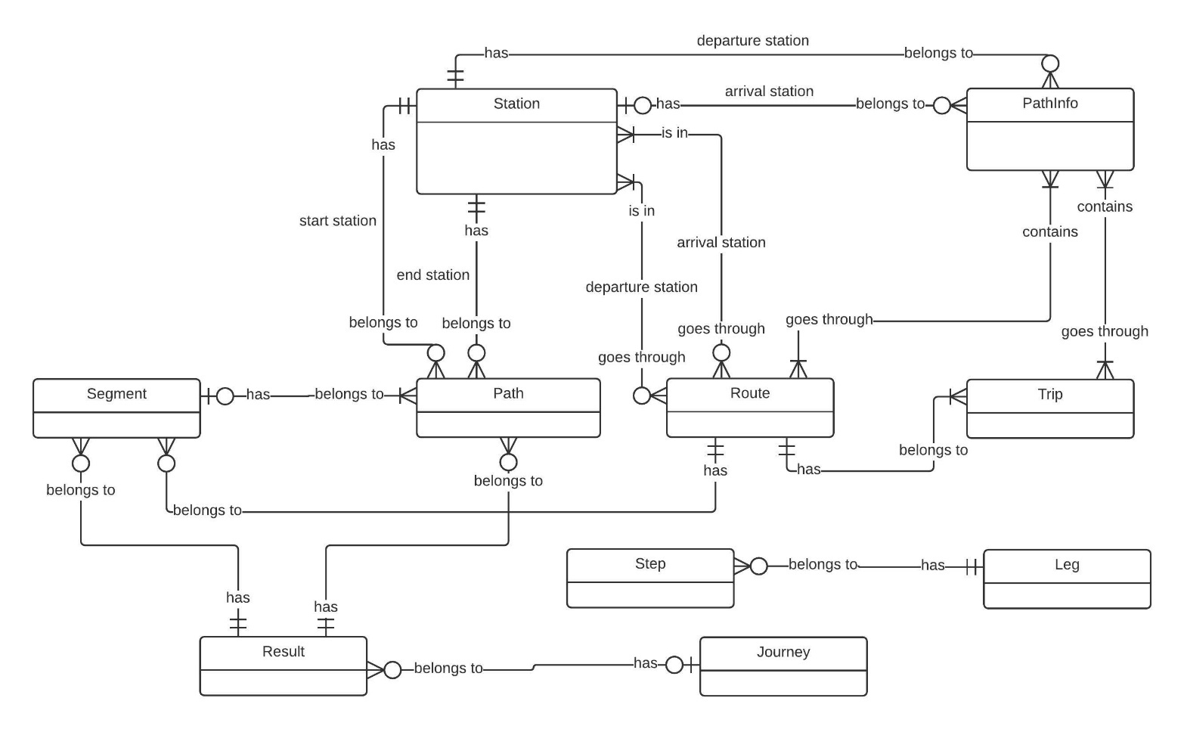

Figure 44: Mobile Conceptual diagram

Data Dictionary

|  |  |
| --- | --- |
| Entity Data dictionary: describe all content of all entities | |
| Entity Name | Description |
| Station | Abstract entity represents distinct location in the network where one can board or get off a vehicle (bus, train) |
| Trip | Abstract entity represents a journey of one route with start time from first station and end time of last station. |
| Route | Abstract entity represents a sequence of stations a specific vehicle (train, bus, subway …) |
| PathInfo | Abstract entity represents one bus route’s segment including start station and end station. |
| Result | Abstract entity describes a bus result of two points. |
| Journey | Abstract entity describes a bus result of three or four points. |
| INode | Abstract entity describes common interface for segment and Path. |
| Segment | Abstract entity describes a bus route’s information in one result. |
| Path | Abstract entity describes a detail information between two bus station in one result. |
| Step | Abstract entity describes a detail instruction for motorbike route. |
| Leg | Abstract entity describes detail information for going from one place to another. |

Table 49: Conceptual Diagram Data Dictionary

# **Software Design Description**

## Design Overview

* This document describes the technical and user interface design of SWR system. It includes the architectural design, the detailed design of common functions and business functions and the design of database model.
* The architectural design describes the overall architecture of the system and the architecture of each main component and subsystem.
* The detailed design describes static and dynamic structure for each component and functions. It includes class diagrams, class explanations and sequence diagrams for each use cases.
* The database design describes the relationships between entities and details of each entity.
* Document overview:
  + Section 2: gives an overall description of the system architecture design.
  + Section 3: gives component diagrams that describe the connection and integration of the system.
  + Section 4: gives the detail design description, which includes class diagram, class explanation, and sequence diagram to details the application functions.
  + Section 5: describe a fully attributed Entity Relationship Diagram.

## System Architecture Design

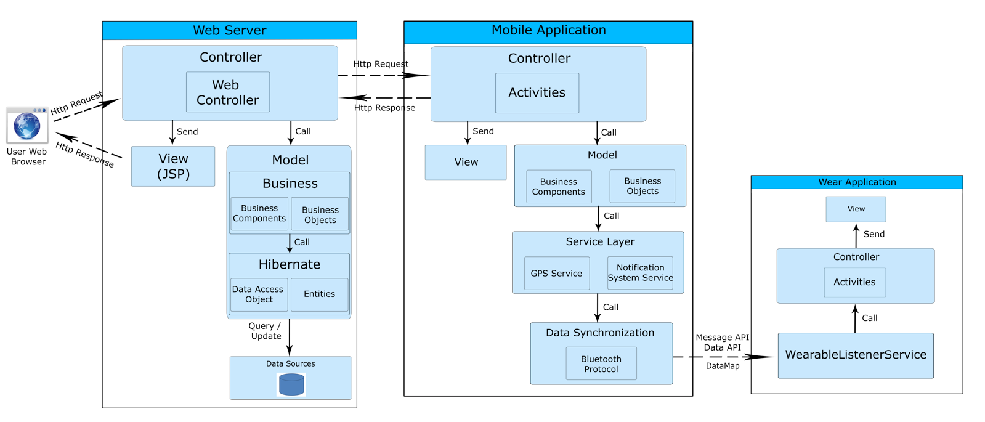

Figure 45 System architecture design

### Web Application architecture description

In Web Application, the system is developed under J2EE MVC architecture style. We choose this architecture for Web application because of following advantages:

* Web app contains Web services with MVC architecture, we can separate business code with Controller and View. So we can use the business code in web service without repeat the code.
* In scope of 4-members team, MVC architecture make it easier to split the big project into small modules and make it easier to assign each module for members in our team.

This project follows MVC architecture with following components:

* **Controller** is the parts of the web server that acts like event handler to handles user interaction.
  + - **Web Controller** is the parts of the controller that acts like event handler for web and server communication via HTTP protocol.
* **Model** is the parts of the web server that acts like a data transfer object between the system and database, handle business of system.
  + - **Business** is the parts of the model that do business processing to solve domain problems.
      * **Business Component** is the parts of the business that do business of system.
      * **Business Objects** is the parts of the business that define some objects to use in business component.
    - **Hibernate** is the parts of the model that transfer object between the system and database.
      * **Data Access Object** is the parts of persistence that provides base methods CRUD to persistent store data into database.
      * **Entities** is the parts of persistence that mapping table’s record in database with each object.
* **View** is the parts of the web server that acts like event handles the display of the data. The selection of View is under control of Controller.

### 2.2. Mobile Application Architecture Description

The application is developed as an Android native application. In general, the application architecture conforms to Android architecture.

This project follows Android application architecture with following component:

* **Controller** is the part of mobile application that handles user input, create thread to run asynchronous tasks and synchronize data, get notify from server
  + - **Activities** is the part of the controller that handles user input, call model and render to view.
* **View** is the part of android application that acts like event handles the display of the data. The selection of View is under control of Controller.
* **Model** is the parts of the mobile application that do business processing to solve domain problems in mobile application.
  + - **Business Component** is the parts of business layer that do business of mobile application.
    - **Business Object** is the part of business layer that define some objects like business objects in server.
* **Data Synchronization** is the part of the mobile application that use to get data from android wear and manage connection with android wear.
  + - **Bluetooth protocol** is the protocol that use for transfer data between android wear and mobile application:
      * **DataMap** is the data structure for sending data from android mobile application to wear**.**
      * **MessageAPI** is the API build above Bluetooth protocol for sending data from mobile to wear and maintain reliability such as keep data for sending later when connection between mobile and wear disconnected**.**
      * **DataAPI** is the API build above Bluetooth protocol for transferring large data items, such as music and movie files, from a mobile to android wearable.

### 2.3. Android Wear Architecture Description

The application is developed as an Android wear application. In general, android wear is the modified version of Android OS so the application architecture conforms to Android architecture.

This project follows Android application architecture with following component:

**- WearableListenerService** is the part of wear application that listen all data from mobile application and send data to controller.

* **Controller** is the part of wear application that handles user input
  + - **Activity** is the part of the controller that handles user input, received data from WearrableListenerService and render to view.
* **View** is the part of the wear that acts like event handles the display of the data. The selection of View is under control of Controller.

## Component Diagram

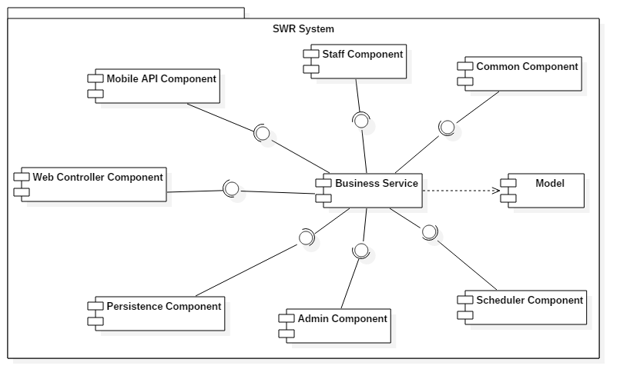

Figure 46 Component Diagram

|  |  |  |
| --- | --- | --- |
| Component Dictionary: Describes components | | |
| Business Service | Component for handle all system business. | com.fpt.router.web.action |
| Model | System model such as algorithm model, persistence model. | Algorithm model: com.fpt.router.artifacter.model.algorithm  Persistence model:  com.fpt.router.artifacter.model.entity |
| Common Component | Component for handle common task | com.fpt.router.artifacter.utils. |
| Persistence Component | Component for handle all database transaction for reading and writing data. | com.fpt.router.artifacter.dao |
| Scheduler Component | Component to handle parse data periodically. | com.fpt.router.web.action.parser |
| Admin Component | Component for admin manages system. | com.fpt.router.web.action.admin |
| Staff Component | Component for staff manages system. | com.fpt.router.web.action.staff |
| Mobile API Component | Component to handle all mobile request. | com.fpt.router.web.action.api |
| Web Controller Component | Component to handle all browser request. | com.fpt.router.web.servlet |

Table 50 Component Dictionary

## Detailed Description Class Diagram

Because web and mobile application need different entities, so conceptual diagram on web will be different to conceptual diagram on mobile application. We decide to design two separated conceptual diagrams.

### Web System class diagram



Figure 47: Web system class diagram

#### 4.1.1. HttpServlet

HttpServlet class is a system class of JavaEE framework. HttpServlet is an abstract class to be subclassed to create an HTTP servlet suitable for a Web site.

#### 4.1.2. DispatcherServlet

DispatcherServlet is an application class, inherits from HttpServlet and get all requests from client. Base on action string from client, DispatcherServlet will call ActionFactory for getting suitable action for processing.

Method:

|  |  |  |  |
| --- | --- | --- | --- |
| Method | Return type | Visibility | Description |
| processRequest | Void | Public | Input parameter:   * HttpServletRequest request * HttpServletResponse response |

Table 51: DispatcherServlet - Method

#### 4.1.3. ApplicationContext

ApplicationContext uses façade pattern, wraps HttpResponse and HttpRequest objects and public all necessary methods.

Attribute

|  |  |  |  |
| --- | --- | --- | --- |
| Attribute | Type | Visibility | Description |
| request | HttpServletRequest | Private | Servlet request |
| response | HttpServletResponse | Private | Servlet response |

Table 52: ApplicationContext - Attribute

Method:

|  |  |  |  |
| --- | --- | --- | --- |
| Method | Return type | Visibility | Description |
| forward | Void | Public | Parameter:   * url: String. Url needs to forward |
| redirect | Void | Public | Parameter:   * url: String. Url needs to redirect. |
| getParameter | String | public | Parameter:   * Parameter:String. Parameter name from client. |
| getAttribute | Object | public | Parameter:   * Parameter:String. Parameter name of attribute. Return null if system doesn’t have this attributes. |

Table 53: ApplicationContext - Method

#### 4.1.4. IActionFactory

Common interface for all factories generate action objects.

Method:

|  |  |  |  |
| --- | --- | --- | --- |
| Method | Return type | Visibility | Description |
| getAction | IAction | Public | Parameter:   * action: String. A string represents action behavior for generating action. |

Table 54: IActionFactory - Method

#### 4.1.5. ActionFactory

ActionFactory uses MethodFactory pattern. ActionFactory will be a unique place creates all types of action object.

#### 4.1.6. IAction

Common interface for all actions.

Method:

|  |  |  |  |
| --- | --- | --- | --- |
| Method | Return type | Visibility | Description |
| execute | String | Public | Parameter:  Context:ApplicationContext: wrapper request response object.  Main method for action execute and return String for view’s name that should be return to client. |

Table 55: IAction - Method

#### 4.1.7. AuthAction

Abstract action for authentication. All actions need authentication (ie: login) must implement this action. When user doesn’t login, AuthAction will automatically redirect to login page.

#### 4.1.8. WebApiAction

Abstract action for all web api actions. Currently, this action does nothing. Nevertheless, in the future, WebApiAction will check validation from client such as checking private key before processing action.

#### 4.1.9. AdminAction

Abstract action for admin. All actions need login under admin role must implement this action. When user doesn’t login as admin role, AdminAction will automatically redirect to login page.

#### 4.1.10. StaffAction

Abstract action for staff. All actions need login under staff role must implement this action. When user doesn’t login as staff role, StaffAction will automatically redirect to login page.

### Web class diagram

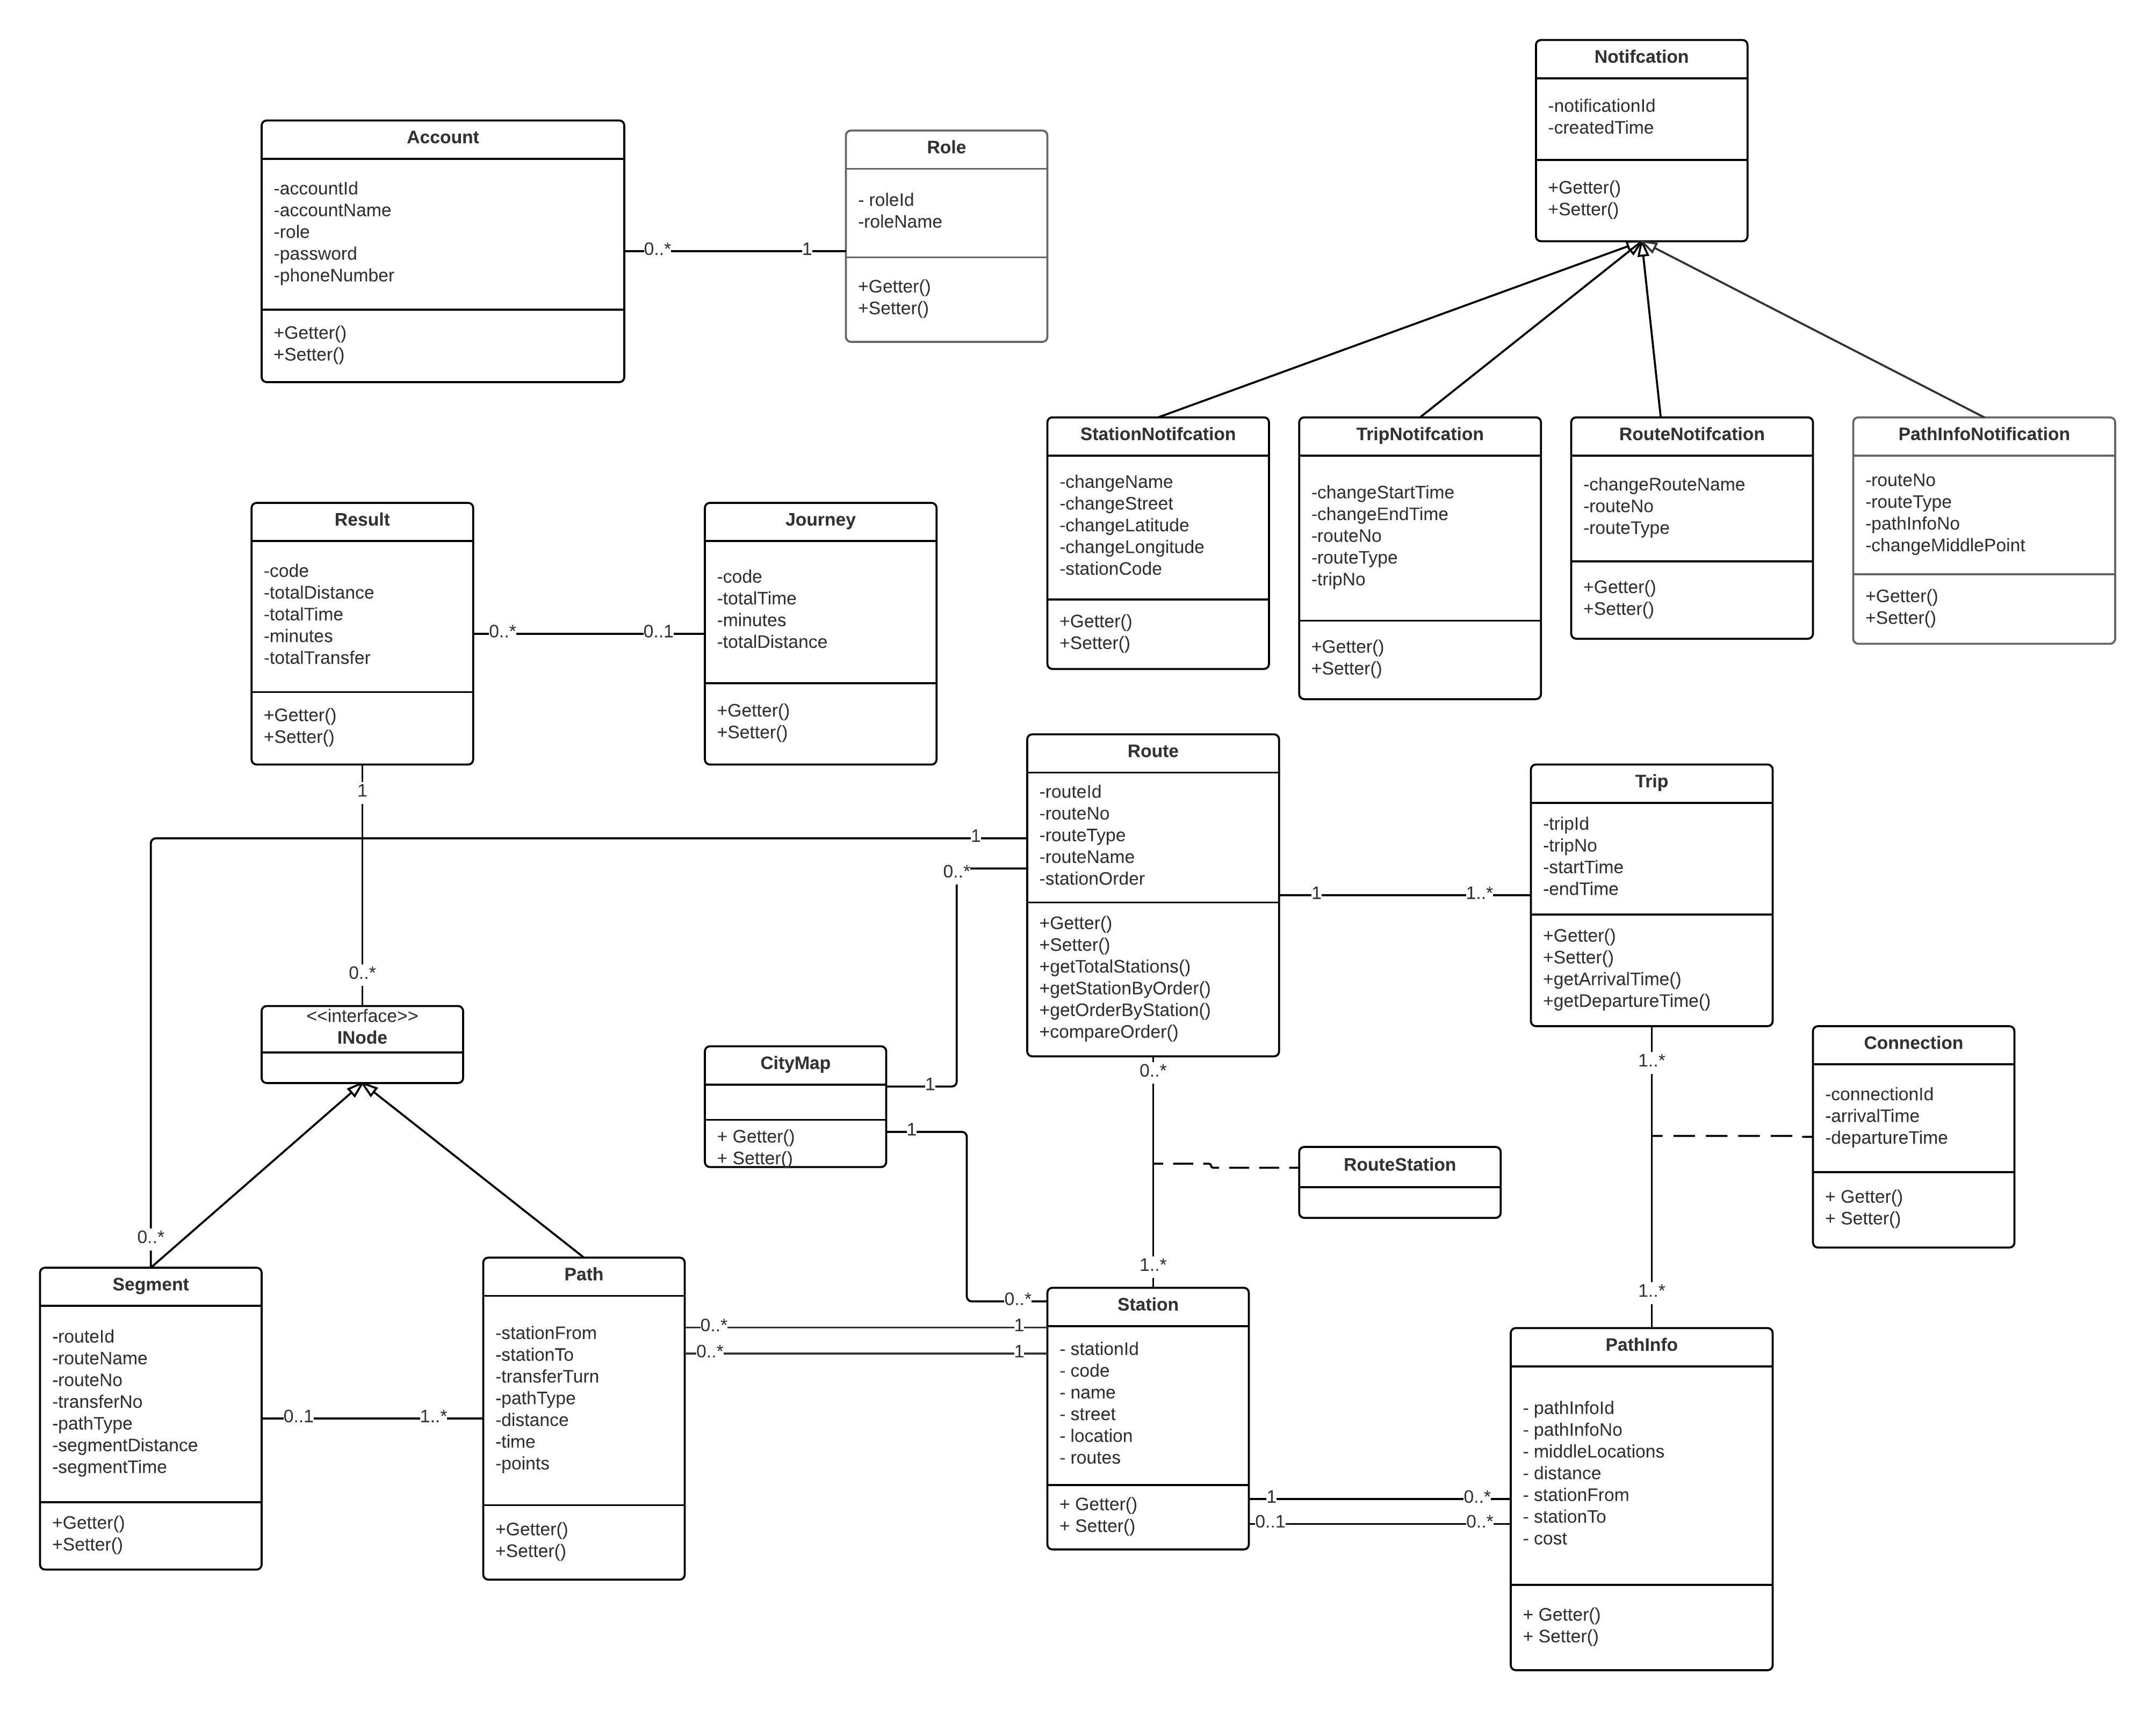

Table 56 Class dictionary

#### CityMap

Attribute

|  |  |  |  |
| --- | --- | --- | --- |
| Attribute | Type | Visibility | Description |
| stations | List<Station> | Private | List all city’s stations. |
| routes | List<Route> | Private | List al city’s routes. |

Table 57: CityMap - Attribute

Method:

|  |  |  |  |
| --- | --- | --- | --- |
| Method | Return type | Visibility | Description |
| Getter | Attribute type | Public | Get attribute value |
| Setter | Void | public | Set value of attribute |

Table 58: CityMap - Method

#### **Route**

Attribute

|  |  |  |  |
| --- | --- | --- | --- |
| Attribute | Type | Visibility | Description |
| routeId | Int | Private | Unique identifier of each route |
| routeNo | Int | Private | List al city’s routes. |
| routeType | Int | Private | Type of this route. One route no always has two way: depart or return. |
| routeName | String | Private | Name of this route. (ie: tuyến xe Bến Thành – Hiệp Thành) |
| stationOrder | Map<Integer,Integer> | Private | Order of stations this route will g through starting from 0. This map will point from station’s order to station’s id. |
| trips | List<Trip> | Private | List all trips of this route |
| pathInfos | List<PathInfo> | Private | List all pathInfos of this route. |

Table 59: Route - Attribute

Method:

|  |  |  |  |
| --- | --- | --- | --- |
| Method | Return type | Visibility | Description |
| Getter | Attribute type | Public | Get attribute value |
| Setter | Void | public | Set value of attribute |
| getTotalStations | Int | Public | Parameter: Void  Get all stations of this route |
| getStationByOrder | Int | Public | Parameter:   * order: int. Order of station need to get.   Get station base on order in this route. |
| getOrderByStation | Int | Public | Parameter:   * station:Station. Station need to get order.   Get order of station in this route |
| compareOrder | Int | Public | Parameter:   * firstStationId:int. first station id need to compare. * secondStationId:int. second station id need to compare.   Comparison between two stations. If return -1, first station is before second station. If return 0, two station are same. If return 1, first station is after second station in this route. |

Table 60: Route - Method

#### Station

Attribute

|  |  |  |  |
| --- | --- | --- | --- |
| Attribute | Type | Visibility | Description |
| Id | Int | Private | Unique identifier of station. |
| code | String | Private | Unique code getting from server of station. |
| name | String | Private | Name of station. |
| street | String | Private | Street of station. |
| location | Location | Private | Location (latitude, longitude) of station. |
| routes | List<Route> | Private | All routes go through this station. |

Table 61: Station - Attribute

Method

|  |  |  |  |
| --- | --- | --- | --- |
| Method | Return type | Visibility | Description |
| Getter | Attribute type | Public | Get attribute value |
| Setter | Void | public | Set value of attribute |

Table 62: Station - Method

#### Trip

Attribute

|  |  |  |  |
| --- | --- | --- | --- |
| Attribute | Type | Visibility | Description |
| tripId | int | Private | Unique identifier of trip. |
| tripNo | int | Private | Order of this trip in route’s trip. |
| startTime | LocalTime | Private | Start time of this trip. |
| endTime | LocalTime | Private | End time of this trip. |
| route | Route | Private | Route of this trip. |
| connections | List<Connection> | private | List connections of this trip. |

Table 63: Trip - Attribute

Method:

|  |  |  |  |
| --- | --- | --- | --- |
| Method | Return type | Visibility | Description |
| Getter | Attribute type | Public | Get attribute value |
| Setter | Void | public | Set value of attribute |
| getArrivalTime | LocalTime | Public | Parameter:   * Station:Station. Station that user needs to get arrival time.   Get arrival time of one station in this trip. |
| getDepartTime | LocalTime | Public | Parameter:   * Station: station that user needs to get arrival time.   Get departure time of one station in this trip. |

Table 64: Trip - Method

#### PathInfo

Attribute

|  |  |  |  |
| --- | --- | --- | --- |
| Attribute | Type | Visibility | Description |
| pathInfoId | int | Private | Unique identifier of pathInfo. |
| pathInfoNo | int | Private | Order of pathInfo on PathInfo’route. |
| middleLocations | List<Location> | Private | Middle locations on this line. (for rendering to customer purpose) |
| distance | double | Private | Distance (in meter) from start station to end station |
| route | Route | Private | Route of this PathInfo. |
| from | Station | Private | Start station |
| to | Station | private | End Station |
| cost | Period | private | Total time travel in this PathInfo |

Table 65: PathInfo - Attribute

Method:

|  |  |  |  |  |  |  |
| --- | --- | --- | --- | --- | --- | --- |
| Method | Return type | | Visibility | | Description | |
| Getter | Attribute type | | Public | | Get attribute value | |
| Setter | Void | | public | | Set value of attribute | |
| cost | | Period | | private | | Total time travel in this PathInfo | |

Table 66: PathInfo - Method

#### Connection

Attribute

|  |  |  |  |
| --- | --- | --- | --- |
| Attribute | Type | Visibility | Description |
| connectionId | int | Private | Unique identifier of Connection. |
| trip | int | Private | Trip of this Connection. |
| pathInfo | List<Location> | Private | PathInfo of this connection. |
| arrivalTime | double | Private | Arrival time of this connection. |
| departureTime | Route | Private | Departure time of this connection. |

Table 67: Connection - Attribute

Method:

|  |  |  |  |
| --- | --- | --- | --- |
| Method | Return type | Visibility | Description |
| Getter | Attribute type | Public | Get attribute value |
| Setter | Void | public | Set value of attribute |

Table 68: Connection - Method

#### INode

Common interface for path and segment. Define a line from one point to another point.

#### Path

Attribute

|  |  |  |  |
| --- | --- | --- | --- |
| Attribute | Type | Visibility | Description |
| stationFrom | Station | Private | From station. |
| stationTo | Station | Private | To station. |
| pathType | int | Private | There are three path type:  0: Walking. Can be from arbitrary point to station. From Station to arbitrary point .  1: between two bus station.  2: critical path: path that user will prepare for get off station. |
| routeNo | int | Private | routeNo of this path. |
| distance | double | Private | Distance (in meter) of this path. |
| time | Period | Private | Total time travel of this path. |
| middleLocations | List<Location> | Private | Middle locations for rendering result to user. |

Table 69: Path - Attribute

Method:

|  |  |  |  |
| --- | --- | --- | --- |
| Method | Return type | Visibility | Description |
| Getter | Attribute type | Public | Get attribute value |
| Setter | Void | public | Set value of attribute |

Table 70: Path - Method

#### Segment

Attribute

|  |  |  |  |
| --- | --- | --- | --- |
| Attribute | Type | Visibility | Description |
| routeId | Int | Private | Unique identifier of route of this segment. |
| routeName | int | Private | Route name of this route. |
| routeNo | int | Private | Route no of this route. |
| transferNo | int | Private | Order of this segment. |
| pathType | int | Private | There are three path type:  0: Walking. Can be from arbitrary point to station. From Station to arbitrary point or from station to station.  1: between two bus.  2: critical path: path that user will prepare for get off. |
| segmentDistance | double | Private | Total distance (in meter) travel of this segment. |
| segmentTime | Period | Private | Total time travel of this segment |
| paths | List<Path> | private | All paths of this segment. |

Table 71: Segment - Attribute

Method:

|  |  |  |  |
| --- | --- | --- | --- |
| Method | Return type | Visibility | Description |
| Getter | Attribute type | Public | Get attribute value |
| Setter | Void | public | Set value of attribute |

Table 72: Segment - Method

#### Result

Attribute

|  |  |  |  |
| --- | --- | --- | --- |
| Attribute | Type | Visibility | Description |
| code | String | Private | Message code returning to client. |
| totalDistance | double | Private | Total distance of this result. |
| totalTime | Period | Private | Total time of this result. |
| minutes | int | Private | Total time in minute of this result. |
| totalTransfer | int | Private | Total bus transfers for getting from start location to end location. |
| nodeList | List<INode> | Private | List all nodes for getting from start location to end location. |

Table 73: Result - Attribute

Method:

|  |  |  |  |
| --- | --- | --- | --- |
| Method | Return type | Visibility | Description |
| Getter | Attribute type | Public | Get attribute value |
| Setter | Void | public | Set value of attribute |

Table 74: Result - Method

#### Journey

Attribute

|  |  |  |  |
| --- | --- | --- | --- |
| Attribute | Type | Visibility | Description |
| code | String | Private | Message code returning to client. |
| totalDistance | double | Private | Total distance of this journey. |
| totalTime | Period | Private | Total time of this result. |
| minutes | int | Private | Total time in minute of this result. |
| results | List<Result> | Private | List all results of this journey. |

Table 75: Journey - Attribute

Method:

|  |  |  |  |
| --- | --- | --- | --- |
| Method | Return type | Visibility | Description |
| Getter | Attribute type | Public | Get attribute value |
| Setter | Void | public | Set value of attribute |

Table 76: Journey - Method

#### Account

Attribute

|  |  |  |  |
| --- | --- | --- | --- |
| Attribute | Type | Visibility | Description |
| accountId | int | Private | Unique identifier of account. |
| accountName | String | Private | account name. |
| accountEmail | String | Private | account email. |
| password | String | Private | account password encrypted using MD5 algorithm. |
| Role | Role | Private | Role of this account. Can be normal staff or admin. |
| phoneNumber | String | Private | Phone number of this account. |

Table 77: Account - Attribute

Method:

|  |  |  |  |
| --- | --- | --- | --- |
| Method | Return type | Visibility | Description |
| Getter | Attribute type | Public | Get attribute value |
| Setter | Void | public | Set value of attribute |

Table 78: Account - Method

#### Role

Attribute

|  |  |  |  |
| --- | --- | --- | --- |
| Attribute | Type | Visibility | Description |
| roleId | int | Private | Unique identifier of role. |
| roleName | String | Private | role name. |

Table 79: Role - Attribute

Method:

|  |  |  |  |
| --- | --- | --- | --- |
| Method | Return type | Visibility | Description |
| Getter | Attribute type | Public | Get attribute value |
| Setter | Void | public | Set value of attribute |

Table 80: Role - Method

#### Notification

Attribute

|  |  |  |  |
| --- | --- | --- | --- |
| Attribute | Type | Visibility | Description |
| notificationId | int | Private | Unique identifier of notification. |
| createdTime | DateTime | Private | Created date of this notification. |

Table 81: Notification - Attribute

Method:

|  |  |  |  |
| --- | --- | --- | --- |
| Method | Return type | Visibility | Description |
| Getter | Attribute type | Public | Get attribute value |
| Setter | Void | public | Set value of attribute |

Table 82: Notification - Method

#### StationNotification

Attribute

|  |  |  |  |
| --- | --- | --- | --- |
| Attribute | Type | Visibility | Description |
| stationCodeId | int | private | Station’s code of station has data changed. |
| changeName | String | Private | Changed station name. Value will be null if station name doesn’t change. |
| changeStreet | String | private | Changed station street name. Value will be null if station street name doesn’t change |
| changeLatitude | double | private | Change station’s latitude. Value will be 0.0 if station latitude doesn’t change. |
| changeLongitude | double | private | Change station’s longitude. Value will be 0.0 if station longitude doesn’t change. |

Table 83: StationNotification - Attribute

Method:

|  |  |  |  |
| --- | --- | --- | --- |
| Method | Return type | Visibility | Description |
| Getter | Attribute type | Public | Get attribute value |
| Setter | Void | public | Set value of attribute |

Table 84: StationNotification - Method

#### RouteNotification

Attribute

|  |  |  |  |
| --- | --- | --- | --- |
| Attribute | Type | Visibility | Description |
| routeNo | int | private | Route no of route has been changed. |
| routeType | int | Private | Route type of this route. Can be two types:  0. DEPART  1. RETURN. |
| changeRouteName | String | private | Route name has been changed. Value will be null if route name doesn’t change. |

Table 85: RouteNotification - Attribute

Method:

|  |  |  |  |
| --- | --- | --- | --- |
| Method | Return type | Visibility | Description |
| Getter | Attribute type | Public | Get attribute value |
| Setter | Void | public | Set value of attribute |

Table 86: RouteNotification - Method

#### TripNotification

Attribute

|  |  |  |  |
| --- | --- | --- | --- |
| Attribute | Type | Visibility | Description |
| routeNo | int | private | Route no of trip has been changed. |
| routeType | int | Private | Route type of this route. Can be two types:  0. DEPART  1. RETURN. |
| changeStartTime | LocalTime | Private | Changed start time of this trip. Value will be null if trip’s start time doesn’t change. |
| changeEndTime | LocalTime | Private | Changed end time of this trip. Value will be null if trip’s end time doesn’t change. |
| tripNo | String | private | Route name has been changed. Value will be null if route name doesn’t change. |

Table 87: TripNotification - Attribute

Method:

|  |  |  |  |
| --- | --- | --- | --- |
| Method | Return type | Visibility | Description |
| Getter | Attribute type | Public | Get attribute value |
| Setter | Void | public | Set value of attribute |

Table 88: TripNotification - Method

#### 4.2.18. PathInfoNotification

Attribute

|  |  |  |  |
| --- | --- | --- | --- |
| Attribute | Type | Visibility | Description |
| routeNo | int | private | Route no of pahtinfo has been changed. |
| routeType | int | Private | Route type of this route. Can be two types:  0. DEPART  1. RETURN. |
| PathInfoNo | Int | Private | PathInfo order of this route. |
| changeMiddlePoint | String | Private | Changed middlepoint of this PathInfo. Value will be null if PathInfo middle points doesn’t change. |

Table 89: PathInfoNotification - Attribute

Method:

|  |  |  |  |
| --- | --- | --- | --- |
| Method | Return type | Visibility | Description |
| Getter | Attribute type | Public | Get attribute value |
| Setter | Void | public | Set value of attribute |

Table 90: PathInfoNotification - Method

### Interactive Diagram

#### Web Application

##### Staff

##### Parse source local action

* Summary this allows staff parse data from local.

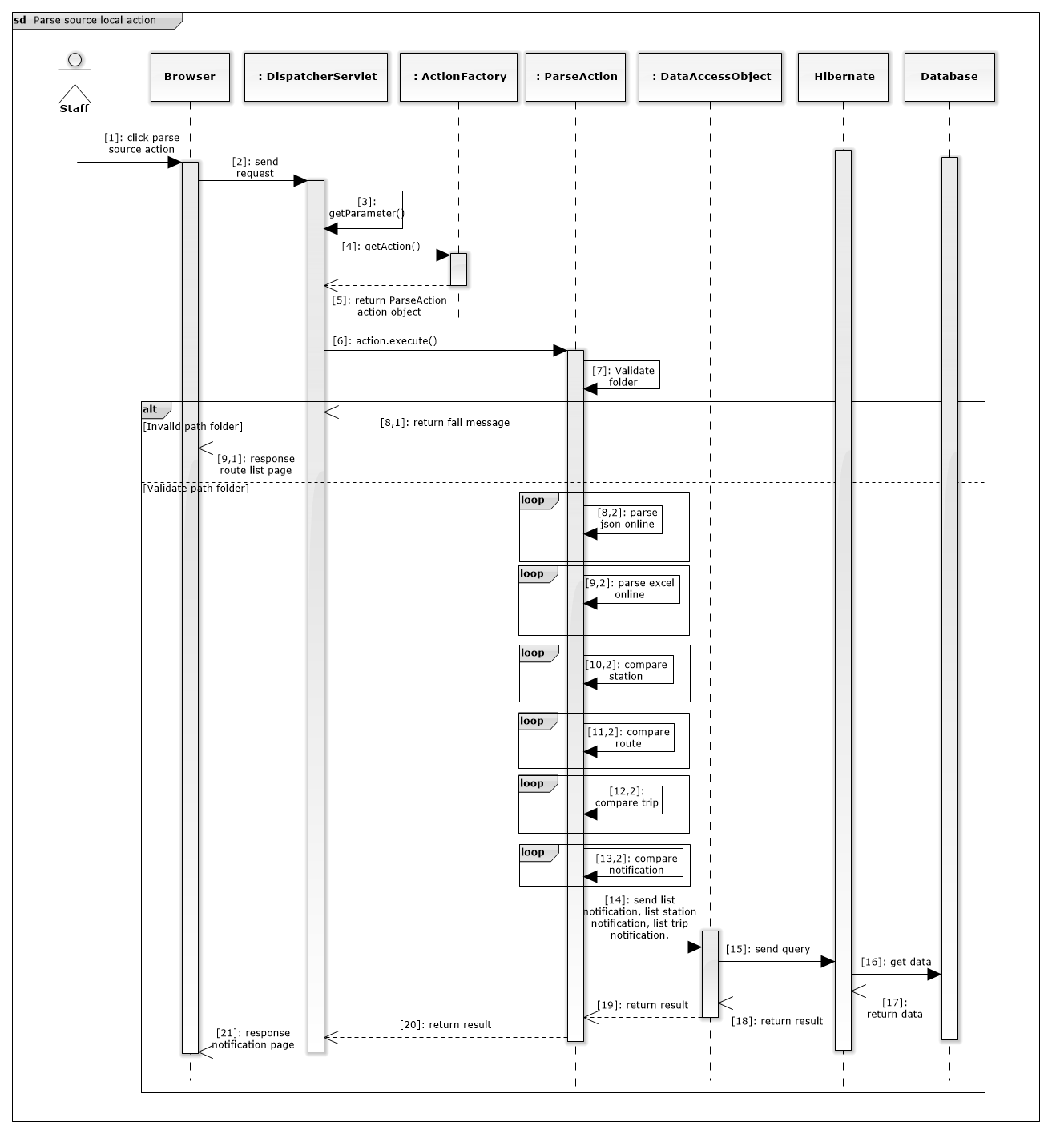

Figure 48: Sequence diagram - Parse source local action

##### Search two-point bus route

* This diagram allows user search suiable route from two point on the map.

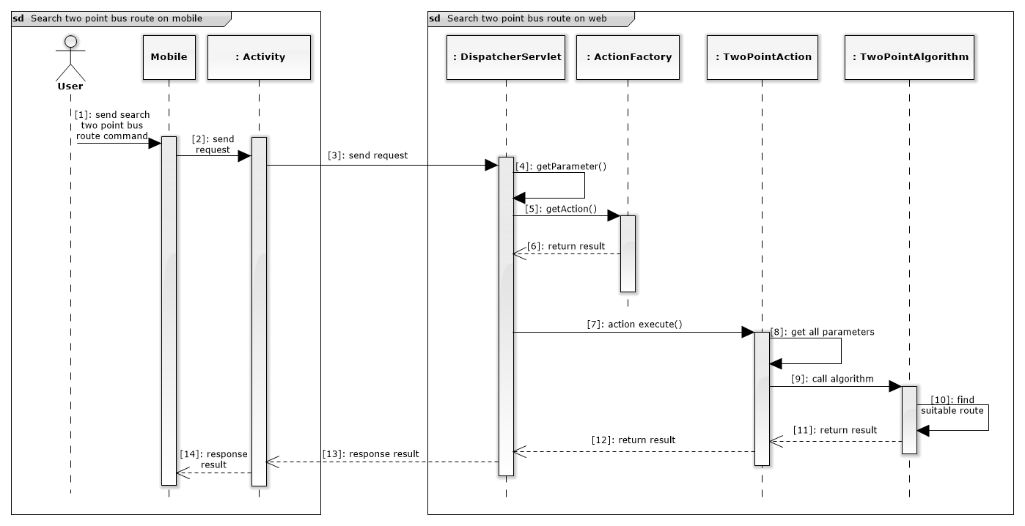

Figure 49: Sequence diagram - Search two point bus route

##### Search multi point bus route

* This diagram allows user search suitable route from multi point on the map.

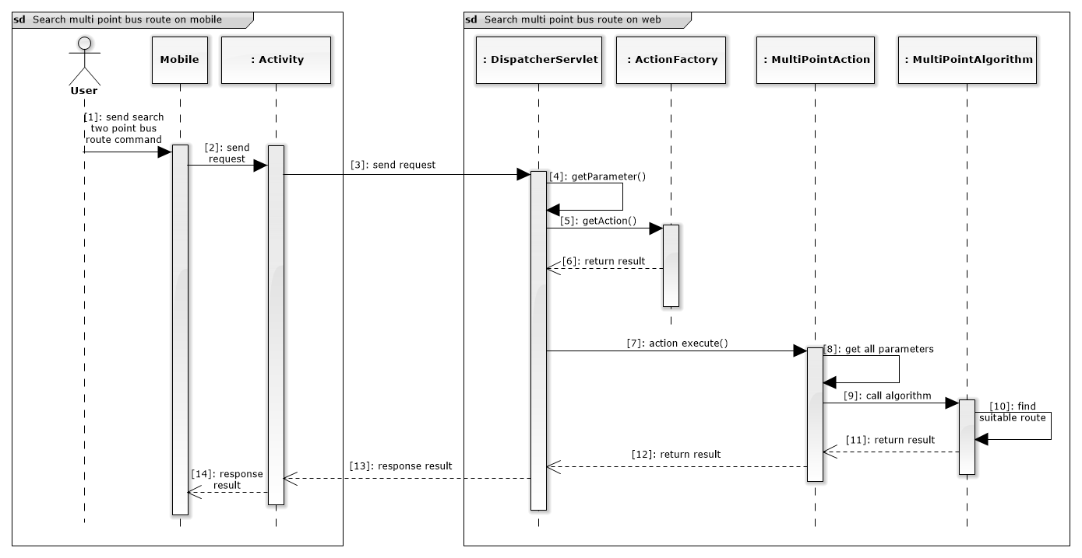

Figure 50: Sequence diagram - Search multi point bus route

#### Mobile Application

##### <Guest> Navigate Current Location on Map

* Summary: This diagram allows Guest search current location on the map with GPS for mobile application.



Figure 51: Activity Diagram - <Guest> Navigate current location on map

##### <Guest> Setting

Summary: This diagram allows the Guest change setting from mobile application.



Figure 52: Activity Diagram - <Guest> Setting

##### <Guest> View Detail

Summary: This diagram show detail information of route when Guest select one route in list route.



Figure 53: Activity Diagram - <Guest> View detail

##### <Guest> Search Bus Route

Summary: This diagram allows Guest search bus route through some locations (from two to four points) on the mobile application.



Figure 54 Activity Diagram - <Guest> Search bus route

##### <Guest> Search Motorbike Route

Summary: This diagram allows Guest search motorbike route thought some locations (from two to four) on the mobile application.



Figure 55 Activity Diagram - <Guest> Search motorbike route

##### <Guest> Search Arbitrary location on map

Summary: This diagram allows Guest search an arbitrary location on the map for the mobile application.



Figure 56: Activity Diagram - <Guest> Search arbitrary location on map

##### <Guest> Download Audio File

Summary: This diagram allows the Guest download audio file from FPT service for mobile application.



Figure 57: Activity Diagram - <Guest> Download audio file

##### <Guest> Recommend place when user search

Summary: this diagram allows guest to search location with key word



Figure 59: Activity diagram - <Guest> Recommend place when user search

##### <Guest> Route street

Summary: this diagram notifies to user. And that notification depends on user’s location



Figure 60: Activity diagram - <Guest> Route street

## Interface

### Component interface

#### Web service interface

|  |  |  |  |  |  |
| --- | --- | --- | --- | --- | --- |
| © | Description | Input | Output | Output Format | Exception |
| /api/bus/twopoint | Find bus route between two points | **latStart:double**. Latitude of start location.  **longStart:double**.Longitude of start location.  **latEnd:double**. Latitude of end location.  **longEnd:double**. Longitude of end location.  **addressStart:String**. Address of start location.  **addressEnd:String**. Address of end location.  **hour:Integer**. Hour that customer wants to search.  **minute**: minute that customer wants to search.  **walkingDistance:Integer**. Walking distance.  **transferTurn:Integer**. Maximum transfers for one search. | Json string of Result object. | Json | ParameterFormatException |
| api/bus/multipoint | Find bus route from three point to four point with optimize or not | **latStart:double**. Latitude of start location.  **longStart:double**.Longitude of start location.  **latEnd:double**. Latitude of end location.  **longEnd:double**.Longitude of end location.  **latMidFirst:double**. Latitude of first middle point.  **longMidFirst:double**.Longitude of first middle point.  **latMidSecond:double**. Latitude of second middle location.  **longMidSecond:double**.Longitude of second middle location.  **addressStart:String**. Address of start location.  **addressEnd:String**. Address of end location.  **addressMidFirst:String**. Address of first middle location.  **addressMidSecond:String**. Address of second middle location.  **isOp:Boolean**. Marking this search is optimize or not.  **hour:Integer**. Hour that customer wants to search.  **minute**: minute that customer wants to search.  **walkingDistance:Integer**. Walking distance.  **transferTurn:Integer**. Maximum transfers for one search. | Json String of Journey object. | json | ParameterFormatException |

### Web application design

#### Configure parse source

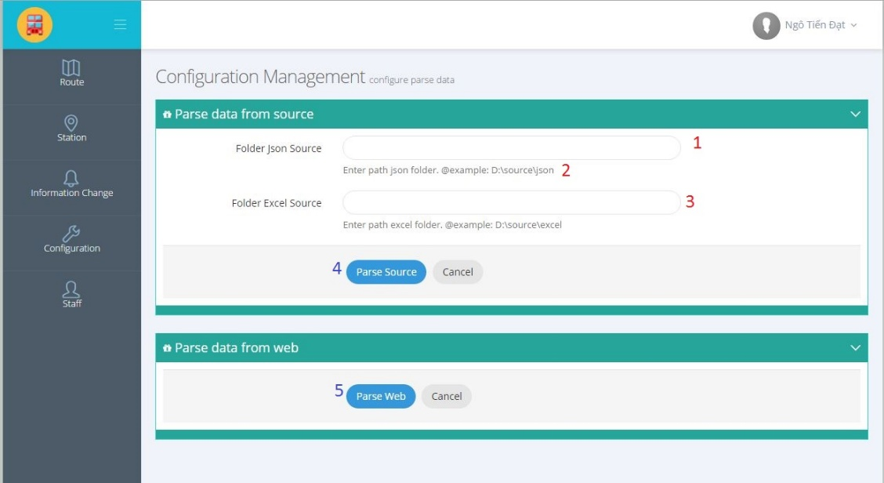

Figure 64 Interface - <Staff> Configure parse source

**Fields**

|  |  |  |  |  |  |  |  |
| --- | --- | --- | --- | --- | --- | --- | --- |
| No | Field Name | Description | Read only | Mandatory | Control Type | Data Type | Length |
| 1 | Folder json | Fill path of json folder | No | Yes | Textbox | String | 3-250 |
| 2 | Help title | Title suggest staff fill correct path | Yes | Yes | Label | N/A | N/A |
| 3 | Folder excel | Fill excel path of excel folder | No | Yes | Textbox | String | 3-250 |

Table 97: Configure Parse Source - fields

**Button/Hyperlinks**

|  |  |  |  |  |
| --- | --- | --- | --- | --- |
| No | Function | Description | Validation | Outcome |
| 4 | btnParseSource | Parse list of file in selected folder | N/A | Notification for notifying various data and all notification will be added into storage. |
| 5 | btnParseWeb | Parse data from specified web | N/A | Notification for notifying various data and all notification will be added into storage. |

Table 98: Configure Parse Source - Buttons/Hyperlinks

#### Manage bus trip information change

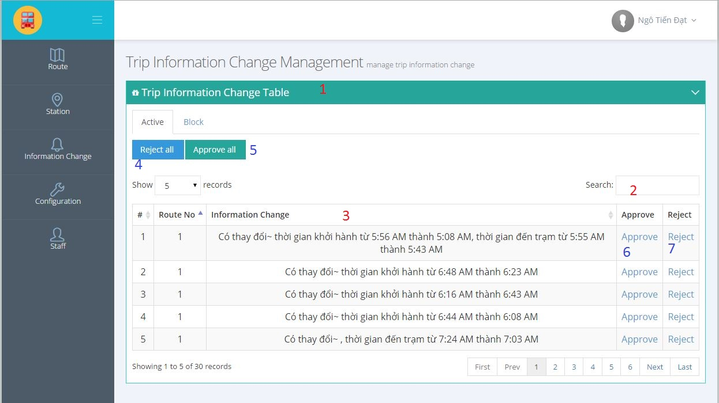

Figure 65 Interface - <Staff> Manage trip bus information change.

**Fields**

|  |  |  |  |  |  |  |  |
| --- | --- | --- | --- | --- | --- | --- | --- |
| No | Field Name | Description | Read only | Mandatory | Control Type | Data Type | Length |
| 1 | Header | Header of trip table | Yes | Yes | Label | N/A | N/A |
| 2 | txtSearchValue | Fill text search | No | Yes | String | N/A | N/A |
| 3 | Table | Table of trip information change | No | Yes | Table | N/A | N/A |

Table 99: Manage Trip Information Change - fields.

**Button/Hyperlinks**

|  |  |  |  |  |
| --- | --- | --- | --- | --- |
| No | Function | Description | Validation | Outcome |
| 4 | btnRejectAll | Reject all information change | N/A | Reject all trip information change. |
| 5 | btnApproveAll | Approve all information change | N/A | Approve all trip information change. |
| 6 | linkApprove | Approve the change of information change | N/A | Then change trip information will updated. |
| 7 | linkReject | Reject selected information change | N/A | Selected trip information change will be changed state in storage. |

Table 100: Manage Trip Information Change - Buttons/Hyperlinks

### Mobile application design

#### Search Bus Three or Four Points

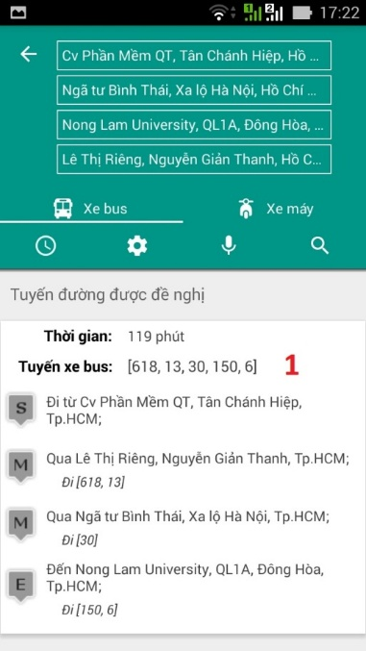

Figure : Interface - <Guest> Search Bus Three or Four Points

**List View**

|  |  |  |  |  |
| --- | --- | --- | --- | --- |
| No | Function | Description | Validation | Outcome |
| 1 | lvRoute | List of routes which Guest finished search. | N/A | Show list route or error message |

Table 110 Search Bus Three or Four Points – List View

#### View Detail Result Bus Three or Four Points

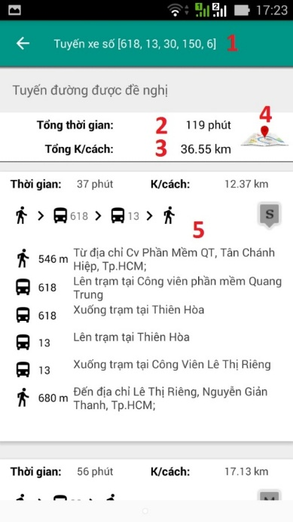

Figure : Interface - <Guest> View Detail Result Bus Three or Four Points

**Fields**

|  |  |  |  |  |  |  |
| --- | --- | --- | --- | --- | --- | --- |
| No | Field Name | Description | Read only | Mandatory | Control Type | Data Type |
| 1 | txtViewBusNonpen print card screen supporto view detail information of that contractCard | Show list of bus number when search bus. | Yes | Yes | Textbox | String |
| 2 | txtTotalTime | Show total time of one route | Yes | Yes | Textview | String |
| 3 | txtTotalDistance | Show total distance of one route | Yes | Yes | Textview | String |

Table 111 View Detail Result Bus Three or Four Points - Fields

**Image Buttons**

|  |  |  |  |  |
| --- | --- | --- | --- | --- |
| No | Function | Description | Validation | Outcome |
| 4 | btnViewMap | Show map and detail step. | N/A | Go to view map screen. |

Table 112 View Detail Result Bus Three or Four Points – Image Buttons

**List View**

|  |  |  |  |  |
| --- | --- | --- | --- | --- |
| No | Function | Description | Validation | Outcome |
| 5 | lvDetailInformation | List detail information about one route. | N/A | Show list detail information |

Table 113 View Detail Result Bus Three or Four Points – List View

#### Search Motorbike

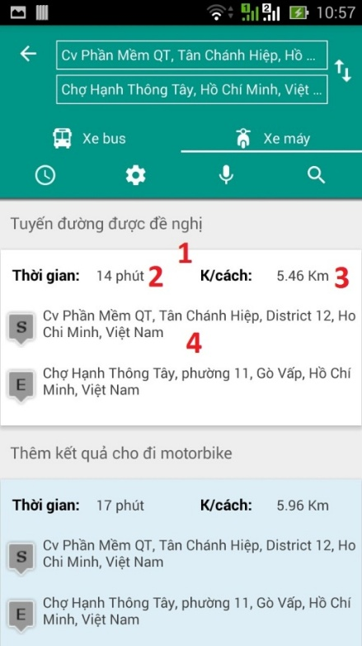

Figure : Interface - <Guest> Search Motorbike

**Fields**

|  |  |  |  |  |  |  |
| --- | --- | --- | --- | --- | --- | --- |
| No | Field Name | Description | Read only | Mandatory | Control Type | Data Type |
| 2 | txtTotalTime | Show total time of one route | Yes | Yes | Textview | String |
| 3 | txtTotalDistance | Show total distance of one route | Yes | Yes | Textview | String |
| 4 | txtDetailInformation | Show detail information of one route | Yes | Yes | Textview | String |

Table 117 Search Motorbike - Fields

**List View**

|  |  |  |  |  |
| --- | --- | --- | --- | --- |
| No | Function | Description | Validation | Outcome |
| 1 | lvRoute | List of routes which Guest finished search. | N/A | Show list route or error message |

Table 118 Search Motorbike – List View

#### Search with Voice

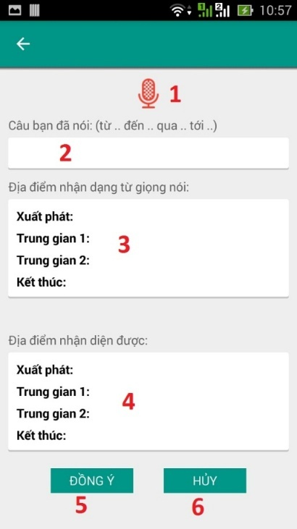

Figure : Interface - <Guest> Search with Voice

**Image Buttons**

|  |  |  |  |  |
| --- | --- | --- | --- | --- |
| No | Function | Description | Validation | Outcome |
| 1 | btnVoiceSearch | Search with Voice | N/A | Go to speed screen. |

Table 127 Search with Voice – Image Buttons

**Fields**

|  |  |  |  |  |  |  |
| --- | --- | --- | --- | --- | --- | --- |
| No | Field Name | Description | Read only | Mandatory | Control Type | Data Type |
| 1 | txtSentenceSaynpen print card screen supporto view detail information of that contractCard | Display sentence Guest say. | Yes | Yes | Textview | String |
| 2 | txtLocationIdentify | Display location identification from sentence Guest says. | Yes | Yes | Textview | String |
| 3 | txtResultSay | Display location result. | Yes | Yes | Textview | String |

Table 128 Search with Voice - Fields

**Buttons**

|  |  |  |  |  |
| --- | --- | --- | --- | --- |
| No | Function | Description | Validation | Outcome |
| 1 | btnOK | Accept change | N/A | Go to search screen. |
| 4 | btnCancel | Cancel change | N/A | Go to search screen. |

Table 129 Search with Voice - Buttons

### Wear application design:

#### Small notification

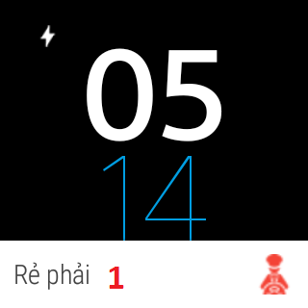

**Text**

|  |  |  |  |  |  |  |
| --- | --- | --- | --- | --- | --- | --- |
| No | Field Name | Description | Read only | Mandatory | Control Type | Data Type |
| 1 | txtNotifynpen print card screen supporto view detail information of that contractCard | Show small notification | Yes | No | Text view | String |

#### Long notification

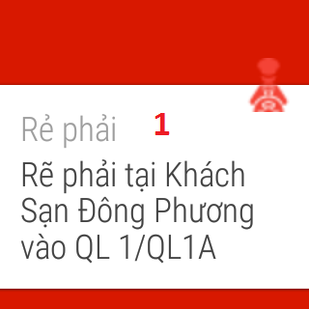

**Text**

|  |  |  |  |  |  |  |
| --- | --- | --- | --- | --- | --- | --- |
| No | Field Name | Description | Read only | Mandatory | Control Type | Data Type |
| 1 | txtNotifynpen print card screen supporto view detail information of that contractCard | Show long notification | Yes | No | Text view | String |

#### Navigate to user’s location

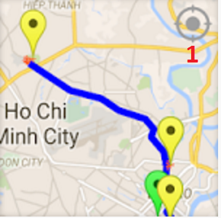

**Button**

|  |  |  |  |  |
| --- | --- | --- | --- | --- |
| No | Function | Description | Validation | Outcome |
| 6 | Navigate | Navigate to user’s location | N/A | Map move to user’s location |

## Database design

Our system has two sub systems. The first system is main database for storing bus information. This main database is the base database for algorithm consuming when searching bus route. The second system is the database allowing staff manage bus route and bus timetable when parsing route from third-party website

### Main Entity Relationship diagram

#### Main entity relationship diagram

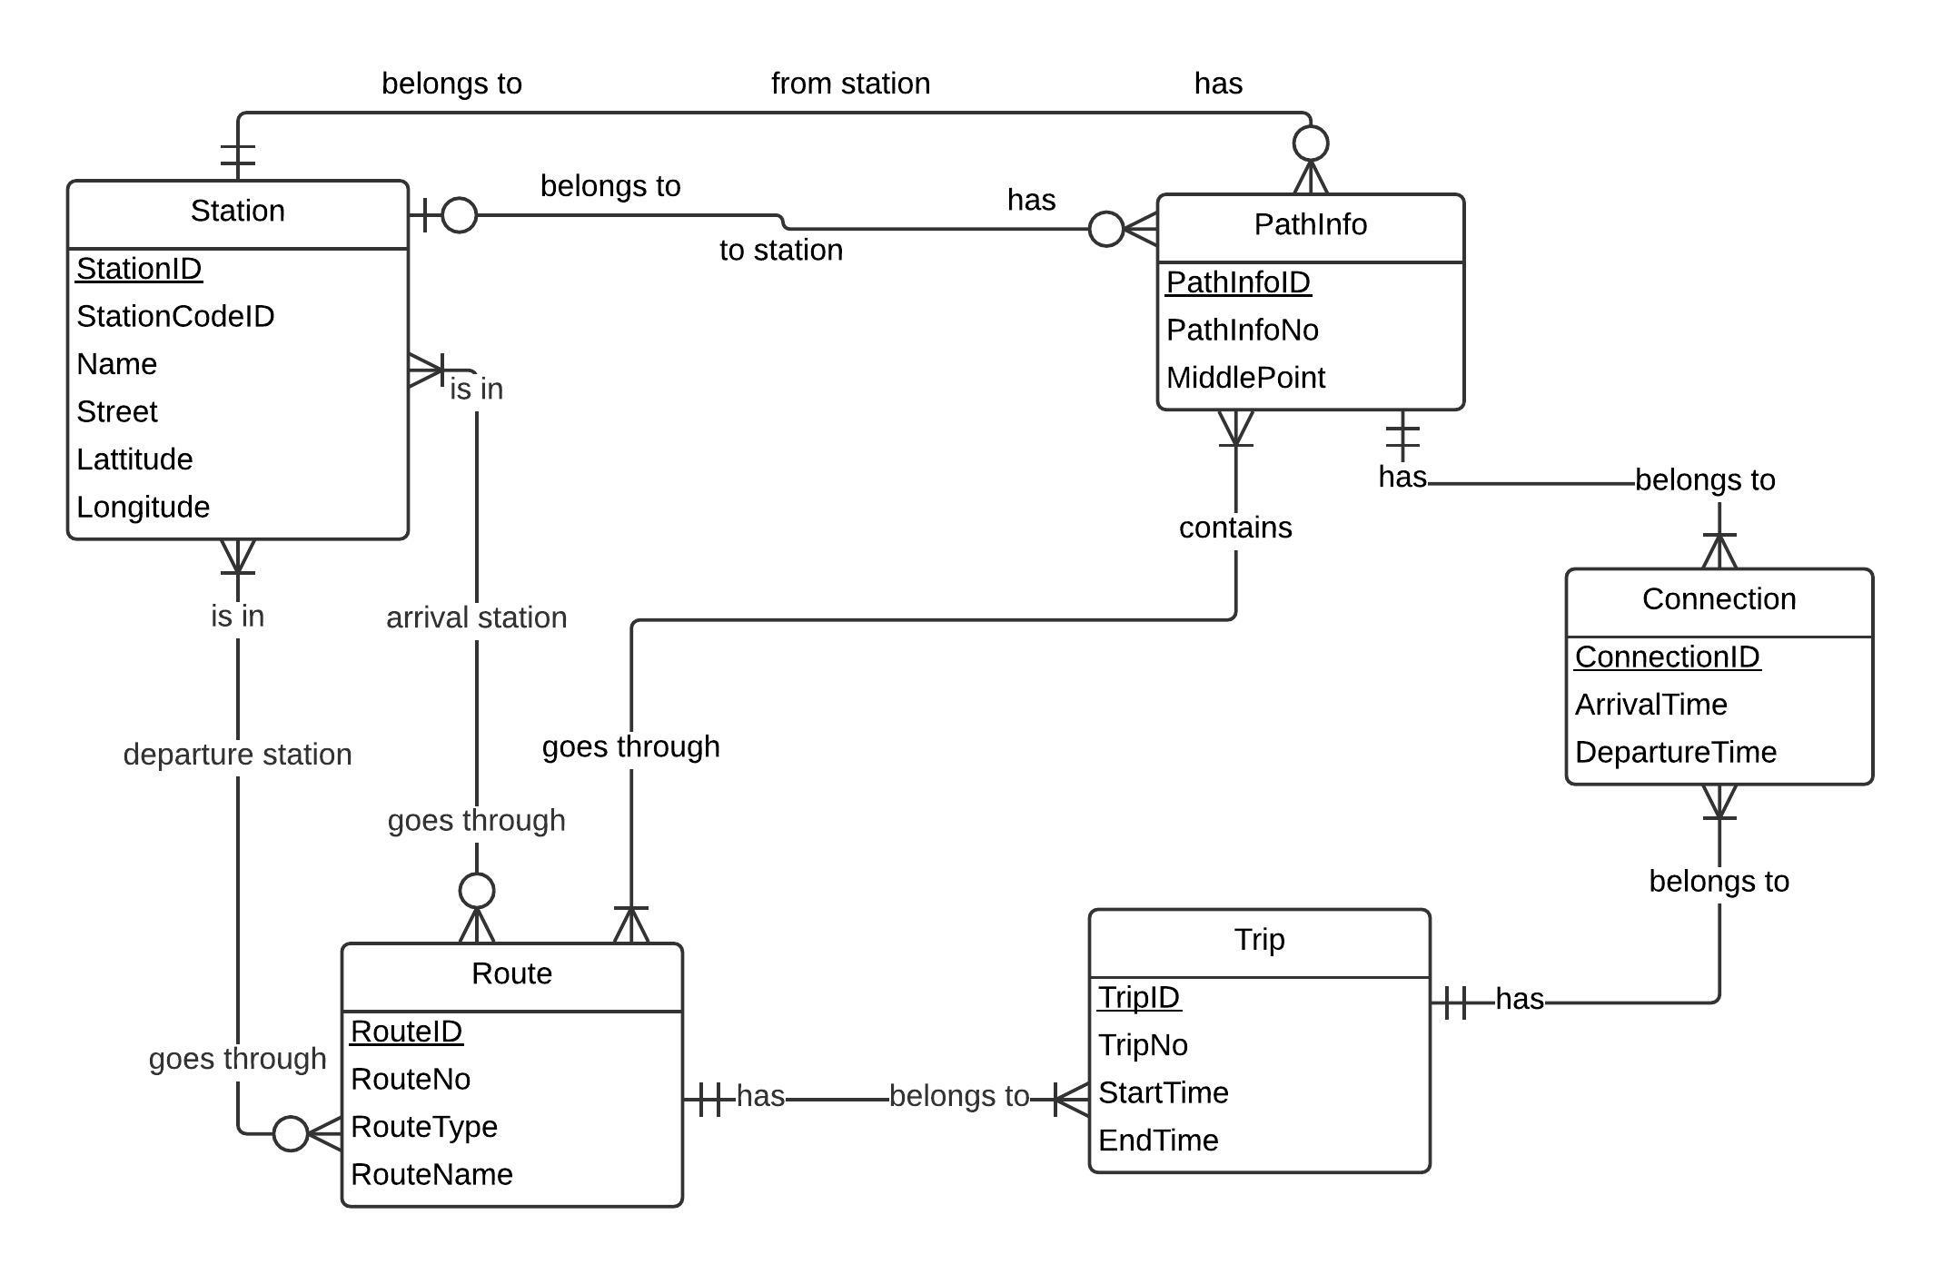

#### 6.1.2. Main entity dictionary

|  |  |
| --- | --- |
| Entity Data Dictionary: describe content of all entities | |
| Entity name | **Description** |
| Station | Abstract entity describes a station in system |
| Route | Abstract entity describes a route in system. |
| PathInfo | Contain the information between two stations in one route. |
| Trip | Abstract entity describes a trip in system. |
| Connection | Contains information about departure time and arrival time of one PathInfo. |

### Sub entity Relationship diagram

#### Sub entity relationship diagram

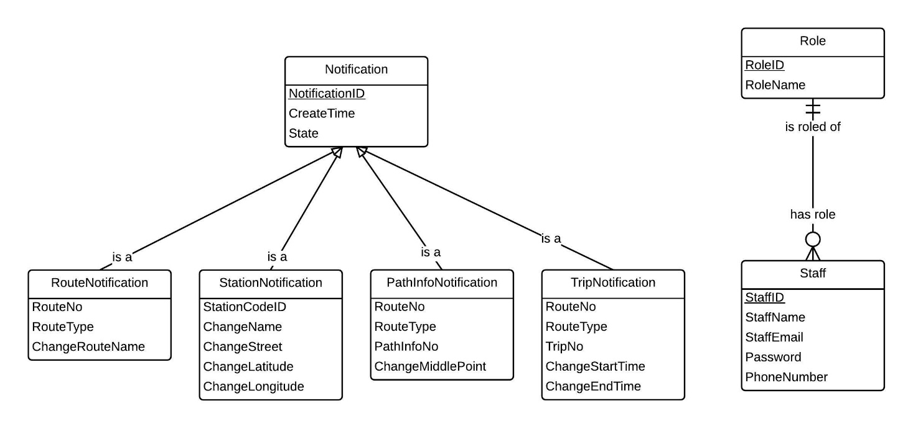

#### Sub entity dictionary

|  |  |
| --- | --- |
| Entity Data Dictionary: describe content of all entities | |
| Entity name | **Description** |
| Staff | Abstract entity describes a staff in system |
| Role | Abstract entity describes a role in system. |
| Notification | Abstract entity describes a notification in system |
| StationNotification | Abstract entity describes a station notification in system. |
| RouteNotification | Abstract entity describes a route notification in system. |
| TripNotification | Abstract entity describes a trip notification in system. |
| PathInforNotification | Abstract entity describes a pathinfo notification in system. |

Figure

## Algorithm

### Raptor algorithm

#### Problem definition:

We need to find the fasted path (the path with less time for traveling) from one station to one station go through some bus routes with some additional conditions: departure time, number of transfers.

#### Introduction:

This problem can be solved by using Raptor algorithm. Raptor algorithm is an algorithm based on paper named “Round-Based Public Transit Routing”. This paper is published by researchers Daniel Delling, Thomas Pajor and Renato F. Werneck on 2012.

Above problem can be known as computing all Pareto-optimal journeys in a dynamic public transit network for multiple criteria such as departure time and number of transfers.

Existing algorithms consider this as a graph problem, and solve it using variants of Dijkstra algorithm such as Layered Dijkstra (2004), multi-label-correcting algorithm (2008).

Starting from arrival time and number of transfers as criteria, this algorithm can be extended to handle more arbitrary additional criteria such as arrival time, ticket price, change time at each station or reliability of transfers.

#### Attribute Definition:

In below algorithm explanation, we use some notations:

* $K$ maximum bus transfers for this search. We can choose this dynamically when searching.
* $S$ is set of city’s stations.
* $R$ is set of city’s routes.
* $T$ is set of trips of all routes. And $T(r)$ is set of trips of route $r$. In our algorithm, we will sort those trips of each route based on departure time of each trip for searching optimization.
* $τ_{k}(p)$ earliest arrival time that we can come to this station using at most k transfers. Our algorithm will optimize those set of values. Note that two points:

1. This time is real time base on departure time (ie: 5:30 PM, 8:15 AM)
2. The total transfers can be any from $0$ to $k$. If value equals 0, it means we cannot reach this station on time by using any routes.

* $τ^{*}\left(p_{i}\right)$ earliest arrival time to this station. After $K$ loops finish, $τ^{*}\left(p_{i}\right)= τ_{|K| }(p)$
* $et\left(r,p_{i}\right)$ be the earliest trip in route r that one can catch at station $p_{i}.$
* $τ_{dep}(t, p_{i})$ be the departure time of trip t at $p_{i}$. Note that, currently, our bus system, arrival time and departure time of trip t at $p_{i}$ are equals. That means no wait time at each station of each trip.
* $τ_{arr}(t, p_{i})$ be the arrival time of trip t at $p_{i}$. Note that, currently, our bus system, arrival time and departure time of trip t at $p_{i}$ are equals. That means no wait time at each station of each trip.

We also have some variables which means:

* **Q**: a map. This map has key is a route and value is a station in this route which previous round has been optimized.
* **TraceUsedRoute[i][j] = R** means: Best way come to j-station using at most i transfers using route R.
* **TraceFromStation[i][j] = S** means: best way come to j-station using at most i transfers must go on at station S.
* **Result[i][j] = T** means: best way come to j-station using at most i transfers it T times.

#### Solution:

Method signature: **Raptor**(source s, target t, departure time r, maximum transfer K)

*Step 1: initialize all variables Q, TraceUsedRoute, TraceFromStation, Result*

*Step 2: optimize each stations for total K rounds. After K rounds, we can have best time go to each stations at maximum K transfers*.

**For all** k 🡨 1,2,3,…K **do**

*Step 3: find all previous round optimize stations. Find all routes go through this station.*

**For all** marked station p **do**

**For all** routes r go through station p **do**

**If** (r, p’) in Q for some p’ **then**

**If** r.order(p) < r.order(p’) **then**

Change (r, p’) -> (r,p) in Q

**Endif**

**Else**

Add (r, p’) 🡪 Q

**Endif**

**endfor**

**endfor**

*Step 4: travel again each route from marked station and optimize time at each station.*

**For all** pair (r,p) in Q **do**

Trip t = null

**Forall** stop $p_{i}$ beginning with p in route r **do**

**If** t != null **and $τ_{arr}\left(t, p_{i}\right)$** < $τ^{*}\left(p_{i}\right)$**then**

$τ_{k}\left(p_{i}\right)= τ_{arr}(t, p_{i})$

$τ^{*}\left(p_{i}\right)$ = $τ_{arr}(t, p_{i})$

Add $p_{i}$ to marked stations for next round

*Step 5: save to trace array for print result later, if necessary*

traceFromStation[k][ $p_{i}]$ = p

traceUsedRoute[k][ $p_{i}]$ = r

result[k][ $p_{i}]$ = t

**endif**

**if $τ_{k-1}\left(p_{i}\right)< τ_{dep}(t, p_{i})$**  **then**

$et\left(r,p_{i}\right)=t$

**endif**

**endfor**

*step 6. Check if no optimize stations anymore*

**if** no marked station in this turn **then**

**break;**

**endif**

**endfor**

#### Algorithm complexity

The worst-case running time of our algorithm can be bounded as follows:

In every round $k∈K$, algorithm scans each route $r∈R$ at most once. If $|r|$ is the number of stations of route $r$, then we look at $\sum_{r∈R}{|r| }$ stations in total to process the route. For each station $p_{i}$, we must find the earliest trip $et\left(r,p_{i}\right)$. If we keep the list of trips serving r sorted by time, while traversing r we can find all $et\left(r,p_{i}\right)$ values with a single sweep over this list, since $et\left(r,p_{i}\right)$ can only decrease. In total, RAPTOR takes $O(\sum_{r∈R}{\left|r\right|+\left|T\right|)}$ time for each round.

If we call sum of all stations and all trips (of all routes) in city equals to $N$. Total algorithm complexity is: $O(K*N$)

#### Flowchart

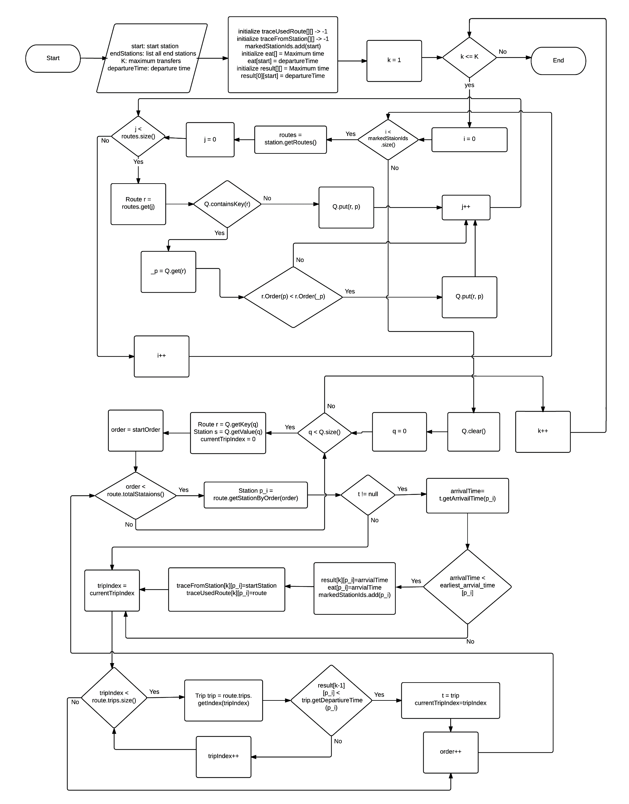

### Search bus two point:

#### Problem definition

* User request 2 points, start point and end point and their settings includes: walking distance, transfer turn. System get requested points and settings, then search for suitable routes, for user travel from start point to end point.

#### Attribute definition

* City Map: includes list of routes and list of stations:
* Each station in list of stations includes attributes: station’s name represent name of station, station’s code represent code of station, station’s street represent where the station locate, station’s latitude and longitude for coordinating station on the map.
  + Each route in list of routes includes attributes: route’s name, route’s no, list of paths, list of trips.
    - List of paths: each path in list of paths include attributes: path no for represent the ordered station of route, station in from and station …,
    - List of trips: each trip in list of trips represent start time and end time of route.
* List of stations round by start point: called LIST_START_STATIONS represent stations are found round by start point.
* List of stations round by end point: called LIST_END_STATIONS represent stations are found round by end point.
* Start path: represent the path includes calculated distance, time from one station in LIST_START_STATIONS to start point.
* End path: represent the path include calculated distance, time from one station in LIST_END_STATIONS to end point.
* List of results: called LIST_RESULTS represent the list result is returned from Raptor’s algorithm and each result in this list will show to user.

#### Solution

* Search route algorithm is based on Raptor’s algorithm.
* To solve problem, we follow these steps:
  + Step 1 - Calculate distance between two stations: if distance less than walking distance, system will show message for user can walking between two points.
  + Step 2 - Find stations nearby selected points: Iterate list of stations of city map, find station have a distance to selected point less than walking distance, then the suitable station will be added into list of stations round by selected point. Within two selected point, we have two output: LIST_START_STATIONS and LIST_END_STATIONS.
  + Step 3 – LIST_START_STATIONS, we build start path from one station in list to start point.
  + Step 4 – LIST_END_STATIONS, we build end path from one station in list to end point.
  + Step 5 – Calculating total distance and total time with entries are start path, start point, end point and end path by using Raptor’s algorithm (reference 7.1 Raptor algorithm). Each result is returned from Raptor’s algorithm will be added into list of results, we call it is LIST_RESULTS:
    - Total distance is total of three distance below:
      * Distance of start path.
      * Distance of end path.
      * Distance from one station in LIST_START_STATIONS to one station in LIST_END_STATIONS.
    - Total time is total of three time below:
      * Time of start path.
      * Time of end path.
      * Time from one station in LIST_START_STATIONS to one station in LIST_END_STATIONS.
  + Step 6 – If LIST_RESULTS is empty, we show message for notify user know no route found from start point to end point. If LIST_RESULT is not empty, we sort the list follow three priorities below:
    - The total transfer turn is high priority: we sort list base on increasing transfer turn.
    - The total time is medium priority: we sort list base on increasing time.
    - The total distance is low priority: we sort list base on increasing total distance.
  + Step 7 – With LIST_RESULTS sorted, we get the first three element for showing to user.

#### Algorithm complexity

In two point’s algorithm, each start point will call Raptor’s algorithm once. Two point’s algorithm get maximum 10 start point so Raptor’s algorithm is called maximum 10 times. So that, two points algorithm complexity is O(K*N): if we call sum of all stations and all trips (of all routes) in city equals to $N$

#### Flowchart

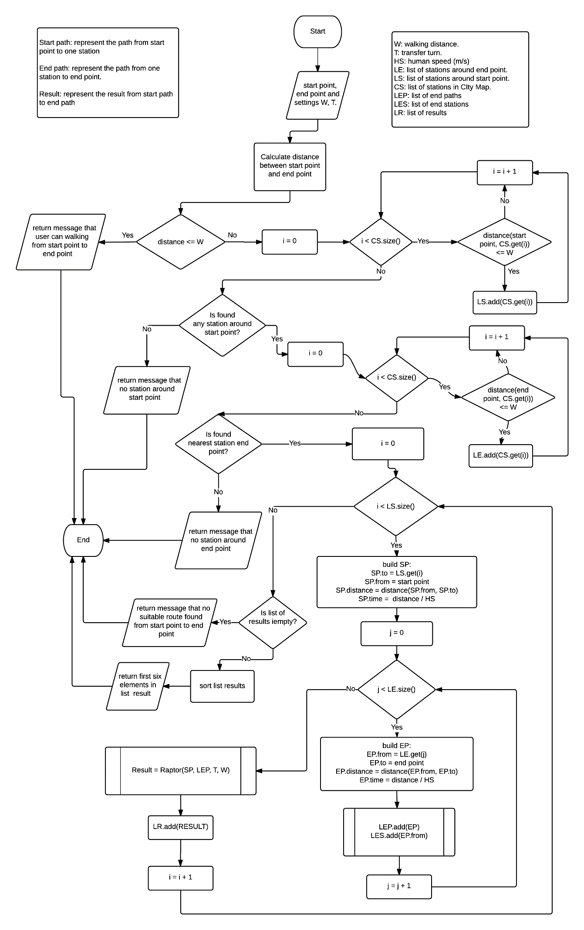

Figure 81: Search bus two point algorithm – flowchart

### Search bus more than two points

#### 7.3.1. Problem definition

**-** User request four points, start point, end point, two middle points and their settings includes: walking distance, transfer turn and not optimize option. System get requested points and settings, then search for suitable routes, for user travel from start point to end point though two middle points.

#### 7.3.2. Attribute definition

* COMBINATIONS: represent list of element which combination from two point adjacent.
* Journey: represent the journey from start point to end point though middle points, includes: total distance, time.

#### 7.3.3. Solution

* Multi points search route base on “Search bus two point algorithm”.
* To solve problem, we follow these steps:
  + Step 1: Swap two point of middle points, then we have two results represent list of point will be passed. Suppose four points are A, B, C, D so we have 2 results are ABCD, ACBD.
  + Step 2: With two result above. We exhaust two points of four points of each result, each point and the next point will be combined to an element. And each combined element will be added into list of element we call it is COMBINATIONS. Suppose four inputted points from user are A, B, C, D, so COMBINATIONS is AB, BC, and CD.
  + Step 3: We use “two points algorithm” to solve each element of COMBINATIONS. Each element is include LIST_RESULTS – the attribute from algorithm.
  + Step 4: Build list of journey, we call it is LIST_JOURNEYS. Each journey will be built from COMBINATIONS and includes:
    - Total time: total of time from each result of LIST_RESULT of each element in COMBINATIONS.
    - Total distance: total of distance from each result of LIST_RESULT each element of COMBINATIONS.
  + Step 5: Sort LIST_JOURNEYS follow two priorities:
    - Time is high priority. We sort the list base on increasing time.
    - Distance is low priority. We sort the list base on increasing distance.
  + Step 6: With LIST_JOURNEYS sorted, we get first six element for show to user.

#### 7.3.4. Algorithm complexity

Search bus more than two points will call “Two point’s algorithm” maximum 3 times. So that, search bus more than two points have algorithm complexity is O(K*N): if we call sum of all stations and all trips (of all routes) in city equals to $N$.

#### 7.3.5. Flowchart

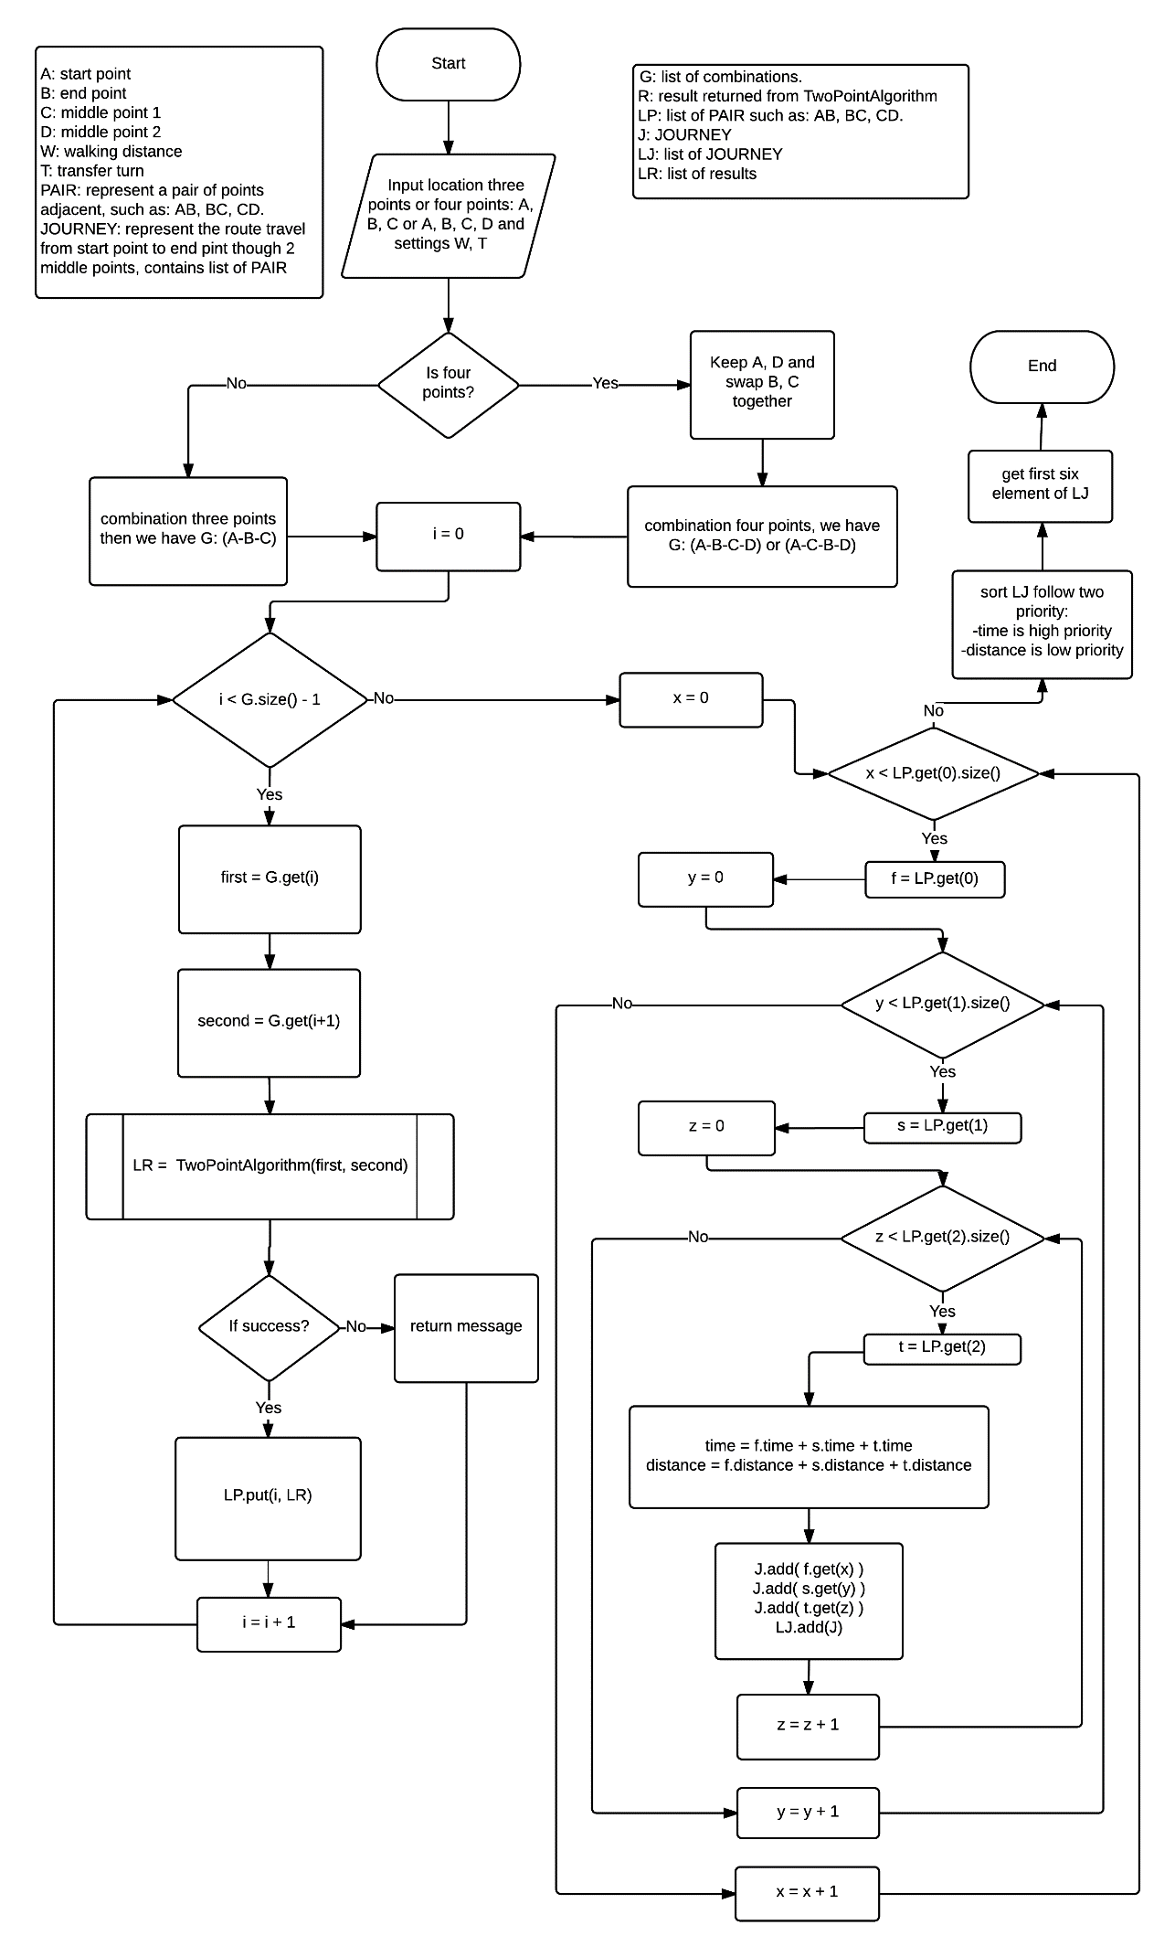

Figure 82: Search bus more than two points algorithm – flowchart

### Search bus more than two points with optimize

#### Problem definition

* User request four points, start point, end point, two middle points and their settings includes: walking distance, transfer turn and optimize option. System get requested points and settings, then search for suitable routes, for user travel from start point to end point though two middle points.

#### Introduction

#### Attribute definition

* LIST_JOURNEYS (reference attribute LIST_JOURNEYS in search bus more than two points)
* COMBINATIONS: represent the list of element which combination from four points.

#### Solution

* Multi points search optimize route base one “Multi points algorithm not optimize”.
* To solve the problem, we follow these steps:
  + Step 1: Within four points: start point, end point and two middle points. We keep the start point and swap the remaining three points for creating the combinations, well call it is COMBINATIONS which include list of elements combination from four points. Suppose four inputted point from user is A, B, C, D so we have the COMBINATIONS is ABCD, ACDB, and ABDC.
  + Step 2: We use “multi point algorithm not optimize” to solve for each element in COMBINATIONS.
  + Step 3: With all LIST_JOURNEYS are returned from “multi point algorithm not optimize” will retrieved first six element after the list is sorted follow two priorities below:
    - Time is high priority. We sort the list base on increasing time.
    - Distance is high priority. We sort the list base on increasing distance.

#### Algorithm complexity

Search bus more than two points with optimize will call “search bus more than two points” algorithm maximum 3 times. So that, the algorithm complexity is O(K*N): if we call sum of all stations and all trips (of all routes) in city equals to $N$.

#### Flowchart

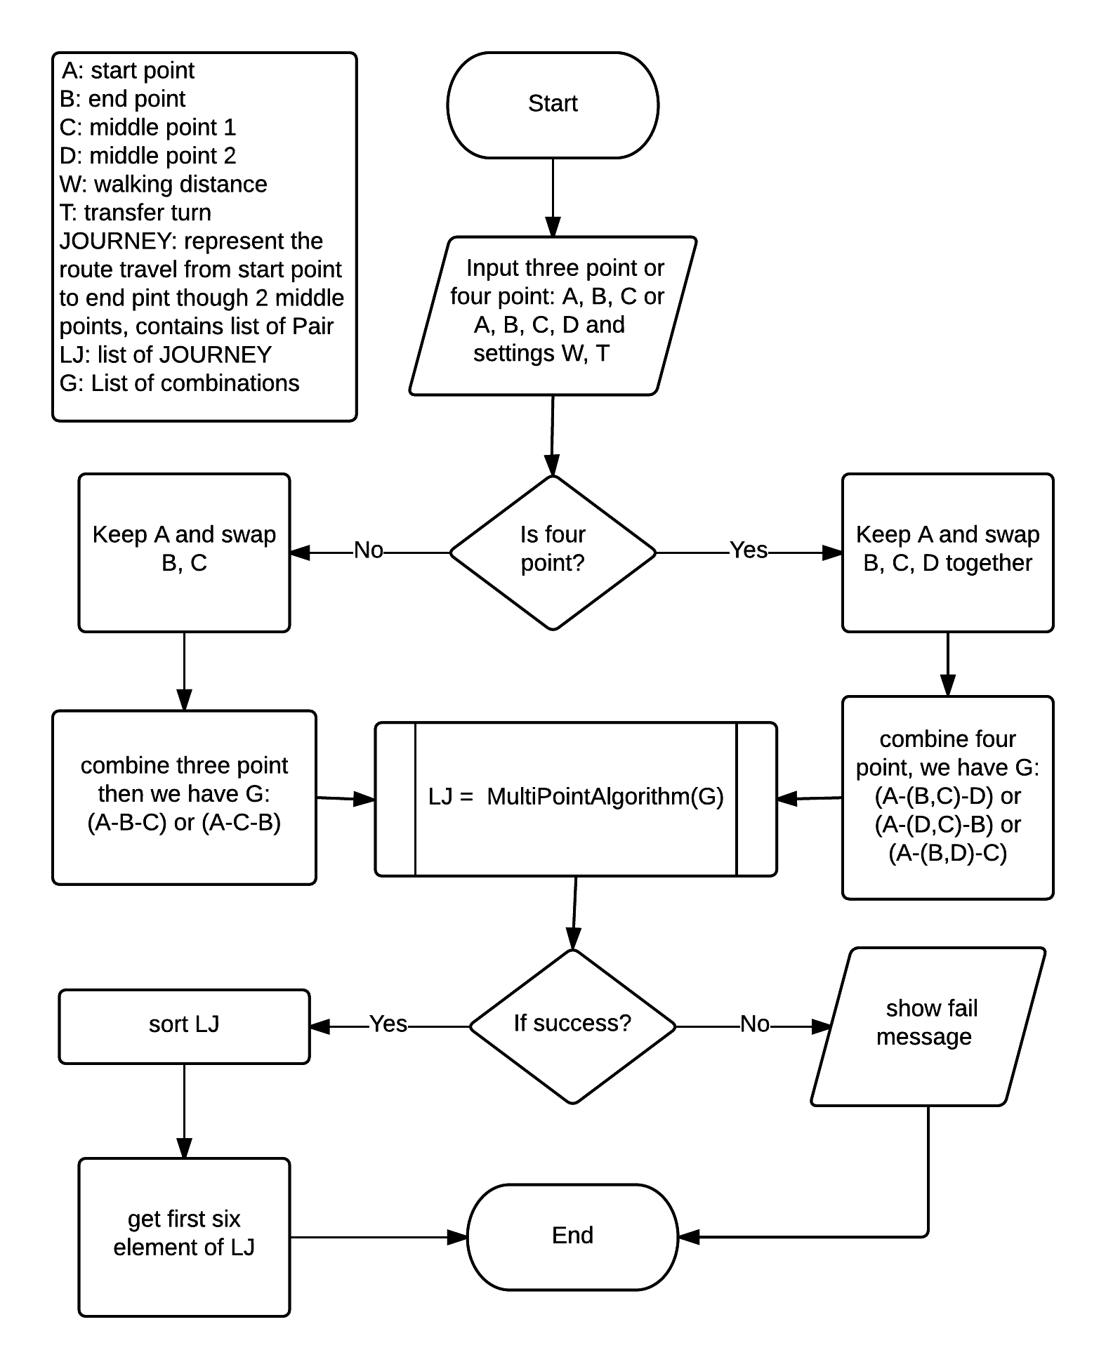

### Search motorbike more than two points

#### Problem definition

* User request search more than two points for motorbike no optimize including start point, end point, and two middle points and with some additional conditions: departure time, number of transfers. System gets requested points and settings, then send request to Google Map Direction API (The Google Maps Directions API is a service that calculates directions between locations using an HTTP request) to calculates directions between locations, for user travel from start point to end point though two middle points.

#### Attribute definition

* Reference: <https://developers.google.com/maps/documentation/directions/intro>
* COMBINATIONS: represent list of element which combination of points together.
* PAIRS: represent list of element which combination from two points adjacent.
* Routes: Each element of the routes array contains a single result from the specified origin and destination. Routes consist of nested [Legs](https://developers.google.com/maps/documentation/directions/intro#Legs) and [Steps](https://developers.google.com/maps/documentation/directions/intro#Steps).
* Each element in the legs array specifies a single leg of the journey from the origin to the destination in the calculated route.
* A step is the most atomic unit of a direction's route, containing a single step describing a specific, single instruction on the journey.
* geocoded_waypoints contain an array with details about the geocoding of origin, destination and waypoints.
* Status contains metadata on the request.

#### Solution

* Multi points search route base on “Search Two points with Google Map Direction API”.
* To solve problem, we follow these steps:
  + Step 1: Within four points: start point, end point and two middle points. We keep the start point and end location then swap the remaining two points for creating the combinations, well call it is COMBINATIONS which include list of elements combination from three or four points. Suppose we assign as follows: start location = A, end location = B, middle location 1 = C and middle location 2 = D.

With three inputted point from user is A, B, C so we have the COMBINATIONS is ABC.

With four inputted point from user is A, B, C, D so we have the COMBINATIONS is ABCD, ACBD.

* + Step 2: We exhaust two points from COMBINATIONS, each point and the next point will be combined to an element. And each combined element will be added into list, we call it is PAIRS.
    - With COMBINATIONS is ABC, we have list PAIRS is AB, BC.
    - With COMBINATIONS is ABCD, ACBD, we have list PAIRS is AB, BC, CD, AC, CB, BD.
  + Step 3: We use “search two point with Google Map Direction API” to solve each element of PAIRS. When the Google Maps Directions API returns results, it places them within a (JSON) routes array. Even if the service returns no results (such as if the origin and/or destination doesn't exist) it still returns an empty routes array.
  + Step 4: Parse JSON into Object, we have list Leg.
  + Step 5: We combination list Leg together to create list result present for search three or four points.
  + Step 6: The list result is sorted follow two priorities below:
    - Time is high priority. We sort the list base on increasing time.
    - Distance is high priority. We sort the list base on increasing distance.
  + Step 7: Get 3 results the best.

#### Algorithm complexity

* O(K): K is total number of requests had send to Google API.
* Three point: K = 2.
* Four point: K = 6.

#### Flowchart



### Search motorbike more than two points optimize

#### Problem definition

* User request search more than two points for motorbike optimize including start point, end point, two middle points and with some additional conditions: departure time, number of transfers and optimize option. System gets requested points and settings, then send request to Google Map Direction API (The Google Maps Directions API is a service that calculates directions between locations using an HTTP request) to calculates directions between locations, for user travel from start point to end point though two middle points.

#### Attribute definition

* Reference: <https://developers.google.com/maps/documentation/directions/intro>
* COMBINATIONS: represent list of element which combination of list points together.
* Routes: Each element of the routes array contains a single result from the specified origin and destination. Routes consist of nested [Legs](https://developers.google.com/maps/documentation/directions/intro#Legs) and [Steps](https://developers.google.com/maps/documentation/directions/intro#Steps).
* Each element in the legs array specifies a single leg of the journey from the origin to the destination in the calculated route.
* A step is the most atomic unit of a direction's route, containing a single step describing a specific, single instruction on the journey.
* geocoded_waypoints contains an array with details about the geocoding of origin, destination and waypoints.
* Status contains metadata on the request.

#### Solution

* Multi points search optimize route base one “Google Map Direction API”.
* To solve the problem, we follow these steps:
  + Step 1: Within four points: start point, end point and two middle points. We keep the start point and swap the remaining three points for creating the combinations, well call it is COMBINATIONS which include list of elements combination from three or four points. Suppose we assign as follows: start location = A, end location = B, middle location 1 = C and middle location 2 = D.

With three inputted point from user is A, B, C so we have the COMBINATIONS is ABC, ACB.

With four inputted point from user is A, B, C, D so we have the COMBINATIONS is ABCD, ABDC, ACDB, ACBD, ADCB, and ADBC. But we don’t care position of two middle locations so we may be reduced ABCD, ABDC, and ACDB.

* + Step 2: We use “Google API” to solve for each element in COMBINATIONS. When the Google Maps Directions API returns results, it places them within a (JSON) routes array. Even if the service returns no results (such as if the origin and/or destination doesn't exist) it still returns an empty routes array.
  + Step 3: Check status of result
    - If status = OK, get result from Google API
    - If status != OK, show message error.
  + Step 3: Parse result are returned from Google Map Direction API, we have list Leg.
  + Step 4: The list result is sorted follow two priorities below:
    - Time is high priority. We sort the list base on increasing time.
    - Distance is high priority. We sort the list base on increasing distance.

#### Algorithm complexity

* O(K): K is total number of requests had send to Google API.
* Three point: K = 2.
* Four point: K = 3.

#### Flowchart



### Distance from one point to segment algorithm

#### Problem definition

* How to calculate of user’s location to one segment on route?

#### Attribute definition

* Current location of user A: get location from Mobile’s GPS.
* Segment BC: that segment, which uses to calculate distance to current location. And it has start location B and end location C.
* Euclid distance of A to B is: $\sqrt{{{(x}_{A}-x_{B})}^{2}+ {{(y}_{A}-y_{B})}^{2}}$
* Perpendicular:

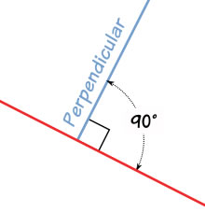

Figure 83: Perpendicular example

#### Solution

* Step 1: Get current location A and segment BC.
* Step 2: Map latitude and longitude of all location to x, y on 2D place (longitude -> x, latitude -> y) using Mercator projection.

Reference: <https://en.wikipedia.org/wiki/Mercator_projection>

* Step 3: Is ${(x}_{B}≤x_{A} ≤ x_{C})$ or ${(x}_{B}≥x_{A} ≥ x_{C})$ or ${(y}_{B}≤y_{A} ≤ y_{C})$ or ${(y}_{B}≥y_{A} ≥ y_{C})$?
  + Yes: Calculate perpendicular distance from A to segment BC.
  + No: Get min Euclid distance of AB and AC.
* Step 4: Return distance.

#### Algorithm complexity

* O(1).

#### Flow chart

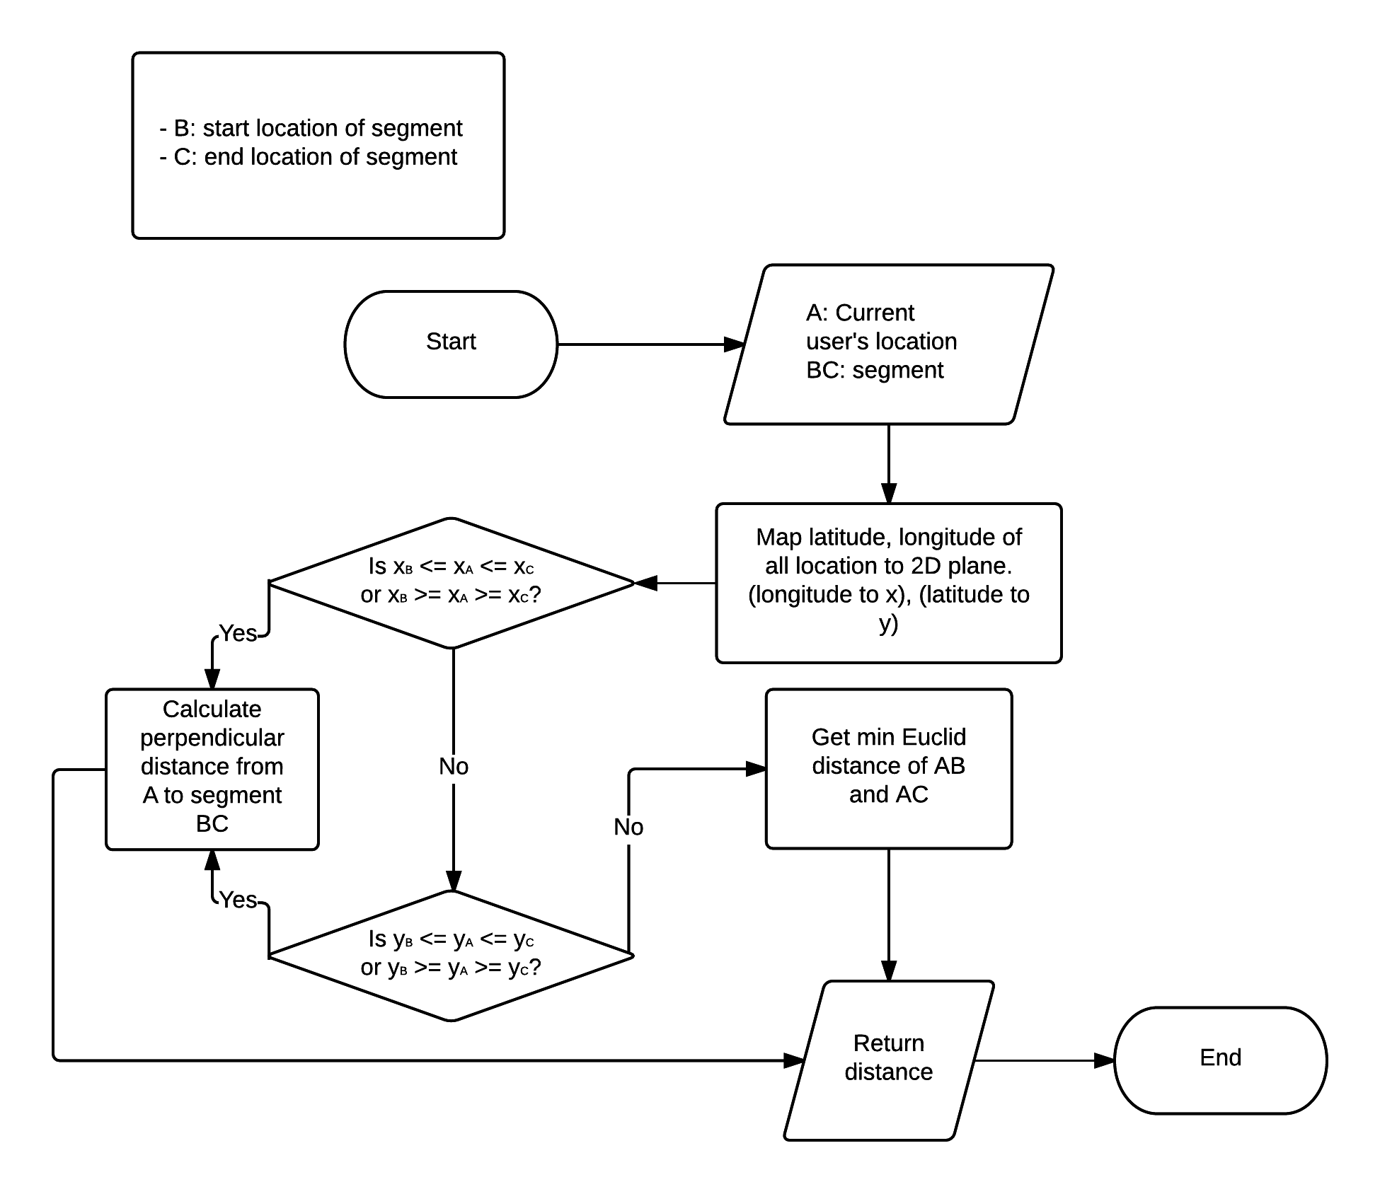

### Notify algorithm when on right route.

#### Problem definition

* Algorithm detects when users are on right route and sends notified signal for user preparing next turn.

#### Attribute definition

* IsTrueWay: variable for checking user currently is on true way or not.
* Current location of user A: get location from Mobile’s GPS.
* Current road: this road use to check current location.
* Allowed range: If distance from location of users to road is in this range, they will be on right route.
* Notified range: If distance from location of users to notified location is in this range, they will be notified.
* Euclid distance of A to B is: $\sqrt{{{(x}_{A}-x_{B})}^{2}+ {{(y}_{A}-y_{B})}^{2}}$

#### Solution

* Step 1:
  + Get user’s location (A) from Mobile’s GPS.
  + Get current road.
  + Get allowed range.
  + Get notified range.
  + Get isTrueWay.
* Step 2: Check isTrueWay
  + True: go to next step.
  + False: Return isTrueWay and current road = null. End
* Step 3: Calculate all distances from user’s location to all segments of current road.
* Step 4: User will be in range if have one distance shorter than or equal allowed range. And opposite is out of range.
  + In range:
    - Map latitude and longitude of all location to x, y on 2D place (longitude -> x, latitude -> y) using Mercator projection.

Reference:

<https://en.wikipedia.org/wiki/Mercator_projection>

* + - Calculate Euclid distance from user’s location to notified location. Is distance shorter than or equal notified range.
      * Yes: system will notify to user. And he/she will know what should do next. Return isTrueWay and current road = next road. End
      * No: Return isTrueWay and current road. End
  + Out of range:
    - Notify to user that he/she is on wrong way.
    - Return isTrueWay = false and current road = null. End

#### Algorithm complexity

* O(N): N is total segments on road.

#### Flow chart

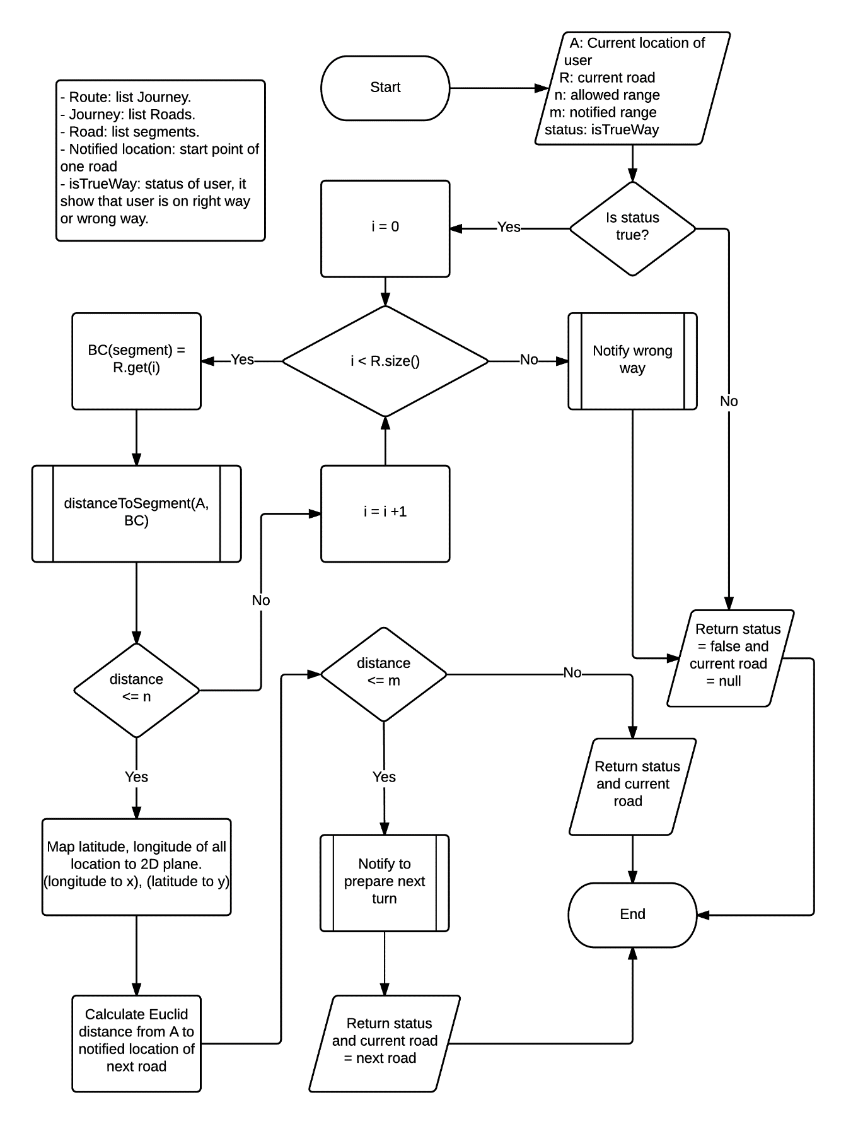

### Notify algorithm when on wrong route

#### Problem definition

* When user is far from searched route, system will change algorithm to wrong way state. In this state, algorithm will continue to detect wrong way and notify for user.

#### Attribute definition

* IsTrueWay: variable for checking user currently is on true way or not.
* Current location of user A: get location from Mobile’s GPS.
* ListAllSegments: list of all segments have in whole route.
* Allowed range: If distance from location of users to road is in this range, they will be on right route.
* Notified range: If distance from location of users to notified location is in this range, they will be notified.
* Euclid distance of A to B is: $\sqrt{{{(x}_{A}-x_{B})}^{2}+ {{(y}_{A}-y_{B})}^{2}}$

#### Solution

* Step 1:
  + Get user’s location (A) from Mobile’s GPS.
  + Get listAllSegment.
  + Get allowed range.
  + Get notified range.
  + Get isTrueWay.
* Step 2: Check isTrueWay
  + True: go to step 3.
  + False: Return isTrueWay and current road = null. End
* Step 3: Calculate all distances from user’s location to all segments of listAllSegment. Go to step 4.
* Step 4: User will be in range if have one distance shorter than or equal allowed range. And opposite is out of range.
  + In range: Call segment, which has shortest distance to user’s location is segment (BC). Change variable of isTrueWay to true. Go to step 5.
  + Out of range: Return isTrueWay and current road = null. End.
* Step 5: Map latitude and longitude of all location to x, y on 2D place (longitude -> x, latitude -> y) using Mercator projection. Go to step 6.

Reference: <https://en.wikipedia.org/wiki/Mercator_projection>

* Step 6: Calculate Euclid distance from user’s location to notified location.
  + If distance is shorter than equal notified range:
    - System will notify to user. And he/she will know what should do next.
    - Return isTrueWay and current road. End
  + If distance is longer than notified range: Go to step 7.
* Step 7: Map latitude and longitude of A, B and C to x, y on 2D place (longitude -> x, latitude -> y) using Mercator projection. Go to step 8.
* Step 8: Check position of A to vector $\vec{BC}$ is left or right.
  + Right: Notify to user that they should navigate to right direction. Go to step 9.
  + Left: Notify to user that they should navigate to left direction. Go to step 9.
* Step 9: Return isTrueWay and current road. End

#### Algorithm complexity

* O(N): N is total segments on whole route.

#### Flowchart

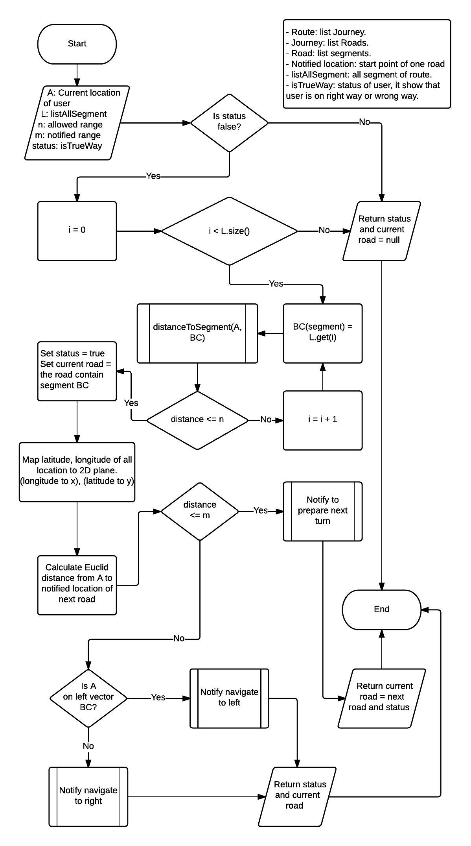

### Download audio file algorithm

#### Problem definition

* When participating traffic, user needs to notify with voice. So, we have to convert message to audio file and save audio file to disk cache of mobile.

#### Attribute definition

* FPT Service: convert from message string to audio file in the form (array byte).
* DiskLruCache: It is library save image into cache provided by Jake Wharton, please reference to link <https://github.com/JakeWharton/DiskLruCache> to view detail. With mechanism a cache that uses a bounded amount of space on a file system. Each cache entry has a string key and a fixed number of values. Each key must match the regex [a-z0-9_-] {1, 64}. Values are byte sequences, accessible as streams or files. Each value must be between 0 and Integer. MAX_VALUE bytes in length.

#### Solution

* FPT Service return byte [] data, while DiskLruCache save image in the format is bitmap. So, we need edit DiskLruCache library to save in the format is byte [].
* To solve the problem downloading audio file, we follow these steps:
* Step 1: We have list string notify from search route.
* Step2: Call FPT Service with Url [http://118.69.135.22/synthesis/file?voiceType=female&text= + message](http://118.69.135.22/synthesis/file?voiceType=female&text=%20+%20message) to download audio file and save into disk cache of mobile.
* If download fail, system show message notify “FPT Service is not available, please try again later.”
* If download success, system will check space disk.
* Step 3: Check space disk.
  + If space disk is greater than 100 mb then check audio file least recent use delete it and save new audio file into cache disk.
  + If space disk is not greater than 100 mb then save new audio file into cache disk.
* Step 4: Show message download success when process is finish.

#### Algorithm complexity

* O(N): N is total audio files need to download.

#### Flow chart



# **System Implementation & Test**

## 1. Introduction

### Overview

This section describes the approach and methodologies used by group to plan, organize and manage the testing of SWR system. It provides in the detail all necessary information about the implementation and testing procedure of the system included test plans, test cases, test result, test environments, pass/fail criteria and risks estimations as well as a checklist to cover all possible cases.

### Test Approach

* Goal: Test all features in the whole SWR system based on the core flow.
* Method: black-box testing
* Technique: check list

The testing for this project will consists of Integration System test level. Testing the program which was integrated and as a complete system to ensure that the software requirements have been met.

* Integration testing would be performed by all member of team and approved by team leader.
* System testing is focused on assessing the system’s reliability. This process is concerned with finding errors that result from unanticipated interactions between components and component interface problems.

## Database Relationship Diagram

### Physical Diagram

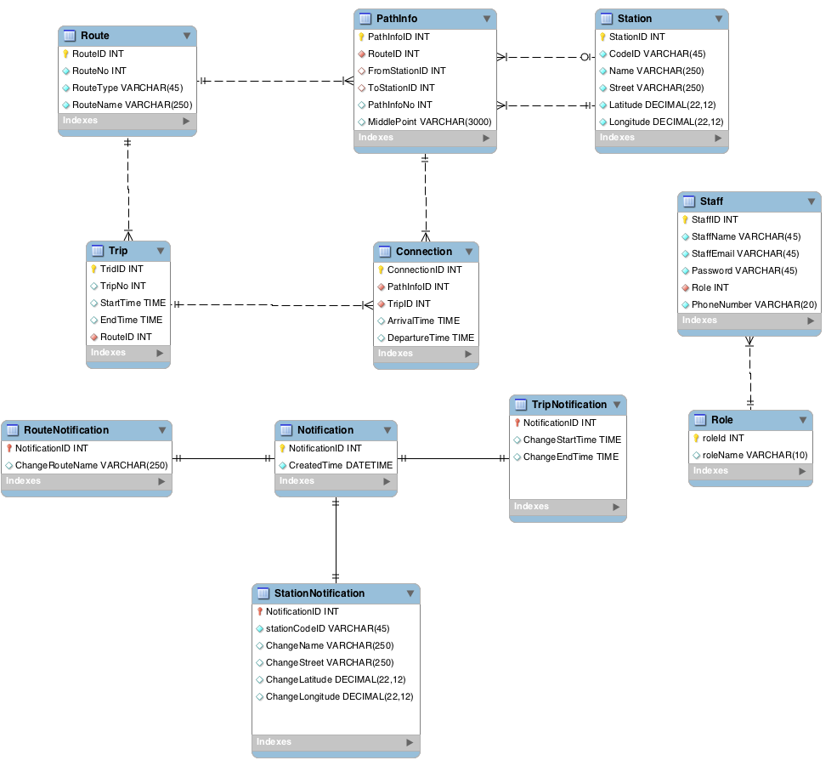

Figure 84 Physical diagram

### Data Dictionary

|  |  |  |
| --- | --- | --- |
| Data dictionary: describe content of all tables | | |
| s | **Mapping with Conceptual diagram** | **Description** |
| Station | Station | Describe all stations in the system. |
| Route | Route | Describe all bus routes in the system. |
| PathInfo | PathInfo | Describe all paths belongs to route and station in the system. |
| Trip | Trip | Describe all trips in the system. |
| Connection | Connection | Describe all connections belong trip in the system. |
| Staff | Staff | Describe all staffs in the system. |
| Role | Role | Describe all roles in the system. |
| Notification | Notification | Describe all notifications in the system. |
| StationNotification | StationNotification | Describe all station notifications in the system. |
| RouteNotification | RouteNotification | Describe all route notifications in the system. |
| PathInfoNotification | PathInfoNotification | Describe all pathinfo notifications in the system |
| TripNotification | TripNotification | Describe all trip notifications in the system. |

Table 135 Data table dictionary

|  |  |  |  |  |
| --- | --- | --- | --- | --- |
| Table Name | Attributes | Description | Domain | Null |
| Station | StationID {PK} | Unique identifier of each bus station. | int | No |
| CodeID | Unique code id of each bus station, getting from server. | varchar(45) | No |
| Name | Name of station. | varchar(250) | No |
| Street | Street of station. | varchar(250) | No |
| Latitude | Latitude of station. | Decimal(22,12) | No |
| Longitude | Longitude of station. | Decimal(22,12) | No |
| Route | RouteID {PK} | Unique identifier of each bus route, auto increment. | int | No |
| RouteNo | Bus Route number. | Int(10) | No |
| RouteType | Can be two values: DEPART or RETURN. | varchar(10) | No |
| RouteName | Bus route name. | varchar(250) | No |
| PathInfo | PathInfoID {PK} | Unique identifier of each PathInfo, auto increment. | int | No |
| RouteID | Route id | int | No |
| FromStationID | From station id | int | No |
| ToStationID | To station id | int | Yes |
| PathInfoNo | Order of PathInfo in route | int | No |
| MiddlePoint | All middle points of this PathInfo, for rendering for client. | varchar(3000) | No |
| Trip | TripID {PK} | Unique identifier each trip, auto increment. | int | No |
| TripNo | Order of this trip in trip’s route. | int | No |
| StartTime | Departure time from first station of this trip | time | No |
| EndTime | Arrival time to last station of this trip. | time | No |
| RouteID | Route id. | int | No |
| Connection | ConnectionID {PK} | Unique identifier of each connection, auto increment. | int | No |
| PathInfoID | PathInfo ID | int | No |
| TripID | Trip ID | int | No |
| ArrivalTime | Arrival time of from station. | time | No |
| DepartureTime | Departure time to station. | time | No |
| Staff | StaffID {PK} | Unique identifier of each staff, auto increment. | int | No |
| StaffName | Staff name | varchar(45) | No |
| StaffEmail | Staff email | varchar(45) | No |
| Password | Staff’s password | varchar(32) | No |
| RoleID | Role id | int | No |
| PhoneNumber | Staff phone number | varchar(20) | No |
| Role | RoleID{PK} | Unique identifier of each role, auto increment. | int | No |
| RoleName | Role name. | varchar(20) | No |
| Notification | NotificationID {PK} | Unique identifier of each notification, auto increment. | int | No |
| CreatedTime | Created time of this notification. | datetime | No |
| Type | Type of this notification. | int | No |
| StationNotification | NotificationID {PK} | Unique identifier of each station notification. | int | No |
| StationCodeID | Station code id of that this notification reference to. | varchar(45) | No |
| ChangeName | New station name | varchar(250) | No |
| ChangeStreet | New station street name | varchar(250) | No |
| ChangeLatitude | New latitude | decimal(22,12) | No |
| ChangeLongitude | New longitude | decimal(22,12) | No |
| RouteNotification | NotificationID {PK} | Unique identifier of each route notification. | int | No |
| RouteNo | Bus route number. | int | No |
| RouteType | Bus route type. Can be two values: DEPART or RETURN | varchar(10) | No |
| ChangeRouteName | New route name | varchar(250) | Yes |
| TripNotification | NotificationID{PK} | Unique identifier of each trip notification | int | No |
| RouteNo | Bus route number | int | No |
| RouteType | Bus route type. Can be two values: DEPART or RETURN | varchar(10) | No |
| TripNo | Trip order in trip’s route. | int | No |
| ChangeStartTime | New start time | time | Yes |
| ChangeEndTime | New end time | time | Yes |
| PathInfoNotification | NotificationID{PK} | Unique identifier of each pathinfo notification | int | No |
| RouteNo | Bus route number | int | No |
| RouteType | Bus route type. Can be two values: DEPART or RETURN | varchar(10) | No |
| PathInfoNo | Order of pathinfo in one route. | int | No |
| ChangeMiddlePoint | New middlepoint list | Varchar(3000) | Yes |

## Performance Measures

### Web application page load speed

#### 3.1.1. Definition

This section tests the general page load speed from all the page of the web application.

#### 3.1.2. Test environment

Server:

* **Operating system:** Window 7 64 bit
* **RAM:** 4GB
* Storage: 40 GB
* **Processor:** 2.6 GHz Intel Core i5
* Network: 1 Mbps

#### 3.1.3. Test cases

Using browser of client side and go to each page of the web application Record the page load time using Chrome Dev Tools at client side.

Test pages:

|  |  |
| --- | --- |
| Public | Route list |
| Login |
| Logout |
| Route Detail |
| Staff | Add route |
| Configure parsing source |
| Configure parsing web |
| Bus route information change |
| Bus station information change |
| Bus timetable information change |
| Admin | Add staff |
| Delete staff |
| Edit staff |

#### 3.4. Test result

The test is run 10 times, each time we go through all the pages listed above and log down the average page load time.

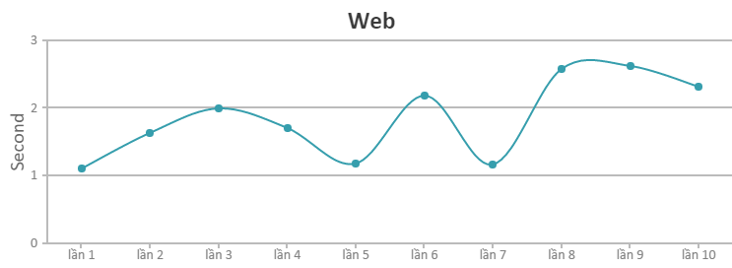

Figure 85 Web application page load speed test result

|  |  |  |
| --- | --- | --- |
| Test No. | Average page load time (second) | Execute date |
| 1 | 1.10 | 6 December 2015 |
| 2 | 1.63 | 6 December 2015 |
| 3 | 2.0 | 6 December 2015 |
| 4 | 1.7 | 6 December 2015 |
| 5 | 1.18 | 6 December 2015 |
| 6 | 2.19 | 6 December 2015 |
| 7 | 1.17 | 6 December 2015 |
| 8 | 2.58 | 6 December 2015 |
| 9 | 2.62 | 6 December 2015 |
| 10 | 2.31 | 6 December 2015 |
|  | Average: 1.84 (seconds) |  |

Table 137 Web application page load speed test result

### 3.2. Mobile application API load speed

#### 3.2.1. Definition

This section tests the load speed of mobile apps when connection to server through API.

#### 3.2.2. Test environment

Server:

* **Operating system:** Window 7 64 bit
* **RAM:** 4 GB
* Storage: 40 GB
* **Processor:** 2.6 GHz Intel Core i5
* Network: 1 Mbps

Client:

|  |  |  |
| --- | --- | --- |
| Hardware Requirements | Minimum | Recommended |
| Internet Connection | Wi-Fi Connection 512Kbps  Bluetooth Connection 4.0 | Wi-Fi Connection 8Mbps  Bluetooth Connection 4.0 |
| Operating System | Android 4.3 | Android 5.0 |
| Hardware | GPS supported | GPS supported |
| Memory | 1 GB RAM | 2 GB or more |

Table 138 Mobile app API load speed client specification

#### 3.2.3. Test cases

Using mobile application to send the entire API request to web server.

List of APIs:

|  |  |  |
| --- | --- | --- |
| No. | API | Description |
| 1 | /api/twopoint | Search bus route with two points |
| 2 | /search/multi | Search bus route with multi points. |

Table 139 Mobile app API load speed test cases

#### 3.2.4. Test result

The test is run 10 times, each time we run all the test cases listed above and log down the average API response time.

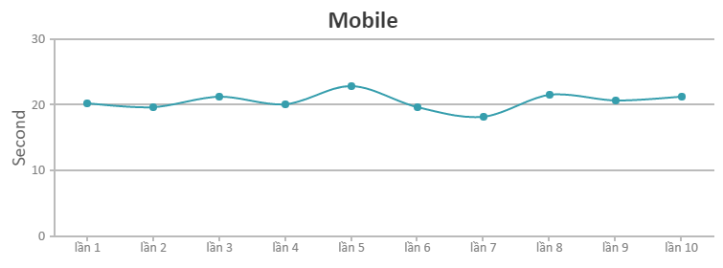

Figure 86 Mobile application API load speed test result

|  |  |  |
| --- | --- | --- |
| Test No. | Average page load time (second) | Execute date |
| 1 | 20.21 | 6 December 2015 |
| 2 | 19.67 | 6 December 2015 |
| 3 | 21.27 | 6 December 2015 |
| 4 | 20.05 | 6 December 2015 |
| 5 | 22.87 | 6 December 2015 |
| 6 | 19.73 | 6 December 2015 |
| 7 | 18.17 | 6 December 2015 |
| 8 | 21.58 | 6 December 2015 |
| 9 | 20.62 | 6 December 2015 |
| 10 | 21.31 | 6 December 2015 |
|  | Average: 20.54 (seconds) |  |

Table 140 Mobile application API load speed test result

## 4. Test Plan

The overall purpose of testing is to ensure SWR system meets its entire technical, functional and business requirement. The purpose of this document is to describe the overall test plan and strategy for testing the SWR system. The approach described in this document provides the framework for all testing related to this application. Individual test cases will be written for each version of the application that is released. This document will also be updated as required for each release.

### Features to be tested

* Staff
* Admin
* System: notify schedule
* Mobile application
* Wear application

### Features not to be tested

* Admin: add staff, remove staff
* View information.

## System Testing Test Case

### Communication Diagrams

Test cases are created from bellow communication diagram:

### Test case

#### <Guest> Search bus

Table 141: Guest – Search Bus Two Points

##### <Guest> Search bus three points no optimize.

|  |  |  |  |  |  |  |
| --- | --- | --- | --- | --- | --- | --- |
| ID | Test Case Description | Test case procedure | Expected output | Inter-test case dependence | Result | Test Date |
| SBTPNO01 | Search bus three points no optimize with location is valid. | 1. Go to search screen.  2. Enter start location at “Bến xe an Sương, Bà Điểm, Tp.HCM”.  3. Enter end location at “Ngã tư Bình Thái, xa lộ Hà Nội, Tp.HCM”.  4. Enter middle location 1 at “Chợ Hạnh Thông Tây, Tp.HCM”.  5. Unchecked checkbox “tối ưu”.  6. Click “Search” button. | Show list result of route go though:  Start location -> middle location -> end location. |  | pass | From: 10/10/2015 To: 25/11/2015  (about 150 times) |
| SBTPNO02 | Search bus three points no optimize with start location is empty. | 1. Go to search screen.  2. Enter start location is empty.  3. Enter end location at “Ngã tư Bình Thái, xa lộ Hà Nội, Tp.HCM”.  4. Enter middle location 1 at “Chợ Hạnh Thông Tây, Tp.HCM”.  5. Unchecked checkbox “tối ưu”.  6. Click “Search” button. | System shows message “Phải nhập điểm khởi hành”. |  | pass | From: 10/10/2015 To: 25/11/2015  (about 20 times) |
| SBTPNO03 | Search bus three points no optimize with end location is empty. | 1. Go to search screen.  2. Enter start location at “Bến xe an Sương, Bà Điểm, Tp.HCM”.  3. Enter end location is empty.  4. Enter middle location 1 at “Chợ Hạnh Thông Tây, Tp.HCM”.  5. Unchecked checkbox “tối ưu”.  6. Click “Search” button. | System shows message “Phải nhập điểm đến”. |  | pass | From: 10/10/2015 To: 25/11/2015  (about 20 times) |
| SBTPNO04 | Search bus three points no optimize with start location is invalid (not found location). | 1. Go to search screen.  2. Enter start location at “djdjdjdj848484”.  3. Enter end location at “Ngã tư Bình Thái, xa lộ Hà Nội, Tp.HCM”.  4. Enter middle location 1 at “Bến xe an Sương, Bà Điểm, Tp.HCM”.  5. Unchecked checkbox “tối ưu”.  6. Click “Search” button. | System shows message “Địa điểm bạn tìm kiếm không được tìm thấy, vui long nhập lại”. |  | pass | From: 10/10/2015 To: 25/11/2015  (about 100 times) |
| SBTPNO05 | Search bus three points no optimize with end location is invalid (not found location). | 1. Go to search screen.  2. Enter start location at “Ngã tư Bình Thái, xa lộ Hà Nội, Tp.HCM”.  3. Enter end location at “djdjdjdj848484”.  4. Enter middle location 1 at “Bến xe an Sương, Bà Điểm, Tp.HCM”.  5. Unchecked checkbox “tối ưu”.  6. Click “Search” button. | System shows message “Địa điểm bạn tìm kiếm không được tìm thấy, vui long nhập lại”. |  | pass | From: 10/10/2015 To: 25/11/2015  (about 100 times) |
| SBTPNO06 | Search bus three points no optimize with start location is invalid (location is so far). | 1. Go to search screen.  2. Enter start location at “KTX Khu A DHQG-HCM, tx. Dĩ an, Bình Dương”.  3. Enter end location at “Ngã tư Bình Thái, xa lộ Hà Nội, Tp.HCM”.  4. Enter middle location 1 at “Chợ Hạnh Thông Tây, Tp.HCM”.  5. Unchecked checkbox “tối ưu”.  6. Click “Search” button. | System shows message “Không có trạm xe bus nào gần KTX Khu A DHQG-HCM, tx. Dĩ an, Bình Dương”. |  | pass | From: 10/10/2015 To: 25/11/2015  (about 100 times) |
| SBTPNO07 | Search bus three points no optimize with end location is invalid (location is so far). | 1. Go to search screen.  2. Enter start location at “Ngã tư Bình Thái, xa lộ Hà Nội, Tp.HCM”.  3. Enter end location at “KTX Khu A DHQG-HCM, tx. Dĩ an, Bình Dương”.  4. Enter middle location 1 at “Chợ Hạnh Thông Tây, Tp.HCM”.  5. Unchecked checkbox “tối ưu”.  6. Click “Search” button. | System shows message “Không có trạm xe bus nào gần KTX Khu A DHQG-HCM, tx. Dĩ an, Bình Dương”. |  | pass | From: 10/10/2015 To: 25/11/2015  (about 100 times) |
| SBTPNO08 | Search bus three points no optimize with distance walking is 600 m | 1. Go to search screen.  2. Enter needed information.  3. Distance walking is 600 m.  4. Unchecked checkbox “Tối ưu”  5. Click “Search” button. | Show list result satify 3 condition:  - Start time of bus is greater than or equal current time.  - Have max transfer equals default transfer.  - Have max distance walking equals 600 m.  -If list don’t have result show message: “Không tìm thấy kết quả”. |  | pass | From: 10/10/2015 To: 25/11/2015  (about 100 times) |
| SBTPNO09 | Search bus three points no optimize with departure time is 13:00 PM | 1. Go to search screen.  2. Enter needed information.  3. Departure time is 13:00 PM.  4. Unchecked checkbox “tối ưu”  5. Click “Search” button. | Show list result satify 3 condition:  - Start time of bus equals 13:00 PM.  - Have max transfer equals default transfer.  - Have max distance walking equals default distance.  -If list don’t have result show message: “Không tìm thấy kết quả”. |  | pass | From: 10/10/2015 To: 25/11/2015  (about 50 times) |
| SBTP10 | Search bus three points no optimize with transfer is 1 | 1. Go to search screen.  2. Enter needed information.  3. Transfer is 1  4. Unchecked checkbox “tối ưu”  5. Click “Search” button. | Show list result satify 3 condition:  - Start time of bus is greater than current time.  - Have max transfer equals 1.  - Have max distance walking equals default distance.  -If list don’t have result show message: “Không tìm thấy kết quả”. |  | pass | From: 10/10/2015 To: 25/11/2015  (about 70 times) |
| SBTPNO11 | Search bus three points no optimize with result can walk between two points. | 1. Go to search screen.  2. Enter start location at “Bến xe an Sương, Bà Điểm, Tp.HCM”.  3. Enter end location at “Trung tâm đào tạo Khu Công nghê cao TPHCM”.  4. Enter middle location 1 at “Ngã tư an Sương, quận 12, Tp.HCM”.  5. Unchecked checkbox “tối ưu”.  6. Click “Search” button. | System show message “Có thể đi bộ trực tiếp giữa 2 điểm” |  | pass | From: 10/10/2015 To: 25/11/2015  (about 30 times) |

Table 142: Guest – Search Bus Three Points no Optimize

##### <Guest> Search bus three points optimize.

|  |  |  |  |  |  |  |
| --- | --- | --- | --- | --- | --- | --- |
| ID | Test Case Description | Test case procedure | Expected output | Inter-test case dependence | Result | Test Date |
| SBTPO01 | Search bus three points optimize with location is valid. | 1. Go to search screen.  2. Enter start location at “Bến xe an Sương, Bà Điểm, Tp.HCM”.  3. Enter end location at “Ngã tư Bình Thái, xa lộ Hà Nội, Tp.HCM”.  4. Enter middle location 1 at “Chợ Hạnh Thông Tây, Tp.HCM”.  5. Checked checkbox “tối ưu”.  6. Click “Search” button. | Show list best results of 2 list:  - List results 1: Route go though  Start location -> middle location-> end location.  - List results 2: Route go though  Start location -> end location -> middle location.  - |  | pass | From: 10/10/2015 To: 25/11/2015  (about 150 times) |
| SBTPO02 | Search bus three points optimize with start location is empty. | 1. Go to search screen.  2. Enter start location is empty.  3. Enter end location at “Ngã tư Bình Thái, xa lộ Hà Nội, Tp.HCM”.  4. Enter middle location 1 at “Chợ Hạnh Thông Tây, Tp.HCM”.  5. Checked checkbox “tối ưu”.  6. Click “Search” button. | System shows message “Phải nhập điểm khởi hành”. |  | pass | From: 10/10/2015 To: 25/11/2015  (about 30 times) |
| SBTPO03 | Search bus three points no optimize with end location is empty. | 1. Go to search screen.  2. Enter start location at “Bến xe an Sương, Bà Điểm, Tp.HCM”.  3. Enter end location is empty.  4. Enter middle location 1 at “Chợ Hạnh Thông Tây, Tp.HCM”.  5. Checked checkbox “tối ưu”.  6. Click “Search” button. | System shows message “Phải nhập điểm đến”. |  | pass | From: 10/10/2015 To: 25/11/2015  (about 30 times) |
| SBTPO04 | Search bus three points optimize with start location is invalid (not found location). | 1. Go to search screen.  2. Enter start location at “djdjdjdj848484”.  3. Enter end location at “Ngã tư Bình Thái, xa lộ Hà Nội, Tp.HCM”.  4. Enter middle location 1 at “Bến xe an Sương, Bà Điểm, Tp.HCM”.  5. Checked checkbox “tối ưu”.  6. Click “Search” button. | System shows message “Địa điểm bạn tìm kiếm không được tìm thấy, vui long nhập lại”. |  | pass | From: 10/10/2015 To: 25/11/2015  (about 150 times) |
| SBTPO05 | Search bus three points optimize with end location is invalid (not found location). | 1. Go to search screen.  2. Enter start location at “Ngã tư Bình Thái, xa lộ Hà Nội, Tp.HCM”.  3. Enter end location at “djdjdjdj848484”.  4. Enter middle location 1 at “Bến xe an Sương, Bà Điểm, Tp.HCM”.  5. Checked checkbox “tối ưu”.  6. Click “Search” button. | System shows message “Địa điểm bạn tìm kiếm không được tìm thấy, vui long nhập lại”. |  | pass | From: 10/10/2015 To: 25/11/2015  (about 150 times) |
| SBTPO06 | Search bus three points optimize with start location is invalid (location is so far). | 1. Go to search screen.  2. Enter start location at “KTX Khu A DHQG-HCM, tx. Dĩ an, Bình Dương”.  3. Enter end location at “Ngã tư Bình Thái, xa lộ Hà Nội, Tp.HCM”.  4. Enter middle location 1 at “Chợ Hạnh Thông Tây, Tp.HCM”.  5. Checked checkbox “tối ưu”.  6. Click “Search” button. | System shows message “Không có trạm xe bus nào gần KTX Khu A DHQG-HCM, tx. Dĩ an, Bình Dương”. |  | pass | From: 10/10/2015 To: 25/11/2015  (about 100 times) |
| SBTPO07 | Search bus three points optimize with end location is invalid (location is so far). | 1. Go to search screen.  2. Enter start location at “Ngã tư Bình Thái, xa lộ Hà Nội, Tp.HCM”.  3. Enter end location at “KTX Khu A DHQG-HCM, tx. Dĩ an, Bình Dương”.  4. Enter middle location 1 at “Chợ Hạnh Thông Tây, Tp.HCM”.  5. Checked checkbox “tối ưu”.  6. Click “Search” button. | System shows message “Không có trạm xe bus nào gần KTX Khu A DHQG-HCM, tx. Dĩ an, Bình Dương”. |  | pass | From: 10/10/2015 To: 25/11/2015  (about 80 times) |
| SBTPO08 | Search bus three points optimize with distance walking is 600 m | 1. Go to search screen.  2. Enter needed information.  3. Distance walking is 600 m.  4. Checked checkbox “Tối ưu”  5. Click “Search” button. | Show list result satify 3 condition:  - Start time of bus is greater than or equal current time.  - Have max transfer equals default transfer.  - Have max distance walking equals 600 m.  -If list don’t have result show message: “Không tìm thấy kết quả”. |  | pass | From: 10/10/2015 To: 25/11/2015  (about 80 times) |
| SBTPO09 | Search bus three points optimize with departure time is 13:00 PM | 1. Go to search screen.  2. Enter needed information.  3. Departure time is 13:00 PM.  4. Checked checkbox “tối ưu”  5. Click “Search” button. | Show list result satify 3 condition:  - Start time of bus equals 13:00 PM.  - Have max transfer equals default transfer.  - Have max distance walking equals default distance.  -If list don’t have result show message: “Không tìm thấy kết quả”. |  | pass | From: 10/10/2015 To: 25/11/2015  (about 50 times) |
| SBTPO10 | Search bus three points optimize with transfer is 1 | 1. Go to search screen.  2. Enter needed information.  3. Transfer is 1  4. Checked checkbox “tối ưu”  5. Click “Search” button. | Show list result satify 3 condition:  - Start time of bus is greater than current time.  - Have max transfer equals 1.  - Have max distance walking equals default distance.  -If list don’t have result show message: “Không tìm thấy kết quả”. |  | pass | From: 10/10/2015 To: 25/11/2015  (about 50 times) |
| SBTPO11 | Search bus three points optimize with result can walk between two points. | 1. Go to search screen.  2. Enter start location at “Bến xe an Sương, Bà Điểm, Tp.HCM”.  3. Enter end location at “Trung tâm đào tạo Khu Công nghê cao TPHCM”.  4. Enter middle location 1 at “Ngã tư an Sương, quận 12, Tp.HCM”.  5. Checked checkbox “tối ưu”.  6. Click “Search” button. | System show message “Có thể đi bộ trực tiếp giữa 2 điểm” |  | pass | From: 10/10/2015 To: 25/11/2015  (about 50 times) |

Table 143: Guest – Search Bus Three Points Optimize

##### <Guest> Search bus four points no optimize.

|  |  |  |  |  |  |  |
| --- | --- | --- | --- | --- | --- | --- |
| ID | Test Case Description | Test case procedure | Expected output | Inter-test case dependence | Result | Test Date |
| SBFPNO01 | Search bus four points no optimize with location is valid. | 1. Go to search screen.  2. Enter start location at “Cv Phần mềm Quang Trung, Tân Chánh Hiệp, Tp.HCM”.  3. Enter end location at “23 Trần Chánh Chiếu, Tp.HCM”.  4. Enter middle location 1 at “971 Âu Cơ, phường 14, Tp.HCM”.  5. Enter middle location 2 at “Cty TNHH Công Nghệ số Halo, Tân Thới Hiệp, Tp.HCM”  6. Unchecked checkbox “tối ưu”.  7. Click “Search” button. | Show list best results of 2 list:  - List results 1: Route go though  Start location -> middle location 1 -> middle location 2 -> end location.  - List results 2: Route go though  Start location -> middle location 2 -> middle location 1 -> end location. |  | pass | From: 10/10/2015 To: 28/11/2015  (about 150 times) |
| SBFPNO02 | Search bus four points no optimize with start location is empty. | 1. Go to search screen.  2. Enter start location is empty.  3. Enter end location at “23 Trần Chánh Chiếu, Tp.HCM”.  4. Enter middle location 1 at “971 Âu Cơ, phường 14, Tp.HCM”.  5. Enter middle location 2 at “Cty TNHH Công Nghệ số Halo, Tân Thới Hiệp, Tp.HCM”.  6. Unchecked checkbox “tối ưu”.  7. Click “Search” button. | System shows message “Phải nhập điểm khởi hành”. |  | pass | From: 10/10/2015 To: 28/11/2015  (about 40 times) |
| SBFPNO03 | Search bus four points no optimize with end location is empty. | 1. Go to search screen.  2. Enter start location at “Cv Phần mềm Quang Trung, Tân Chánh Hiệp, Tp.HCM”.  3. Enter end location is empty.  4. Enter middle location 1 at “971 Âu Cơ, phường 14, Tp.HCM”.  5. Enter middle location 2 at “Cty TNHH Công Nghệ số Halo, Tân Thới Hiệp, Tp.HCM”.  6. Unchecked checkbox “tối ưu”.  7. Click “Search” button. | System shows message “Phải nhập điểm đến”. |  | pass | From: 10/10/2015 To: 28/11/2015  (about 40 times) |
| SBFPNO04 | Search bus four points no optimize with start location is invalid (not found location). | 1. Go to search screen.  2. Enter start location at “djdjdjdj848484”.  3. Enter end location at “Cty TNHH Công Nghệ Số Halo, Tân Thới Hiệp, Hồ Chí Minh”.  4. Enter middle location 1 at “971 Âu Cơ, phường 14, Hồ Chí Minh”.  5. Enter middle location 2 at “Cty TNHH Công Nghệ số Halo, Tân Thới Hiệp, Tp.HCM”.  6. Unchecked checkbox “tối ưu”.  7. Click “Search” button. | System shows message “Địa điểm bạn tìm kiếm không được tìm thấy, vui long nhập lại”. |  | pass | From: 10/10/2015 To: 28/11/2015  (about 50 times) |
| SBFPNO05 | Search bus four points no optimize with end location is invalid (not found location). | 1. Go to search screen.  2. Enter start location at “Cty TNHH Công Nghệ Số Halo, Tân Thới Hiệp, Hồ Chí Minh”.  3. Enter end location at “djdjdjdj848484”.  4. Enter middle location 1 at “971 Âu Cơ, phường 14, Hồ Chí Minh”.  5. Enter middle location 2 at “Cty TNHH Công Nghệ số Halo, Tân Thới Hiệp, Tp.HCM”.  6. Unchecked checkbox “tối ưu”.  7. Click “Search” button. | System shows message “Địa điểm bạn tìm kiếm không được tìm thấy, vui long nhập lại”. |  | pass | From: 10/10/2015 To: 28/11/2015  (about 100 times) |
| SBFPNO06 | Search bus four points no optimize with start location is invalid (location is so far). | 1. Go to search screen.  2. Enter start location at “KTX Khu A DHQG-HCM, tx. Dĩ an, Bình Dương”.  3. Enter end location at “Diamond Plaza, Bến Nghé, Tp.HCM”.  4. Enter middle location 1 at “Nhà thờ Thánh Phaolo, Vành Đai Trong, Bình Trị Đông B, Tp.HCM”.  5. Enter middle location 2 at “chung cư Thái an, Nguyễn Văn Qúa, Đông Hưng Thuật, Hồ Chí Minh”.  6. Unchecked checkbox “tối ưu”.  7. Click “Search” button. | System shows message “Không có trạm xe bus nào gần KTX Khu A DHQG-HCM, tx. Dĩ an, Bình Dương”. |  | pass | From: 10/10/2015 To: 28/11/2015  (about 100 times) |
| SBFPNO07 | Search bus four points no optimize with end location is invalid (location is so far). | 1. Go to search screen.  2. Enter start location at “Dương Diamond Plaza, Bến Nghé Tp.HCM”.  3. Enter end location at “KTX Khu A DHQG-HCM, tx. Dĩ an, Bình”.  4. Enter middle location 1 at “Nhà thờ Thánh Phaolo, Vành Đai Trong, Bình Trị Đông B, Tp.HCM”.  5. Enter middle location 2 at “chung cư Thái an, Nguyễn Văn Qúa, Đông Hưng Thuật Hồ Chí Minh”.  6. Unchecked checkbox “tối ưu”.  7. Click “Search” button. | System shows message “Không có trạm xe bus nào gần KTX Khu A DHQG-HCM, tx. Dĩ an, Bình Dương”. |  | pass | From: 10/10/2015 To: 28/11/2015  (about 150 times) |
| SBFPNO08 | Search bus four points no optimize with distance walking is 600 m | 1. Go to search screen.  2. Enter start location at “Cv Phần mềm QT, Tân Chánh Hiệp, Tp.HCM”.  3. Enter end location at “Nông Lâm University, QL 1A, Đồng Hòa, Tp.HCM”.  4. Enter middle location 1 at “Karaoke Thap Eiffel, Bình Long, Tân Qúy, Tp. HCM”.  5. Enter middle location 2 at “khu công nghiệp Tân Bình, Kỳ Sơn, Hồ Chí Minh”.  6. Unchecked checkbox “tối ưu”.  7. Distance walking is 600 m.  8. Click “Search” button. | Show list result satify 3 condition:  - Start time of bus is greater than or equal current time.  - Have max transfer equals default transfer.  - Have max distance walking equals 600 m.  -If list don’t have result show message: “Không tìm thấy kết quả”. |  | pass | From: 10/10/2015 To: 28/11/2015  (about 100 times) |
| SBFPNO09 | Search bus four points no optimize with departure time is 13:00 PM | 1. Go to search screen.  2. Enter start location at “Cv Phần mềm QT, Tân Chánh Hiệp, Tp.HCM”.  3. Enter end location at “Nông Lâm University, QL 1A, Đồng Hòa, Tp.HCM”.  4. Enter middle location 1 at “Karaoke Thap Eiffel, Bình Long, Tân Qúy Tp. HCM”.  5. Enter middle location 2 at “khu công nghiệp Tân Bình, Kỳ Sơn, Hồ Chí Minh”.  6. Unchecked checkbox “tối ưu”.  7. Departure time is 13:00 PM.  8. Click “Search” button. | Show list result satify 3 condition:  - Start time of bus equals 13:00 PM.  - Have max transfer equals default transfer.  - Have max distance walking equals default distance.  -If list don’t have result show message: “Không tìm thấy kết quả”. |  | pass | From: 10/10/2015 To: 28/11/2015  (about 50 times) |
| SBFPNO10 | Search bus four points no optimize with transfer is 1 | 1. Go to search screen.  2. Enter start location at “Cv Phần mềm QT, Tân Chánh Hiệp, Tp.HCM”.  3. Enter end location at “Nông Lâm University, QL 1A, Đồng Hòa, Tp.HCM”.  4. Enter middle location 1 at “Karaoke Thap Eiffel, Bình Long, Tân Qúy Tp. HCM”.  5. Enter middle location 2 at “khu công nghiệp Tân Bình, Kỳ Sơn, Hồ Chí Minh”.  6. Unchecked checkbox “tối ưu”.  7. Transfer is 1  8. Click “Search” button. | Show list result satify 3 condition:  - Start time of bus is greater than current time.  - Have max transfer equals 1.  - Have max distance walking equals default distance.  -If list don’t have result show message: “Không tìm thấy kết quả”. |  | pass | From: 10/10/2015 To: 28/11/2015  (about 50 times) |
| SBFPNO11 | Search bus four points no optimize with result can walk between two points. | 1. Go to search screen.  2. Enter start location at “Bến xe an Sương, Bà Điểm, Tp.HCM”.  3. Enter end location at “Trung tâm đào tạo Khu Công nghê cao TPHCM”.  4. Enter middle location 1 at “Ngã tư an Sương, quận 12, Tp.HCM”.  5. Enter middle location 2 at “Bệnh viện chợ rẫy, Nguyễn Chí Kha, Hồ Chí Minh”.  6. Unchecked checkbox “tối ưu”.  7. Click “Search” button. | System show message “Có thể đi bộ trực tiếp giữa 2 điểm” |  | pass | From: 10/10/2015 To: 28/11/2015  (about 50 times) |

Table 144: Guest – Search Bus Four Points no Optimize

##### <Guest> Search bus four points optimize.

|  |  |  |  |  |  |  |
| --- | --- | --- | --- | --- | --- | --- |
| ID | Test Case Description | Test case procedure | Expected output | Inter-test case dependence | Result | Test Date |
| SBFPO01 | Search bus four points optimize with location is valid. | 1. Go to search screen.  2. Enter start location at “Cv Phần mềm Quang Trung, Tân Chánh Hiệp, Tp.HCM”.  3. Enter end location at “23 Trần Chánh Chiếu, Tp.HCM”.  4. Enter middle location 1 at “971 Âu Cơ, phường 14, Tp.HCM”.  5. Enter middle location 2 at “Cty TNHH Công Nghệ số Halo, Tân Thới Hiệp, Tp.HCM”  6. Checked checkbox “tối ưu”.  7. Click “Search” button. | Show list best results of 3 list:  - List results 1: Route go though  Start location -> two residual locations-> end location.  - List results 2: Route go though  Start location -> two residual locations-> middle location 1.  - List results 3: Route go though  Start location -> two residual locations-> middle location 2. |  | pass | From: 10/10/2015 To: 28/11/2015  (about 150 times) |
| SBFPO02 | Search bus four points optimize with start location is empty. | 1. Go to search screen.  2. Enter start location is empty.  3. Enter end location at “23 Trần Chánh Chiếu, Tp.HCM”.  4. Enter middle location 1 at “971 Âu Cơ, phường 14, Tp.HCM”.  5. Enter middle location 2 at “Cty TNHH Công Nghệ số Halo, Tân Thới Hiệp, Tp.HCM”.  6. Checked checkbox “tối ưu”.  7. Click “Search” button. | System shows message “Phải nhập điểm khởi hành”. |  | pass | From: 10/10/2015 To: 28/11/2015  (about 40 times) |
| SBFPO03 | Search bus four points optimize with end location is empty. | 1. Go to search screen.  2. Enter start location at “Cv Phần mềm Quang Trung, Tân Chánh Hiệp, Tp.HCM”.  3. Enter end location is empty.  4. Enter middle location 1 at “971 Âu Cơ, phường 14, Tp.HCM”.  5. Enter middle location 2 at “Cty TNHH Công Nghệ số Halo, Tân Thới Hiệp, Tp.HCM”.  6. Checked checkbox “tối ưu”.  7. Click “Search” button. | System shows message “Phải nhập điểm đến”. |  |  | From: 10/10/2015 To: 28/11/2015  (about 40 times) |
| SBFPO04 | Search bus four points optimize with start location is invalid (not found location). | 1. Go to search screen.  2. Enter start location at “djdjdjdj848484”.  3. Enter end location at “Cty TNHH Công Nghệ Số Halo, Tân Thới Hiệp, Hồ Chí Minh”.  4. Enter middle location 1 at “971 Âu Cơ, phường 14, Hồ Chí Minh”.  5. Enter middle location 2 at “Cty TNHH Công Nghệ số Halo, Tân Thới Hiệp, Tp.HCM”.  6. Checked checkbox “tối ưu”.  7. Click “Search” button. | System shows message “Địa điểm bạn tìm kiếm không được tìm thấy, vui long nhập lại”. |  | pass | From: 10/10/2015 To: 28/11/2015  (about 100 times) |
| SBFPO05 | Search bus four points optimize with end location is invalid (not found location). | 1. Go to search screen.  2. Enter start location at “Cty TNHH Công Nghệ Số Halo, Tân Thới Hiệp, Hồ Chí Minh”.  3. Enter end location at “djdjdjdj848484”.  4. Enter middle location 1 at “971 Âu Cơ, phường 14, Hồ Chí Minh”.  5. Enter middle location 2 at “Cty TNHH Công Nghệ số Halo, Tân Thới Hiệp, Tp.HCM”.  6. Checked checkbox “tối ưu”.  7. Click “Search” button. | System shows message “Địa điểm bạn tìm kiếm không được tìm thấy, vui long nhập lại”. |  | pass | From: 10/10/2015 To: 28/11/2015  (about 100 times) |
| SBFPO06 | Search bus four points optimize with start location is invalid (location is so far). | 1. Go to search screen.  2. Enter start location at “KTX Khu A DHQG-HCM, tx. Dĩ an, Bình Dương”.  3. Enter end location at “Diamond Plaza, Bến Nghé, Tp.HCM”.  4. Enter middle location 1 at “Nhà thờ Thánh Phaolo, Vành Đai Trong, Bình Trị Đông B, Tp.HCM”.  5. Enter middle location 2 at “chung cư Thái an, Nguyễn Văn Qúa, Đông Hưng Thuật, Hồ Chí Minh”.  6. Checked checkbox “tối ưu”.  7. Click “Search” button. | System shows message “Không có trạm xe bus nào gần KTX Khu A DHQG-HCM, tx. Dĩ an, Bình Dương”. |  | pass | From: 10/10/2015 To: 28/11/2015  (about 150 times) |
| SBFPO07 | Search bus four points optimize with end location is invalid (location is so far). | 1. Go to search screen.  2. Enter start location at “Dương Diamond Plaza, Bến Nghé Tp.HCM”.  3. Enter end location at “KTX Khu A DHQG-HCM, tx. Dĩ an, Bình”.  4. Enter middle location 1 at “Nhà thờ Thánh Phaolo, Vành Đai Trong, Bình Trị Đông B, Tp.HCM”.  5. Enter middle location 2 at “chung cư Thái an, Nguyễn Văn Qúa, Đông Hưng Thuật Hồ Chí Minh”.  6. Checked checkbox “tối ưu”.  7. Click “Search” button. | System shows message “Không có trạm xe bus nào gần KTX Khu A DHQG-HCM, tx. Dĩ an, Bình Dương”. |  | pass | From: 10/10/2015 To: 28/11/2015  (about 150 times) |
| SBFPO08 | Search bus four points optimize with distance walking is 600 m | 1. Go to search screen.  2. Enter start location at “Cv Phần mềm QT, Tân Chánh Hiệp, Tp.HCM”.  3. Enter end location at “Nông Lâm University, QL 1A, Đồng Hòa, Tp.HCM”.  4. Enter middle location 1 at “Karaoke Thap Eiffel, Bình Long, Tân Qúy, Tp. HCM”.  5. Enter middle location 2 at “khu công nghiệp Tân Bình, Kỳ Sơn, Hồ Chí Minh”.  6. Checked checkbox “tối ưu”.  7. Distance walking is 600 m.  8. Click “Search” button. | Show list result satify 3 condition:  - Start time of bus is greater than or equal current time.  - Have max transfer equals default transfer.  - Have max distance walking equals 600 m.  -If list don’t have result show message: “Không tìm thấy kết quả”. |  | pass | From: 10/10/2015 To: 28/11/2015  (about 150 times) |
| SBFPO09 | Search bus four points optimize with departure time is 13:00 PM | 1. Go to search screen.  2. Enter start location at “Cv Phần mềm QT, Tân Chánh Hiệp, Tp.HCM”.  3. Enter end location at “Nông Lâm University, QL 1A, Đồng Hòa, Tp.HCM”.  4. Enter middle location 1 at “Karaoke Thap Eiffel, Bình Long, Tân Qúy Tp. HCM”.  5. Enter middle location 2 at “khu công nghiệp Tân Bình, Kỳ Sơn, Hồ Chí Minh”.  6. Checked checkbox “tối ưu”.  7. Departure time is 13:00 PM.  8. Click “Search” button. | Show list result satify 3 condition:  - Start time of bus equals 13:00 PM.  - Have max transfer equals default transfer.  - Have max distance walking equals default distance.  -If list don’t have result show message: “Không tìm thấy kết quả”. |  | pass | From: 10/10/2015 To: 28/11/2015  (about 50 times) |
| SBFPO10 | Search bus four points optimize with transfer is 1 | 1. Go to search screen.  2. Enter start location at “Cv Phần mềm QT, Tân Chánh Hiệp, Tp.HCM”.  3. Enter end location at “Nông Lâm University, QL 1A, Đồng Hòa, Tp.HCM”.  4. Enter middle location 1 at “Karaoke Thap Eiffel, Bình Long, Tân Qúy Tp. HCM”.  5. Enter middle location 2 at “khu công nghiệp Tân Bình, Kỳ Sơn, Hồ Chí Minh”.  6. Checked checkbox “tối ưu”.  7. Transfer is 1  8. Click “Search” button. | Show list result satify 3 condition:  - Start time of bus is greater than current time.  - Have max transfer equals 1.  - Have max distance walking equals default distance.  -If list don’t have result show message: “Không tìm thấy kết quả”. |  | pass | From: 10/10/2015 To: 28/11/2015  (about 50 times) |
| SBFPO11 | Search bus four points optimize with result can walk between two points. | 1. Go to search screen.  2. Enter start location at “Bến xe an Sương, Bà Điểm, Tp.HCM”.  3. Enter end location at “Trung tâm đào tạo Khu Công nghê cao TPHCM”.  4. Enter middle location 1 at “Ngã tư an Sương, quận 12, Tp.HCM”.  5. Enter middle location 2 at “Bệnh viện chợ rẫy, Nguyễn Chí Kha, Hồ Chí Minh”.  6. Checked checkbox “tối ưu”.  7. Click “Search” button. | System show message “Có thể đi bộ trực tiếp giữa 2 điểm” |  | pass | From: 10/10/2015 To: 28/11/2015  (about 50 times) |

Table 145: Guest – Search Bus Four Points Optimize

#### <Guest> Search motor

##### <Guest> Search motor three point

|  |  |  |  |  |  |  |
| --- | --- | --- | --- | --- | --- | --- |
| **ID** | **Test Case Decription** | **Test Case Procedure** | **Expected Output** | **Inter-test case dependence** | **Result** | **Text Date** |
| SM4 | Search motor three point | 1: Input from Location:  "Cv Phần Mềm QT, Tân Chánh Hiệp, Hồ Chí Minh, Việt Nam" 2: Input to Location: "Bến Thành, Quận 1, Hồ Chí Minh, Việt Nam" 3: Input First Middle Location: "Vincom Đồng Khởi, Lê Thánh Tôn, Hồ Chí Minh, Việt Nam" 4: Check optimize option. 5: Select motor's tabview 6: Select search button. | Show list results of motor three point. List has two result with different end location. "Bến Thành, Quận 1, Hồ Chí Minh, Việt Nam" and "Vincom Đồng Khởi, Lê Thánh Tôn, Hồ Chí Minh, Việt Nam" |  | Pass | 10/11/2015 - 30/11/2015 about: 98 |
| SM5 | 1: Input from Location:  "Cv Phần Mềm QT, Tân Chánh Hiệp, Hồ Chí Minh, Việt Nam" 2: Input to Location: "Bến Thành, Quận 1, Hồ Chí Minh, Việt Nam" 3: Input First Middle Location: "Vincom Đồng Khởi, Lê Thánh Tôn, Hồ Chí Minh, Việt Nam" 4: Check optimize option. 5: Select motor's tabview 6: Select search button. | Show list results of motor three point. List has max three result with same end location. "Bến Thành, Quận 1, Hồ Chí Minh, Việt Nam" |  | Pass | 10/11/2015 - 30/11/2015 about: 133 |

Table 149: Guest – Search Motorbike Three Points

##### <Guest> Search motor four point

|  |  |  |  |  |  |  |
| --- | --- | --- | --- | --- | --- | --- |
| **ID** | **Test Case Decription** | **Test Case Procedure** | **Expected Output** | **Inter-test case dependence** | **Result** | **Text Date** |
| SM6 | Search motor four point | 1: Input from Location:  "Cv Phần Mềm QT, Tân Chánh Hiệp, Hồ Chí Minh, Việt Nam" 2: Input to Location: "Bến Thành, Quận 1, Hồ Chí Minh, Việt Nam" 3: Input First Middle Location: "Vincom Đồng Khởi, Lê Thánh Tôn, Hồ Chí Minh, Việt Nam" 4: Check optimize option. 5: Select motor's tabview 6: Select search button. | Show list results of motor three point. List has two result with different end location. "Bến Thành, Quận 1, Hồ Chí Minh, Việt Nam" and "Vincom Đồng Khởi, Lê Thánh Tôn, Hồ Chí Minh, Việt Nam" |  | Pass | 10/11/2015 - 30/11/2015 about: 98 |
| SM7 | 1: Input from Location:  "Cv Phần Mềm QT, Tân Chánh Hiệp, Hồ Chí Minh, Việt Nam" 2: Input to Location: "Bến Thành, Quận 1, Hồ Chí Minh, Việt Nam" 3: Input First Middle Location: "Vincom Đồng Khởi, Lê Thánh Tôn, Hồ Chí Minh, Việt Nam" 4: Check optimize option. 5: Select motor's tabview 6: Select search button. | Show list results of motor three point. List has max three result with same end location. "Bến Thành, Quận 1, Hồ Chí Minh, Việt Nam" |  | Pass | 10/11/2015 - 30/11/2015 about: 133 |
| SM8 | 1: Input from Location:  "Cv Phần Mềm QT, Tân Chánh Hiệp, Hồ Chí Minh, Việt Nam" 2: Input to Location: Bến Thành, Quận 1, Hồ Chí Minh, Việt Nam" 3: Input First Middle Location: "Vincom Đồng Khởi, Lê Thánh Tôn, Hồ Chí Minh, Việt Nam" 4: Input First Middle Location: "Galaxy Nguyen Trai Cinema, Nguyễn Cư Trinh, Quận 1, Hồ Chí Minh, Việt Nam" 5: Check optimize option. 6: Select motor's tabview 7: Select search button. | Show list results of motor four point. List has three result with different end location. "Bến Thành, Quận 1, Hồ Chí Minh, Việt Nam", "Vincom Đồng Khởi, Lê Thánh Tôn, Hồ Chí Minh, Việt Nam" and "Galaxy Nguyen Trai Cinema, Nguyễn Cư Trinh, Quận 1, Hồ Chí Minh, Việt Nam" |  | Pass | 10/11/2015 - 30/11/2015 about: 111 |
| SM9 | 1: Input from Location:  Cv Phần Mềm QT, Tân Chánh Hiệp, Hồ Chí Minh, Việt Nam 2: Input to Location: Bến Thành, Quận 1, Hồ Chí Minh, Việt Nam 3: Input First Middle Location: Vincom Đồng Khởi, Lê Thánh Tôn, Hồ Chí Minh, Việt Nam 4: Input First Middle Location: Galaxy Nguyen Trai Cinema, Nguyễn Cư Trinh, Quận 1, Hồ Chí Minh, Việt Nam 5: Uncheck optimize option. 6: Select motor's tabview 7: Select search button. | Show list results of motor four point. List has max three result with same end location. "Bến Thành, Quận 1, Hồ Chí Minh, Việt Nam" |  | Pass | 10/11/2015 - 30/11/2015 about: 79 |
| SM10 | 1: Input from Location:  "iibus%QALEBE" 2: Input to Location: "Bến Thành, Quận 1, Hồ Chí Minh, Việt Nam" 4. Select motor's tabview 5: Select search button. | Show message error: "Địa điểm bạn nhập không được tìm thấy" |  | Pass | 10/11/2015 - 30/11/2015 about: 144 |
| SM11 | 1: Input from Location:  "Cv Phần Mềm QT, Tân Chánh Hiệp, Hồ Chí Minh, Việt Nam" 2: Input to Location: "iibus%QALEBE" 4. Select motor's tabview 5: Select search button. | Show message error: "Địa điểm bạn nhập không được tìm thấy" |  | Pass | 10/11/2015 - 30/11/2015 about: 145 |
| SM12 | 1: Input from Location:  "Cv Phần Mềm QT, Tân Chánh Hiệp, Hồ Chí Minh, Việt Nam" 2: Input to Location: "Bến Thành, Quận 1, Hồ Chí Minh, Việt Nam" 3: Input First Middle Location: "iibus%QALEBE" 4: Select motor's tabview 5: Select search button. | Show message error: "Địa điểm bạn nhập không được tìm thấy" |  | Pass | 10/11/2015 - 30/11/2015 about: 78 |
| SM13 | 1: Input from Location:  "Cv Phần Mềm QT, Tân Chánh Hiệp, Hồ Chí Minh, Việt Nam" 2: Input to Location: Bến Thành, Quận 1, Hồ Chí Minh, Việt Nam" 3: Input First Middle Location: "Vincom Đồng Khởi, Lê Thánh Tôn, Hồ Chí Minh, Việt Nam" 4: Input First Middle Location: "iibus%QALEBE" 6: Select motor's tabview 7: Select search button. | Show message error: "Địa điểm bạn nhập không được tìm thấy" |  | Pass | 10/11/2015 - 30/11/2015 about: 152 |

Table 150: Guest – Search Motorbike Four Points

#### <Guest> Notify

##### <Guest> Notify when on right route

|  |  |  |  |  |  |  |
| --- | --- | --- | --- | --- | --- | --- |
| **ID** | **Test Case Decription** | **Test Case Procedure** | **Expected Output** | **Inter-test case dependence** | **Result** | **Text Date** |
| N1 | Notify to user when he/she on right route | 1. Turn on tracking mode 2. Move on right route and meet notified location | Notify next turn to user prepare by message, by sound and send data to wear to notify on it. |  | Pass | 10/11/2015 - 30/11/2015 about: 98 |
| N2 | 1. Turn on tracking mode 2. Move on right route to wrong route | Notify to user that he/she is on wrong route |  | Pass | 10/11/2015 - 30/11/2015 about: 79 |
| N3 | 1. Turn on tracking mode 2. Move on right route to wrong route | Show recommend button to help user research route |  | Pass | 10/11/2015 - 30/11/2015 about: 88 |

Table 151: Guest – Notify When on Right Route

##### <Guest> Notify when on wrong route

|  |  |  |  |  |  |  |
| --- | --- | --- | --- | --- | --- | --- |
| **ID** | **Test Case Decription** | **Test Case Procedure** | **Expected Output** | **Inter-test case dependence** | **Result** | **Text Date** |
| N4 | Notify to user when he/she on wrong route | 1. Turn on tracking mode 2. Move on wrong route to right route | Hide recommend button |  | Pass | 10/11/2015 - 30/11/2015 about: 58 |
| N5 | 1. Turn on tracking mode 2. Move on wrong route to right route and meet notified location | Notify next turn to user prepare by message, by sound and send data to wear to notify on it. |  | Pass | 10/11/2015 - 30/11/2015 about:70 |
| N6 | 1. Turn on tracking mode 2. Move on wrong route to right route | Notify to user that he/she should navigate to left or right. It depends on user's location |  | Pass | 10/11/2015 - 30/11/2015 about: 95 |

Table 152: Guest – Notify When on Wrong Route

#### <Staff> Configure parsing source

|  |  |  |  |  |  |  |
| --- | --- | --- | --- | --- | --- | --- |
| **ID** | **Test Case Description** | **Test case procedure** | **Expected output** | **Inter-test case dependence** | **Result** | **Test Date** |
| PS01 | Test parse source from local with wrong path folder | 1. Staff inputs two path folder:  Path json folder: “asdasd”  Path excel folder: “askdjhasd”  2. Staff choose parse source local. | Show message that: “Json folder is not exist”, “excel folder is not exist”. |  | Pass | 25/09/15  -  23/11/15  about 40 |
| PS02 | Test parse source from local with folder is empty | 1. Staff input two path folder:  Path json folder: “D:\json”  Path excel folder:  “D:\excel”  2. Staff choose parse source local. | Show message that: “json folder is empty”, “excel folder is empty”. |  | Pass | 25/09/15  -  23/11/15  about 40 |
| PS03 | Test parse source from local with folder contains correct file for parsing | 1. Staff input two path folder:  Path json folder:  “D:\json”  Path excel folder:  “D:\excel” | Show the change data about station, route and trip between source and storage. |  | Pass | 25/09/15  -  23/11/15  about 40 |
| PS04 | Test parse source from local with folder contains incorrect file for parsing | 1. Staff inputs two path folder:  Path json folder:  “D:\json”. In folder contains path excel folder:  “D:\excel”. In excel folder contains abcd.xls | Show the message that: “Cannot parse abcd.xls. This file can be incorrect format” |  | Pass | 25/09/15  -  23/11/15  about 40 |

Table 155: Staff – Configure Parsing Source

#### <Staff> Configure parse from web

|  |  |  |  |  |  |  |
| --- | --- | --- | --- | --- | --- | --- |
| ID | Test Case Description | Test case procedure | Expected output | Inter-test case dependence | Result | Test Date |
| PW01 | Test parse source from web | 1. Staff chooses configure parse from web. | Show the change data about station, route and trip between source and storage. |  | Pass | 25/09/15  -  23/11/15  about 40 |

Table 156: Staff – Configure Parsing from Web

# **Software User’s Manual**

## 1. Installation Guide

## 2. User Guide

### Web Application

#### Staff

##### Staff view route detail

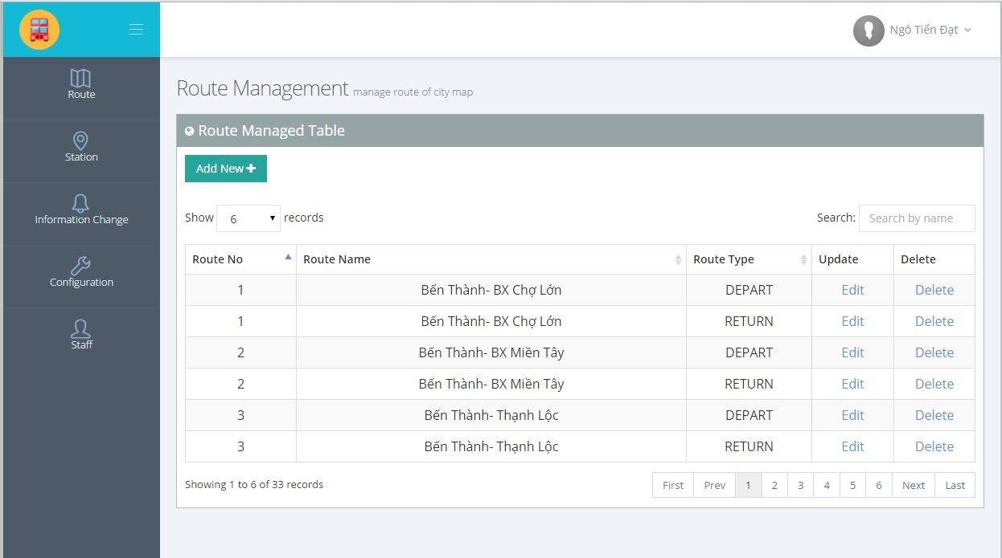

|  |  |
| --- | --- |
| Step | Description |
| 1 | Click on route name |

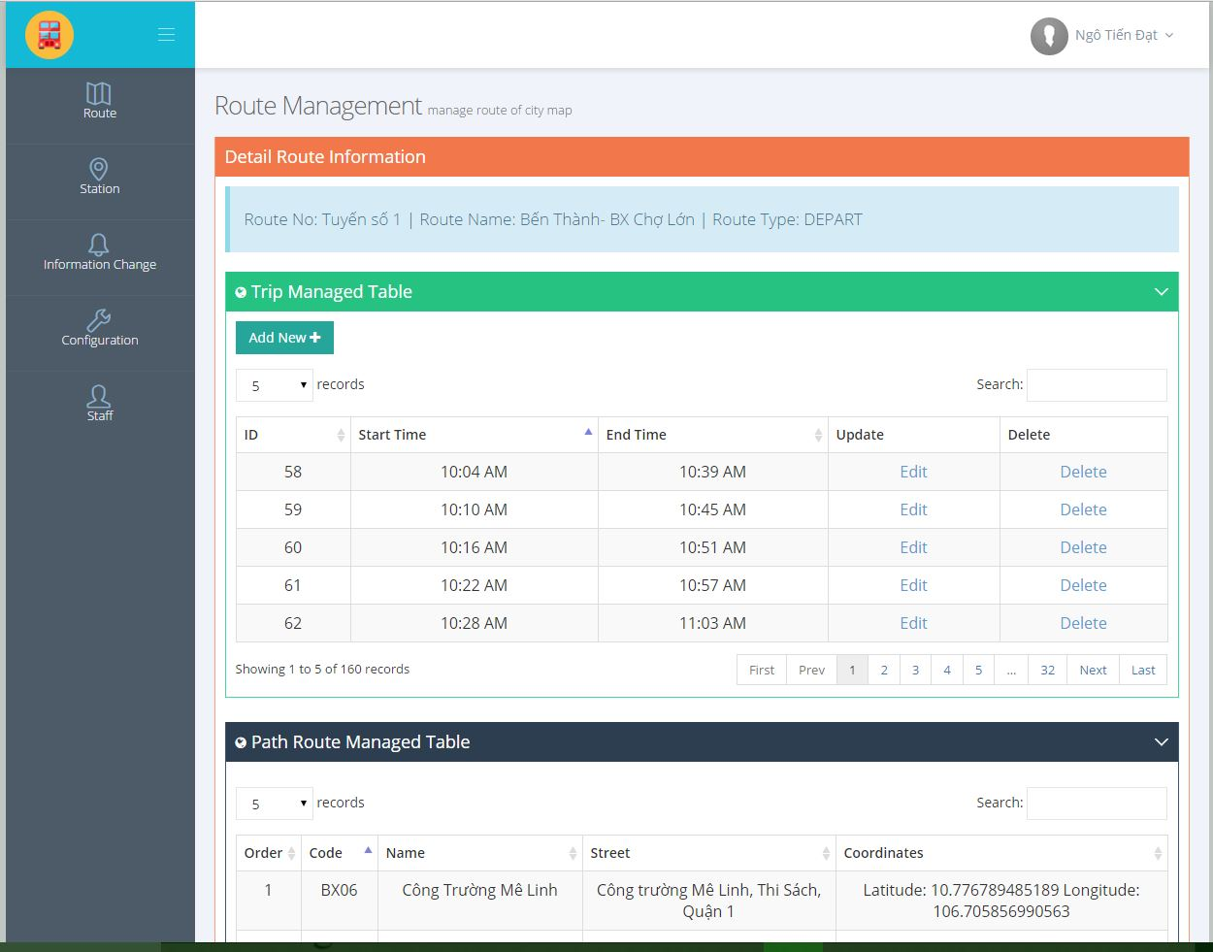

##### Staff configure parse source

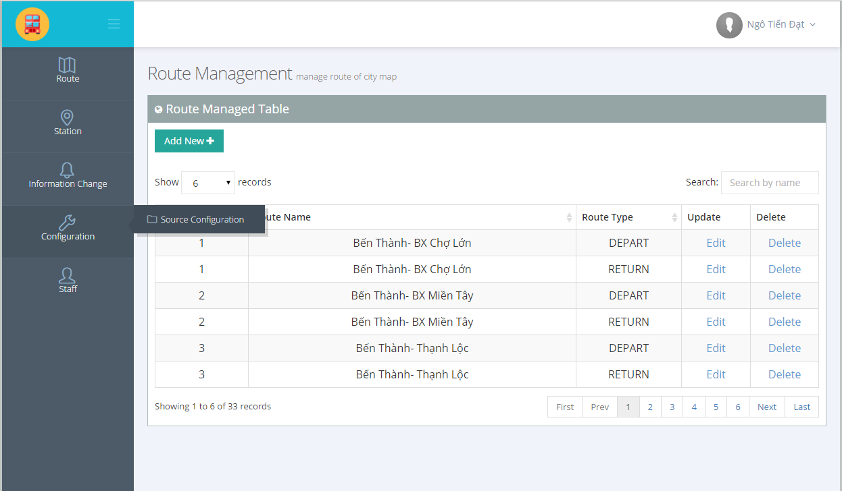

|  |  |
| --- | --- |
| Step | Description |
| 1 | Click side bar “Source Configuration”. |

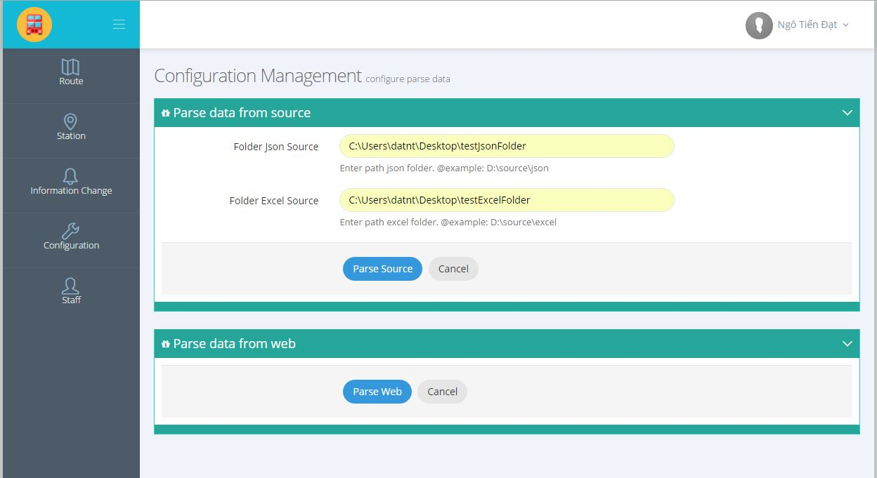

|  |  |
| --- | --- |
| Step | Description |
| 1 | Input fields:   * Folder json source: absolute path json folder contains list correct format file. * Folder excel source: absolute path excel folder contains list correct format file. |
| 2 | Click “Parse Source” button. |

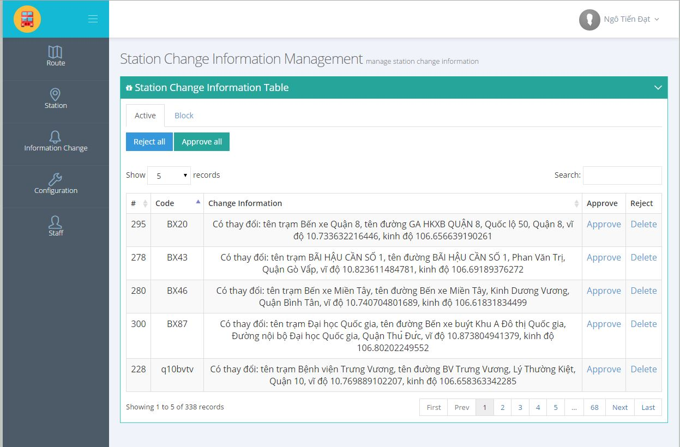

##### Staff configure parse web



|  |  |
| --- | --- |
| Step | Description |
| 1 | Click side bar “Source Configuration”. |



|  |  |
| --- | --- |
| Step | Description |
| 1 | Click on “Parse Web” button |



### Mobile Application

#### Search bus four points.



|  |  |
| --- | --- |
| Step | Description |
| 1 | Fill in fields:  “Chọn điểm khởi hành”: start location  “Chọn điểm đến”: end location |
| 2 | Click “departure time” button |
| 3 | Click “optional” button |



|  |  |
| --- | --- |
| Step | Description |
| 1 | Choose 10:56 |
| 2 | Click “OK” button |



|  |  |
| --- | --- |
| Step | Description |
| 1 | Fill in fields:  “Điểm trung gian 1”: middle location 1  “Điểm trung gian 2”: middle location 2  “Distance”: distance walking maximum between two stations. |
| 2 | Choose 2 transfer number |
| 3 | Checked “Tối ưu” |
| 4 | Click “Đồng ý” button |



|  |  |
| --- | --- |
| Step | Description |
| 1 | Click “search” button. |
| 2 | Display list results. |
| 3 | Double click on item to display detail information about one route. |



|  |  |
| --- | --- |
| Step | Description |
| 1 | Click “View Map” button, application open new screen to show map. |



|  |  |
| --- | --- |
| Step | Description |
| 1 | Tracking user’s location. |
| 2 | Download Audio File |



|  |  |
| --- | --- |
| Step | Description |
| 1 | Download audio file |
| 2 | Show message error if download fail. |

#### Search motorbike four points

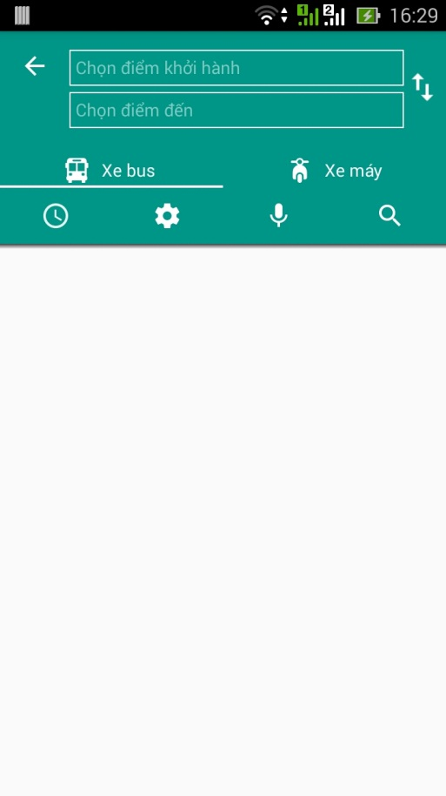

|  |  |
| --- | --- |
| Step | Description |
| 1 | Fill in fields:  “Chọn điểm khởi hành”: start location  “Chọn điểm đến”: end location |
| 2 | Click “Optional” button |

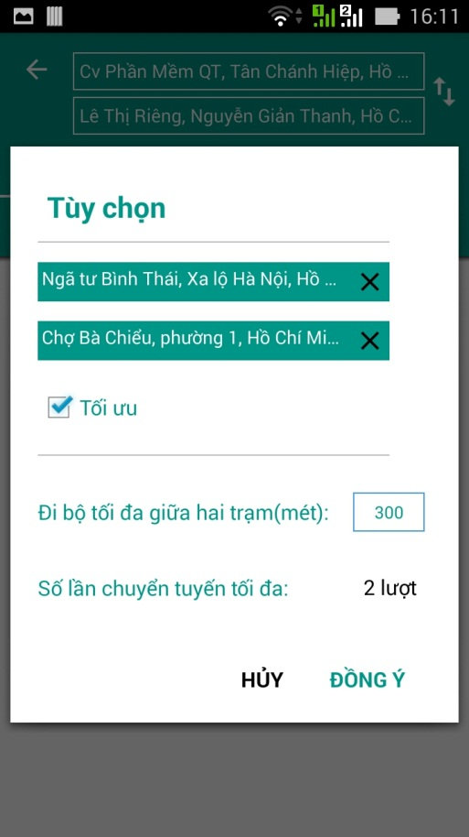

|  |  |
| --- | --- |
| Step | Description |
| 1 | Fill in fields:  “Điểm trung gian 1”: middle location 1  “Điểm trung gian 2”: middle location 2 |
| 2 | Checked “Tối ưu” |
| 3 | Click “Đồng Ý” button |

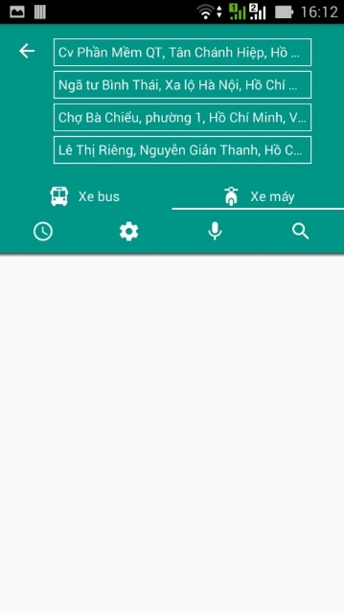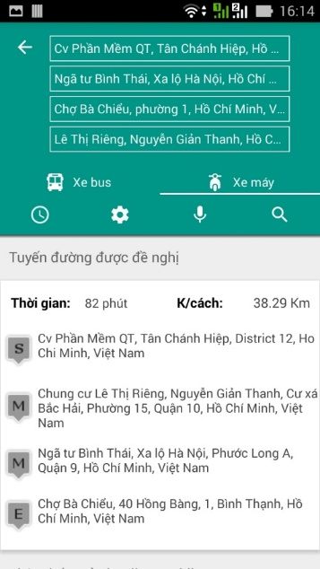

|  |  |
| --- | --- |
| Step | Description |
| 1 | Click “search” button. |
| 2 | Display list results. |
| 3 | Double click on item to display detail information about one route. |

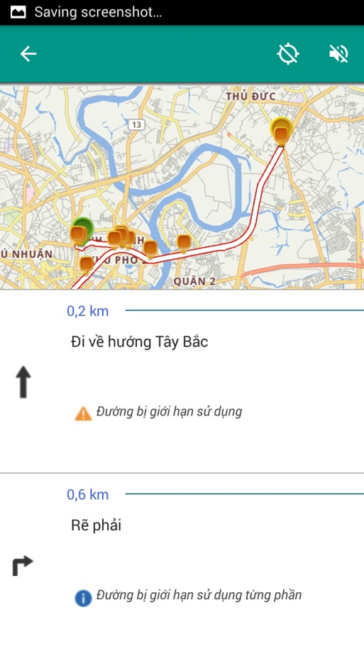

|  |  |
| --- | --- |
| Step | Description |
| 1 | Tracking user’s location. |
| 2 | Download Audio File |

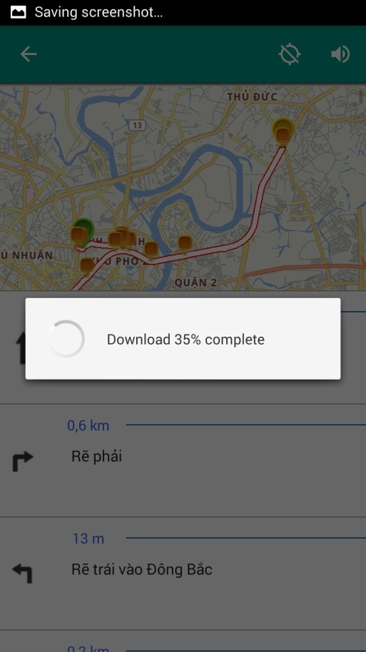

### Wear Application

#### Show notification

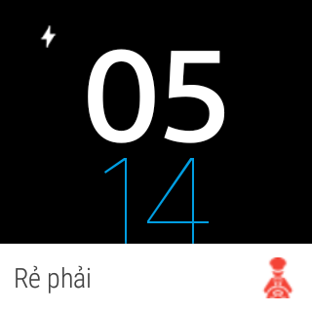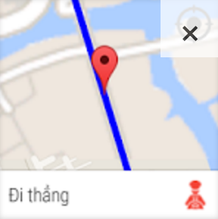

|  |  |
| --- | --- |
| Step | Description |
| 1 | Scroll notification up |

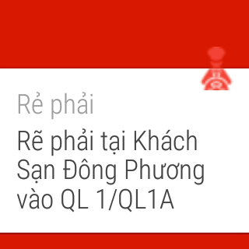

|  |  |
| --- | --- |
| Step | Description |
| 1 | Scroll notification to left |



#### Show map

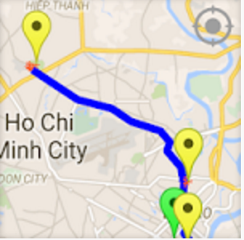

|  |  |
| --- | --- |
| Step | Description |
| 1 | Select current location button to navigate to user’s location |

# Appendix

1, RAPTOR algorithm is based on paper “Round-Based Public Transit Routing” written by Daniel Delling, Renato F. Werneck (Microsoft Research Silicon Valley), Thomas Pajor (Karlsruhe Institute of Technology), public in 2012.

1.